DISEASE DOMAIN | LESSON 8 OF 20 | EPIDEMIOLOGIST

How Common Is Mateo's Cleft, and in Whom?
How common is a cleft like Mateo's, and which babies does it happen to most?
CARRY FORWARD  In Robin sequence, the small jaw lets the tongue fall back and block the airway; the palate gap itself is not the blockage. | 10-YEAR TAKEAWAY  Epidemiology describes patterns in groups; it does not identify the cause of one child's cleft.

Cells differentiate | Development sculpts | Cells move | Development can go wrong

1. Observe the analogy before naming the biology
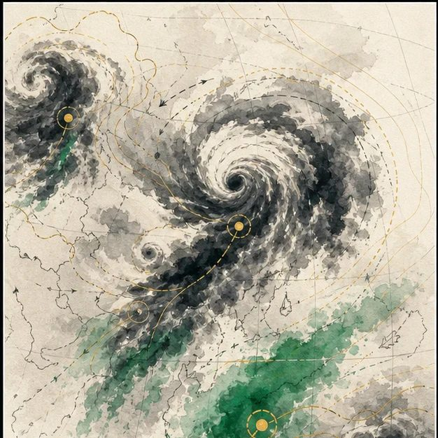
Illustration: A weather map shows patterns, not one raindrop's cause
1. What can the map tell you about a region?
________________________________________________________________________________
2. What can it not tell you about one raindrop?
________________________________________________________________________________
3. Which patterns would need a denominator?
________________________________________________________________________________

DISEASE LESSON 8 | RULES AND BIOLOGY MAPPING
2. Turn observations into rules

1. Rule 1: Count events relative to the population at risk. Explain it in your own words.
________________________________________________________________________________
2. Rule 2: Separate group patterns from individual explanations. Explain it in your own words.
________________________________________________________________________________
3. Rule 3: Treat ancestry patterns as descriptive, not deterministic. Explain it in your own words.
________________________________________________________________________________
Where the analogy stops: Birth prevalence is not weather. The analogy only distinguishes population pattern from individual cause.

3. Map the rules onto the biomedical example
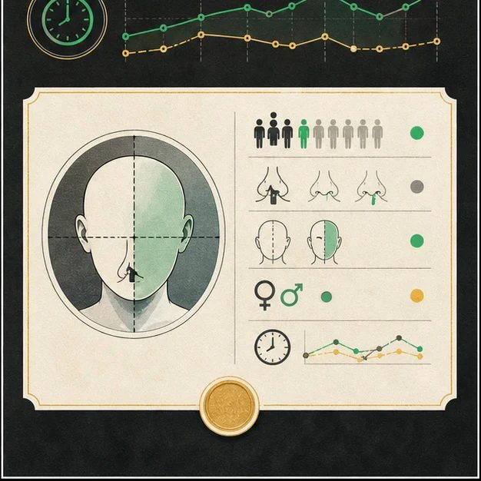
Biomedical teaching illustration: Read population patterns without overclaiming
Analogy step | Biology step | How the relationship stays the same
Regional rainfall rate | Birth prevalence in a defined population | ________________________________
Storm pattern | Differences by cleft type, sex, or side | ________________________________
One raindrop | Mateo's individual cause | ________________________________

DISEASE LESSON 8 | CASE FILE AND DECISION
4. Use the case evidence

ID | Finding supplied in the case | Why it matters
D08-E1 | Cleft lip with or without cleft palate occurs in roughly 1 in 1,000 births in current U.S. CDC estimates. | The condition is uncommon but not rare in population terms.
D08-E2 | Unilateral clefts are more common than bilateral clefts, and left-sided unilateral clefts are more common than right-sided ones. | Mateo fits common laterality patterns.
D08-E3 | Mateo is one patient with a specific history. | Population rates cannot identify his individual cause.

5. Make the clinical decision
You are writing one sentence for Mateo's family and one for a public-health report. Both sentences must use the same data without confusing group patterns with personal cause.
A. Describe the group pattern and state that it does not identify Mateo's cause
B. Use the population pattern to assign blame
C. Avoid all population data because it is never useful
Decision. Write the two sentences and label which one is population-level and which one is patient-level.
________________________________________________________________________________
________________________________________________________________________________
Claim ceiling: You may describe prevalence and pattern. You may not use group data to claim why Mateo's cleft happened.
Claim. State the choice you can defend.
________________________________________________________________________________
Evidence. Use these labeled IDs: D08-E1 + D08-E2 + D08-E3.
________________________________________________________________________________
Reasoning. Explain why the evidence supports the claim and stays inside the claim ceiling.
________________________________________________________________________________
________________________________________________________________________________

DISEASE LESSON 8 | REDUCE, REFLECT, AND PREPARE
6. Reduce the lesson to one lasting idea

Take-home. Epidemiology describes patterns in groups; it does not identify the cause of one child's cleft.
________________________________________________________________________________
________________________________________________________________________________
1. What denominator belongs in a birth-prevalence statement?
________________________________________________________________________________
2. Why can epidemiology not assign individual blame?
________________________________________________________________________________

Glossary
Term | Plain-English definition
epidemiology | The study of how diseases spread, who they affect, and what causes them across populations, used to find patterns and guide prevention.
birth prevalence | How often a condition is present at birth, usually given as the number of affected babies per a fixed number of births.
incidence | The number of new cases of a disease that appear in a population during a set period of time.
sex ratio | The proportion of affected males to females in a condition, a clue that can hint at sex-linked or hormone-related causes.
laterality | Which side of the body a feature affects, such as whether a cleft is on the left, the right, or both sides.
ancestry | A person's population background inherited from earlier generations, which can affect how common certain DNA variants are.

Next lesson unlock
Mateo's cleft fits the single most common pattern, which means it is not rare and not random. So what actually caused it: his genes, something in the pregnancy, or both?
The journal links on the lesson page are optional. Everything required for this guided-notes set is already supplied here and in the case file.

