DISEASE DOMAIN | LESSON 7 OF 20 | NEONATOLOGIST

When a Cleft Is an Airway Emergency
What makes a cleft palate a breathing emergency in one baby and not another?
CARRY FORWARD  An open palate limits suction, so feeding support replaces suction with flow control and positioning. | 10-YEAR TAKEAWAY  In Robin sequence, the small jaw lets the tongue fall back and block the airway; the palate gap itself is not the blockage.

Cells differentiate | Development sculpts | Cells move | Development can go wrong

1. Observe the analogy before naming the biology
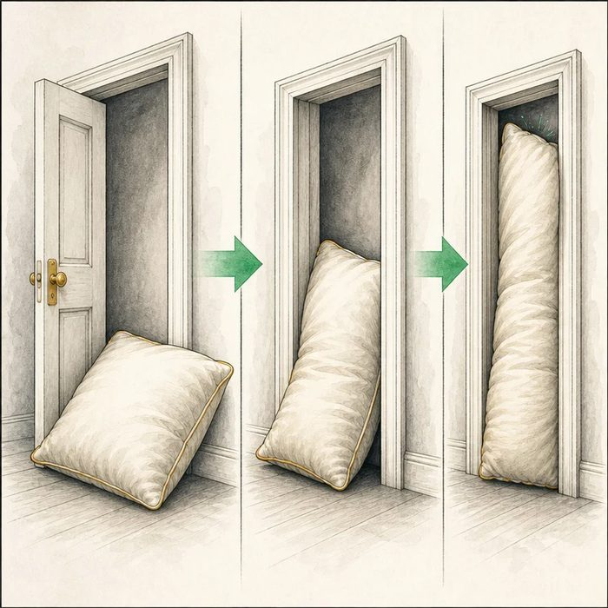
Illustration: A pillow blocks a narrow doorway
1. What makes the doorway easy to block?
________________________________________________________________________________
2. Which object moves into the opening?
________________________________________________________________________________
3. Would cutting a hole in the wall explain the blockage?
________________________________________________________________________________

DISEASE LESSON 7 | RULES AND BIOLOGY MAPPING
2. Turn observations into rules

1. Rule 1: A narrow space leaves less room for movement. Explain it in your own words.
________________________________________________________________________________
2. Rule 2: Position can turn a soft structure into an obstruction. Explain it in your own words.
________________________________________________________________________________
3. Rule 3: Treat the obstruction mechanism, not an unrelated opening. Explain it in your own words.
________________________________________________________________________________
Where the analogy stops: The tongue is living tissue and breathing is dynamic. The analogy only models space and position.

3. Map the rules onto the biomedical example
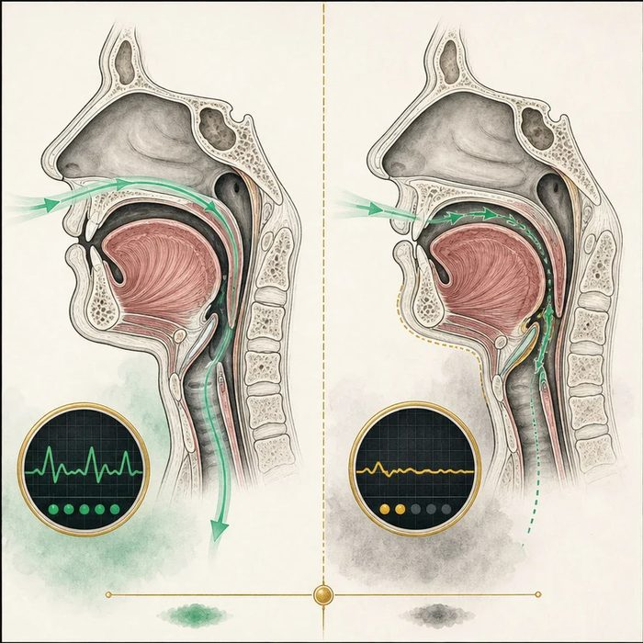
Biomedical teaching illustration: Trace the Robin sequence mechanism
Analogy step | Biology step | How the relationship stays the same
Narrow doorway | Small lower jaw reduces oral space | ________________________________
Pillow shifts backward | Tongue falls toward the throat | ________________________________
Air cannot pass | Upper airway obstruction | ________________________________

DISEASE LESSON 7 | CASE FILE AND DECISION
4. Use the case evidence

ID | Finding supplied in the case | Why it matters
D07-E1 | Mateo has normal jaw size and no tongue-back position on examination. | The key Robin sequence mechanism is absent.
D07-E2 | Breathing is quiet, oxygen level is normal, and there are no retractions. | There is no current sign of airway distress.
D07-E3 | A comparison infant has micrognathia, glossoptosis, noisy breathing, and oxygen drops when lying flat. | This pattern requires urgent airway action.

5. Make the clinical decision
You are triaging two newborns with cleft palate. Only one bassinet needs immediate airway escalation.
A. Escalate the comparison infant with small jaw, tongue-back position, and oxygen drops
B. Escalate Mateo because every palate cleft blocks the airway
C. Wait for feeding failure before checking breathing
Decision. Choose the infant who needs escalation and trace the mechanism in order.
________________________________________________________________________________
________________________________________________________________________________
Claim ceiling: You may rule on the current airway signs. You may not claim that Mateo can never develop a breathing problem later.
Claim. State the choice you can defend.
________________________________________________________________________________
Evidence. Use these labeled IDs: D07-E1 + D07-E2 + D07-E3.
________________________________________________________________________________
Reasoning. Explain why the evidence supports the claim and stays inside the claim ceiling.
________________________________________________________________________________
________________________________________________________________________________

DISEASE LESSON 7 | REDUCE, REFLECT, AND PREPARE
6. Reduce the lesson to one lasting idea

Take-home. In Robin sequence, the small jaw lets the tongue fall back and block the airway; the palate gap itself is not the blockage.
________________________________________________________________________________
________________________________________________________________________________
1. Put the Robin sequence events in order.
________________________________________________________________________________
2. Which findings make the comparison infant urgent?
________________________________________________________________________________

Glossary
Term | Plain-English definition
micrognathia | An unusually small lower jaw that can crowd the tongue backward and is sometimes linked with cleft palate and breathing trouble.
glossoptosis | Backward and downward displacement of the tongue, which can block the airway and is a key feature of Pierre Robin sequence.
sequence | A pattern of birth defects in which one early problem sets off the others, as small jaw leads to tongue and palate problems in Pierre Robin.
Pierre Robin sequence | A chain of features starting with a small lower jaw, which pushes the tongue back and blocks the airway and often comes with a cleft palate.
U-shaped cleft palate | A wide, rounded cleft of the palate shaped like the letter U, characteristic of Pierre Robin sequence.
airway obstruction | A partial or complete blockage of the passages that carry air to the lungs, making breathing difficult.

Next lesson unlock
Mateo's airway is safe, his cleft is isolated, and feeding is handled. Step back: how common is a cleft like his, and in whom does it happen most?
The journal links on the lesson page are optional. Everything required for this guided-notes set is already supplied here and in the case file.

