DISEASE DOMAIN | LESSON 6 OF 20 | FEEDING SPECIALIST

Keeping Mateo Fed and Growing
Why can't Mateo feed like a baby without a cleft, and what can we change today so he grows?
CARRY FORWARD  Testing is most useful when the history and exam create a question the test can answer. | 10-YEAR TAKEAWAY  An open palate limits suction, so feeding support replaces suction with flow control and positioning.

Cells differentiate | Development sculpts | Cells move | Development can go wrong

1. Observe the analogy before naming the biology
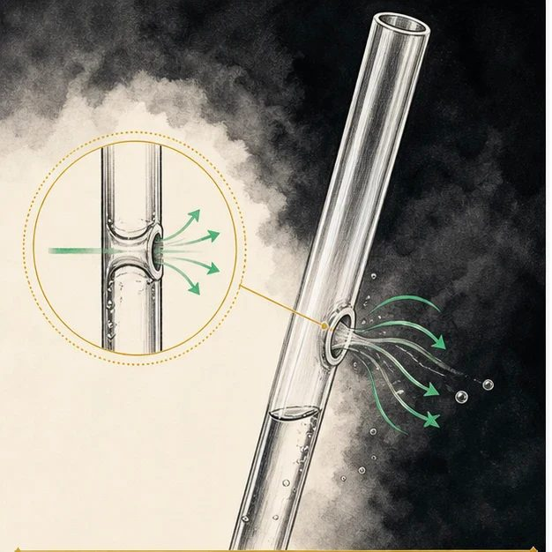
Illustration: A straw with a side hole cannot hold suction
1. Where does air enter the damaged straw?
________________________________________________________________________________
2. What happens to pressure inside it?
________________________________________________________________________________
3. How could you move liquid without relying on suction?
________________________________________________________________________________

DISEASE LESSON 6 | RULES AND BIOLOGY MAPPING
2. Turn observations into rules

1. Rule 1: A sealed pathway is needed to build negative pressure. Explain it in your own words.
________________________________________________________________________________
2. Rule 2: A leak reduces suction even when effort increases. Explain it in your own words.
________________________________________________________________________________
3. Rule 3: Assisted flow can replace the missing pressure step. Explain it in your own words.
________________________________________________________________________________
Where the analogy stops: Infant feeding uses coordinated sucking, swallowing, and breathing. The straw models only the pressure problem.

3. Map the rules onto the biomedical example
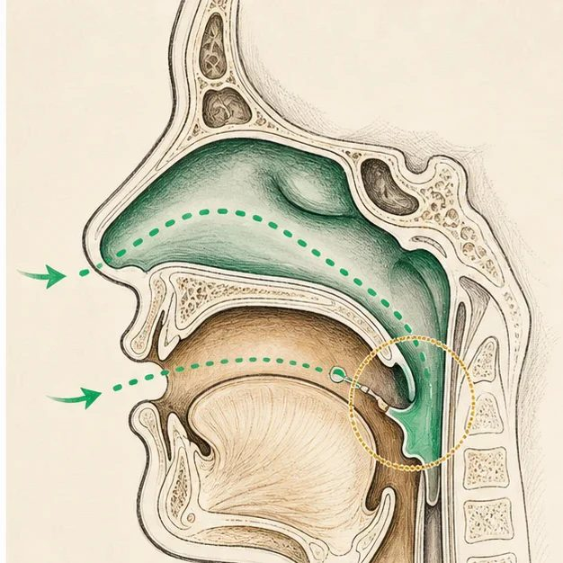
Biomedical teaching illustration: Replace missing suction with controlled assistance
Analogy step | Biology step | How the relationship stays the same
Side hole | Open connection between mouth and nose | ________________________________
Lost suction | Difficulty creating intraoral negative pressure | ________________________________
Squeeze the container | Assisted-delivery bottle provides controlled milk flow | ________________________________

DISEASE LESSON 6 | CASE FILE AND DECISION
4. Use the case evidence

ID | Finding supplied in the case | Why it matters
D06-E1 | Mateo tires during feeding and cannot maintain suction on a standard bottle. | The open palate is interfering with pressure generation.
D06-E2 | Breathing is calm and oxygen level remains normal during the observed feed. | The immediate problem is feeding mechanics rather than respiratory failure.
D06-E3 | With an assisted-delivery bottle, upright position, and pauses, intake improves. | The modified plan addresses the mechanism.

5. Make the clinical decision
You are the feeding specialist before discharge. Mateo must show a safe plan that his family can repeat at home.
A. Use an assisted-delivery bottle, upright position, paced squeezes, and weight follow-up
B. Use a standard bottle and feed faster
C. Stop oral feeding without first assessing safety
Decision. Choose the discharge plan and connect each part to the evidence and pressure model.
________________________________________________________________________________
________________________________________________________________________________
Claim ceiling: You may recommend the observed safe strategy. You may not assume every infant with a cleft has the same feeding ability.
Claim. State the choice you can defend.
________________________________________________________________________________
Evidence. Use these labeled IDs: D06-E1 + D06-E2 + D06-E3.
________________________________________________________________________________
Reasoning. Explain why the evidence supports the claim and stays inside the claim ceiling.
________________________________________________________________________________
________________________________________________________________________________

DISEASE LESSON 6 | REDUCE, REFLECT, AND PREPARE
6. Reduce the lesson to one lasting idea

Take-home. An open palate limits suction, so feeding support replaces suction with flow control and positioning.
________________________________________________________________________________
________________________________________________________________________________
1. What pressure problem does an open palate create?
________________________________________________________________________________
2. How does each part of the feeding plan solve that problem?
________________________________________________________________________________

Glossary
Term | Plain-English definition
intraoral negative pressure | The suction created inside the mouth that lets a baby latch and draw milk; a cleft palate can prevent this seal from forming.
suck | An infant's ability to create suction with the lips and palate to draw milk, which a cleft can disrupt.
failure to thrive | Poor weight gain and growth in an infant or child, often because feeding is difficult or nutrition is not absorbed well.
compressible (assisted-delivery) bottle | A soft squeezable feeding bottle that lets a caregiver push milk into the mouth of a baby who cannot create strong suction, such as one with a cleft.
upright positioning | Holding a baby in a more vertical posture during feeding so gravity helps keep milk out of the nose and airway.

Next lesson unlock
We answered today's question: Mateo can be fed with the right bottle and position. But most is not all. A few cleft babies struggle not just to eat but to breathe, especially when the jaw is small and the tongue falls back. When is a cleft an actual airway emergency?
The journal links on the lesson page are optional. Everything required for this guided-notes set is already supplied here and in the case file.

