DISEASE DOMAIN | LESSON 5 OF 20 | GENETICIST / DYSMORPHOLOGIST (CLEFT TEAM)

The Exam and the Test That Sort Syndromic from Isolated
What exam and what test sort a syndromic cleft from an isolated one, and when do you order the test?
CARRY FORWARD  A red-flag checklist turns a broad syndrome question into specific findings that can be checked. | 10-YEAR TAKEAWAY  Testing is most useful when the history and exam create a question the test can answer.

Cells differentiate | Development sculpts | Cells move | Development can go wrong

1. Observe the analogy before naming the biology

Illustration: Choose the right tool after you inspect the wall
1. Why does the expert inspect before choosing a tool?
________________________________________________________________________________
2. Which tool is broad and which is targeted?
________________________________________________________________________________
3. Could the most expensive tool still be the wrong first choice?
________________________________________________________________________________

DISEASE LESSON 5 | RULES AND BIOLOGY MAPPING
2. Turn observations into rules

1. Rule 1: Define the question before ordering a test. Explain it in your own words.
________________________________________________________________________________
2. Rule 2: Match test scale to the suspected problem. Explain it in your own words.
________________________________________________________________________________
3. Rule 3: A normal result does not erase evidence outside the test's range. Explain it in your own words.
________________________________________________________________________________
Where the analogy stops: DNA testing is not construction work. The analogy models matching a tool to a question.

3. Map the rules onto the biomedical example
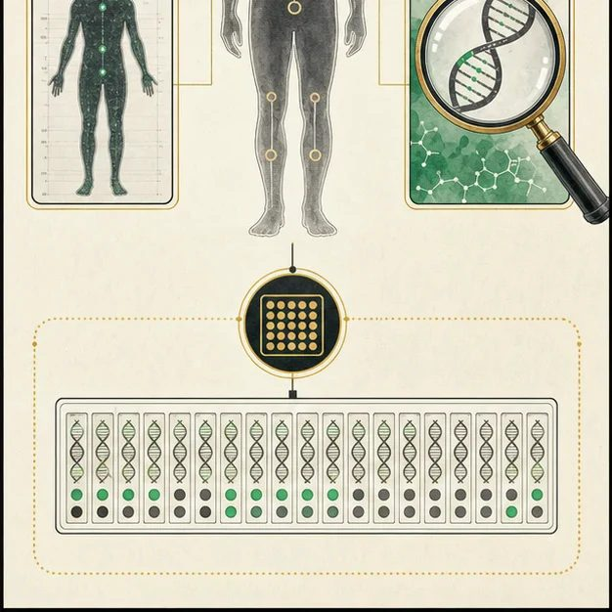
Biomedical teaching illustration: Let the exam choose the genetic test
Analogy step | Biology step | How the relationship stays the same
Visual inspection | Dysmorphology exam and family history | ________________________________
Targeted detector | A gene test when a specific syndrome is suspected | ________________________________
Broad wall scan | Chromosomal microarray for unexplained multiple anomalies | ________________________________

DISEASE LESSON 5 | CASE FILE AND DECISION
4. Use the case evidence

ID | Finding supplied in the case | Why it matters
D05-E1 | Mateo's structured exam shows the cleft but no additional congenital anomalies. | The current pattern is more consistent with an isolated finding than a multiple-anomaly pattern.
D05-E2 | The three-generation family history shows no repeated cleft pattern or matching syndrome features. | There is no clear single-syndrome target from family history.
D05-E3 | Chromosomal microarray is best at detecting missing or extra DNA segments, not every possible DNA change. | A broad test has a defined scope and a normal result has limits.

5. Make the clinical decision
You are the clinical geneticist deciding what to recommend today. Mateo has one major structural finding and no additional anomalies after a careful exam.
A. Document the completed genetics evaluation and reserve testing for new findings or a specific question
B. Order every available genetic test
C. Tell the family genetics has no role
Decision. Choose a testing plan, cite the case evidence, and state one thing your plan cannot rule out.
________________________________________________________________________________
________________________________________________________________________________
Claim ceiling: You may justify a measured testing plan. You may not say a normal microarray proves there is no genetic contribution.
Claim. State the choice you can defend.
________________________________________________________________________________
Evidence. Use these labeled IDs: D05-E1 + D05-E2 + D05-E3.
________________________________________________________________________________
Reasoning. Explain why the evidence supports the claim and stays inside the claim ceiling.
________________________________________________________________________________
________________________________________________________________________________

DISEASE LESSON 5 | REDUCE, REFLECT, AND PREPARE
6. Reduce the lesson to one lasting idea

Take-home. Testing is most useful when the history and exam create a question the test can answer.
________________________________________________________________________________
________________________________________________________________________________
1. What question can a microarray answer?
________________________________________________________________________________
2. Why can a normal result never mean 'no genetic influence'?
________________________________________________________________________________

Glossary
Term | Plain-English definition
dysmorphology exam | A careful physical exam where a specialist looks for unusual body and facial features that, together, can point to a genetic syndrome.
chromosomal microarray (CMA) | A genetic test that scans the whole genome for missing or extra chunks of DNA too small to see under a microscope.
copy-number variant | A change in which a large stretch of DNA is duplicated or deleted, so a person carries extra or missing copies of a region.
diagnostic yield | The fraction of patients in whom a given test actually finds the genetic or medical cause of their condition.
isolated cleft | A cleft of the lip or palate that occurs on its own, without other birth differences or a recognized syndrome.
syndromic cleft | A cleft that comes packaged with other features as part of a named syndrome, accounting for roughly 30 percent of clefts.

Next lesson unlock
We sorted the exam and tests that separate a syndrome from a lone cleft, and Mateo's structured exam and testing point toward an isolated cleft. That workup takes time to complete, and meanwhile a two-day-old still has to eat. So how do we keep Mateo fed and growing while the rest of the picture comes together?
The journal links on the lesson page are optional. Everything required for this guided-notes set is already supplied here and in the case file.

