DISEASE DOMAIN | LESSON 4 OF 20 | GENETICIST / DYSMORPHOLOGIST (CLEFT TEAM)

The Short List: Ruling Out the Big Cleft Syndromes
Which specific syndromes must we rule out for Mateo, and what is the one red flag that flags each?
CARRY FORWARD  A cleft is syndromic only when a pattern of additional findings supports that claim. | 10-YEAR TAKEAWAY  A red-flag checklist turns a broad syndrome question into specific findings that can be checked.

Cells differentiate | Development sculpts | Cells move | Development can go wrong

1. Observe the analogy before naming the biology
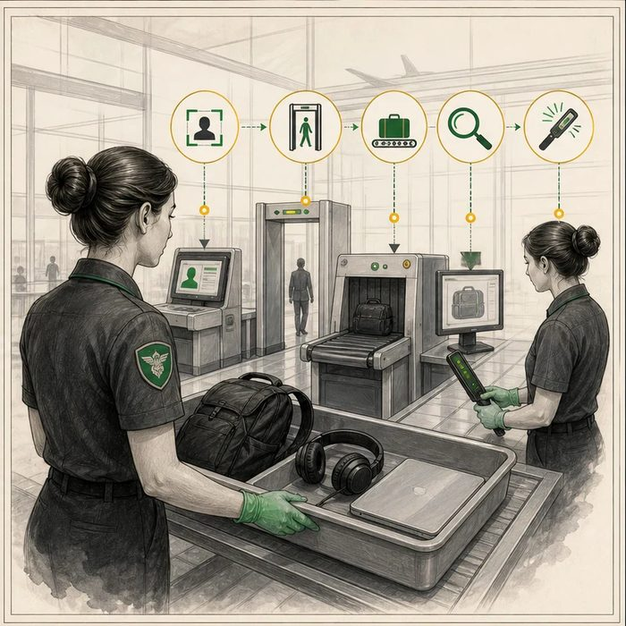
Illustration: Airport screening uses named checks
1. Why are the checkpoints named?
________________________________________________________________________________
2. Which checks are visual and which need a tool?
________________________________________________________________________________
3. What would happen if the screener relied on a general feeling?
________________________________________________________________________________

DISEASE LESSON 4 | RULES AND BIOLOGY MAPPING
2. Turn observations into rules

1. Rule 1: Break a broad risk into visible checks. Explain it in your own words.
________________________________________________________________________________
2. Rule 2: Match each concern to a specific sign. Explain it in your own words.
________________________________________________________________________________
3. Rule 3: A negative check narrows the list but does not erase all uncertainty. Explain it in your own words.
________________________________________________________________________________
Where the analogy stops: Patients are not security threats. The analogy only represents systematic screening.

3. Map the rules onto the biomedical example
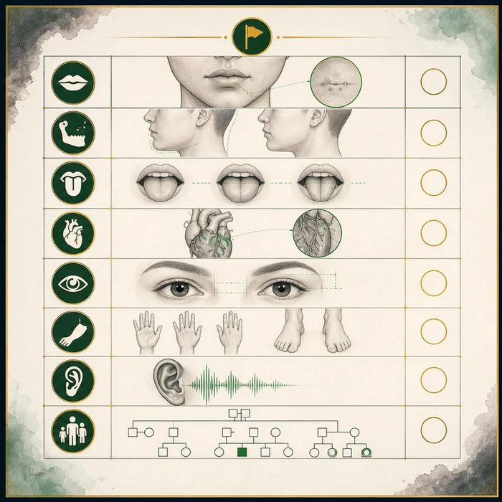
Biomedical teaching illustration: Match named syndromes to named red flags
Analogy step | Biology step | How the relationship stays the same
Passport check | Family history and lip-pit check | ________________________________
Bag scan | Heart, eye, jaw, and limb examination | ________________________________
Secondary screening | Targeted referral or test when a flag is present | ________________________________

DISEASE LESSON 4 | CASE FILE AND DECISION
4. Use the case evidence

ID | Finding supplied in the case | Why it matters
D04-E1 | No lower-lip pits are seen. | A classic Van der Woude clue is absent.
D04-E2 | Jaw size and breathing are normal. | The small-jaw and tongue-back pattern of Robin sequence is not present.
D04-E3 | Heart exam, eye exam, and limb exam are unremarkable. | Several common syndromic red flags are not present on screening.

5. Make the clinical decision
You are the cleft team coordinator reviewing the red-flag matrix. The team has time for one next step before the family leaves.
A. Complete the structured family history and genetics examination
B. Assign a named syndrome from the cleft alone
C. Stop all evaluation because the first exam is normal
Decision. Choose the next step and show how the red-flag evidence narrows, but does not close, the question.
________________________________________________________________________________
________________________________________________________________________________
Claim ceiling: You may say named red flags are absent on today's screen. You may not say every possible syndrome has been ruled out.
Claim. State the choice you can defend.
________________________________________________________________________________
Evidence. Use these labeled IDs: D04-E1 + D04-E2 + D04-E3.
________________________________________________________________________________
Reasoning. Explain why the evidence supports the claim and stays inside the claim ceiling.
________________________________________________________________________________
________________________________________________________________________________

DISEASE LESSON 4 | REDUCE, REFLECT, AND PREPARE
6. Reduce the lesson to one lasting idea

Take-home. A red-flag checklist turns a broad syndrome question into specific findings that can be checked.
________________________________________________________________________________
________________________________________________________________________________
1. What is one red flag and the condition it may suggest?
________________________________________________________________________________
2. Why does a normal screen narrow rather than end the evaluation?
________________________________________________________________________________

Glossary
Term | Plain-English definition
Van der Woude syndrome | The most common syndromic, single-gene form of cleft lip and palate, usually caused by an IRF6 mutation and often marked by small lower-lip pits.
22q11.2 deletion syndrome | A condition caused by missing a small piece of chromosome 22, leading to heart defects, immune problems, and often cleft palate.
Stickler syndrome | An inherited collagen disorder that often pairs cleft palate with severe nearsightedness, joint problems, and hearing loss.
Pierre Robin sequence | A chain of features starting with a small lower jaw, which pushes the tongue back and blocks the airway and often comes with a cleft palate.
lip pits | Small paired depressions on the lower lip that serve as the hallmark sign flagging Van der Woude syndrome, a cleft-related disorder.
micrognathia | An unusually small lower jaw that can crowd the tongue backward and is sometimes linked with cleft palate and breathing trouble.
glossoptosis | Backward and downward displacement of the tongue, which can block the airway and is a key feature of Pierre Robin sequence.
velopharyngeal insufficiency | When the soft palate cannot fully seal off the nose during speech, letting air escape and making speech sound nasal.

Next lesson unlock
We now have a checklist of red flags, and Mateo trips none of them on inspection. But a checklist you eyeball by hand can miss the quiet ones: a tiny deletion of DNA causes no obvious sign, and subtle features hide. How does the team make the syndromic-versus-isolated call rigorous, with an exam protocol and a test, instead of just a confident glance?
The journal links on the lesson page are optional. Everything required for this guided-notes set is already supplied here and in the case file.

