DISEASE DOMAIN | LESSON 3 OF 20 | GENETICIST / DYSMORPHOLOGIST (CLEFT TEAM)

Is the Cleft a Clue? The Syndromic Question
Could Mateo's cleft be a sign of a larger condition, or is it traveling alone?
CARRY FORWARD  A useful cleft description names the structures, the side, and the completeness as three separate choices. | 10-YEAR TAKEAWAY  A cleft is syndromic only when a pattern of additional findings supports that claim.

Cells differentiate | Development sculpts | Cells move | Development can go wrong

1. Observe the analogy before naming the biology
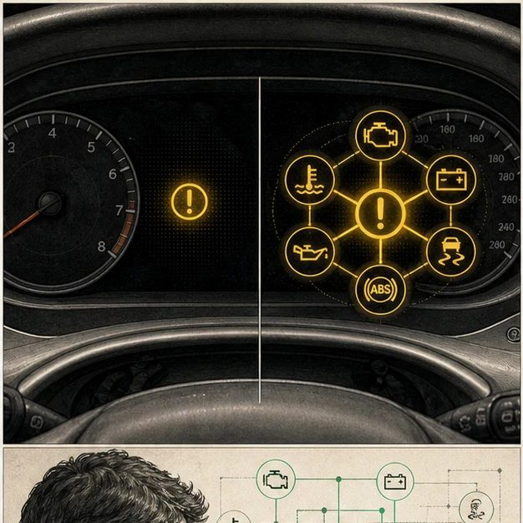
Illustration: One warning light or a dashboard pattern?
1. How does one warning differ from several linked warnings?
________________________________________________________________________________
2. Which situation suggests a broader system problem?
________________________________________________________________________________
3. What information would you check before deciding?
________________________________________________________________________________

DISEASE LESSON 3 | RULES AND BIOLOGY MAPPING
2. Turn observations into rules

1. Rule 1: One finding can be local. Explain it in your own words.
________________________________________________________________________________
2. Rule 2: A repeated pattern across systems can signal a larger condition. Explain it in your own words.
________________________________________________________________________________
3. Rule 3: Absence of red flags is evidence, but not absolute proof. Explain it in your own words.
________________________________________________________________________________
Where the analogy stops: Human development is more complex than a dashboard. The analogy models pattern recognition only.

3. Map the rules onto the biomedical example
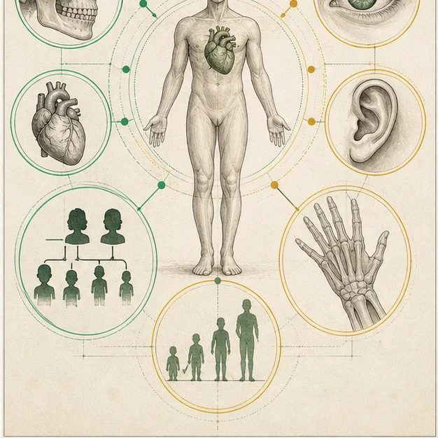
Biomedical teaching illustration: Ask whether the cleft travels alone
Analogy step | Biology step | How the relationship stays the same
Single warning | Cleft with no additional findings | ________________________________
Linked warnings | Cleft plus a repeatable set of other features | ________________________________
Diagnostic scan | Structured history, exam, and selected testing | ________________________________

DISEASE LESSON 3 | CASE FILE AND DECISION
4. Use the case evidence

ID | Finding supplied in the case | Why it matters
D03-E1 | Mateo has a complete unilateral left cleft lip and palate. | This confirms the structural finding but does not classify the cause.
D03-E2 | No jaw, heart, limb, eye, ear, or tone abnormality was found on the newborn exam. | The first exam does not show a broader pattern.
D03-E3 | Family history and targeted syndrome checks are not yet complete. | The classification must remain provisional.

5. Make the clinical decision
You are presenting Mateo at the first genetics huddle. The team must choose how to describe the case today without overstating what is known.
A. Cleft under evaluation, with no additional anomalies found so far
B. Confirmed nonsyndromic cleft
C. Confirmed named syndrome
Decision. Choose the most defensible chart phrase and explain why the other two go beyond the evidence.
________________________________________________________________________________
________________________________________________________________________________
Claim ceiling: You may state that no red flags have been found so far. You may not call the cleft isolated or nonsyndromic until the evaluation is complete.
Claim. State the choice you can defend.
________________________________________________________________________________
Evidence. Use these labeled IDs: D03-E2 + D03-E3.
________________________________________________________________________________
Reasoning. Explain why the evidence supports the claim and stays inside the claim ceiling.
________________________________________________________________________________
________________________________________________________________________________

DISEASE LESSON 3 | REDUCE, REFLECT, AND PREPARE
6. Reduce the lesson to one lasting idea

Take-home. A cleft is syndromic only when a pattern of additional findings supports that claim.
________________________________________________________________________________
________________________________________________________________________________
1. What turns one finding into a syndrome pattern?
________________________________________________________________________________
2. Why is 'so far' an important phrase in today's chart?
________________________________________________________________________________

Glossary
Term | Plain-English definition
isolated cleft | A cleft of the lip or palate that occurs on its own, without other birth differences or a recognized syndrome.
syndrome | A set of features that consistently occur together and share a common underlying cause.
syndromic cleft | A cleft that comes packaged with other features as part of a named syndrome, accounting for roughly 30 percent of clefts.
nonsyndromic cleft | A cleft that occurs on its own, without other birth differences or a recognized syndrome accompanying it.
associated anomaly | An additional birth difference found alongside the main condition, signaling that a broader syndrome or developmental problem may be present.
dysmorphology | The medical study of unusual body and facial features present from birth, used to recognize and diagnose genetic syndromes.

Next lesson unlock
We learned that a cleft can ride alone or come bundled with other features, so the only honest answer right now is 'we do not know yet, we have to check.' But 'check for a syndrome' is too vague to act on. Which specific syndromes must a cleft team actually rule out, and what red flags point to each one?
The journal links on the lesson page are optional. Everything required for this guided-notes set is already supplied here and in the case file.

