DISEASE DOMAIN | LESSON 2 OF 20 | PEDIATRICIAN (CLEFT TEAM COORDINATOR)

Describing the Cleft: Type, Side, and How Complete
How does the team describe Mateo's cleft precisely enough to plan from?
CARRY FORWARD  Day-one cleft care begins with a complete exam and clear, respectful communication. | 10-YEAR TAKEAWAY  A useful cleft description names the structures, the side, and the completeness as three separate choices.

Cells differentiate | Development sculpts | Cells move | Development can go wrong

1. Observe the analogy before naming the biology

Illustration: A three-part mailing address
1. Which address details are independent?
________________________________________________________________________________
2. What happens if one line is missing?
________________________________________________________________________________
3. Could two packages share one detail but still go to different places?
________________________________________________________________________________

DISEASE LESSON 2 | RULES AND BIOLOGY MAPPING
2. Turn observations into rules

1. Rule 1: Use one field for each kind of information. Explain it in your own words.
________________________________________________________________________________
2. Rule 2: Do not replace three fields with one vague label. Explain it in your own words.
________________________________________________________________________________
3. Rule 3: Check every field before making a plan. Explain it in your own words.
________________________________________________________________________________
Where the analogy stops: A diagnosis is not literally an address. The analogy only shows why independent descriptors matter.

3. Map the rules onto the biomedical example
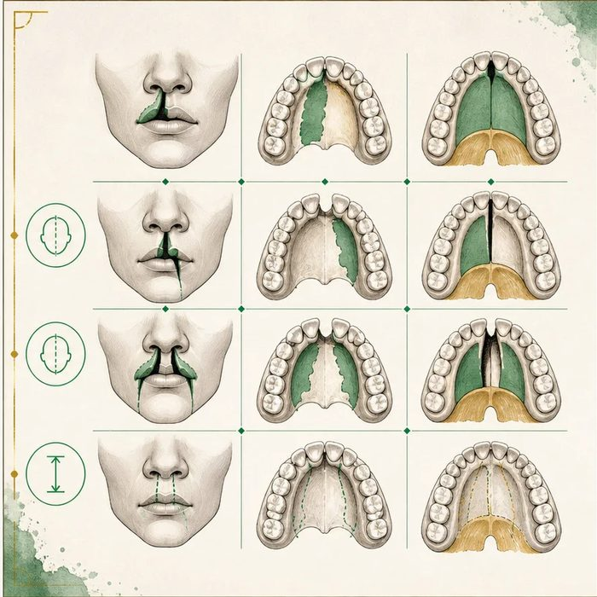
Biomedical teaching illustration: Sort Mateo on three clinical axes
Analogy step | Biology step | How the relationship stays the same
Street | Which structures: lip, palate, or both | ________________________________
Side of street | Laterality: left, right, or bilateral | ________________________________
Unit number | Completeness: partial or full length | ________________________________

DISEASE LESSON 2 | CASE FILE AND DECISION
4. Use the case evidence

ID | Finding supplied in the case | Why it matters
D02-E1 | The gap involves both the lip and the palate. | Structure category: cleft lip and palate.
D02-E2 | Only the left side of the lip is involved. | Laterality: unilateral, left.
D02-E3 | The lip gap reaches the nostril and the palate is open along its length. | Completeness: complete.

5. Make the clinical decision
You are entering Mateo into the cleft team registry. The surgeon will use your entry to plan the first visit. The registry rejects vague labels.
A. Complete unilateral left cleft lip and palate
B. A cleft
C. Bilateral incomplete cleft lip only
Decision. Choose the registry description and cite one evidence ID for each word that narrows the description.
________________________________________________________________________________
________________________________________________________________________________
Claim ceiling: You may classify anatomy. You may not infer a syndrome from the cleft pattern alone.
Claim. State the choice you can defend.
________________________________________________________________________________
Evidence. Use these labeled IDs: D02-E1 + D02-E2 + D02-E3.
________________________________________________________________________________
Reasoning. Explain why the evidence supports the claim and stays inside the claim ceiling.
________________________________________________________________________________
________________________________________________________________________________

DISEASE LESSON 2 | REDUCE, REFLECT, AND PREPARE
6. Reduce the lesson to one lasting idea

Take-home. A useful cleft description names the structures, the side, and the completeness as three separate choices.
________________________________________________________________________________
________________________________________________________________________________
1. Which evidence supports each part of Mateo's description?
________________________________________________________________________________
2. Why is the phrase 'a cleft' not enough for planning?
________________________________________________________________________________

Glossary
Term | Plain-English definition
cleft lip (CL) | A birth difference where the upper lip does not fully fuse before birth, leaving a gap or split that can reach toward the nose.
cleft palate (CP) | A birth difference in which the roof of the mouth does not fully join before birth, leaving an opening between the mouth and nasal cavity.
cleft lip and palate (CLP) | A birth difference in which the lip, the roof of the mouth, or both fail to fully join before birth, leaving a gap.
unilateral | Affecting only one side of the body or face, as opposed to both sides.
bilateral | Affecting both the left and right sides of the body, such as a cleft that appears on both sides of the lip.
complete | Describing a cleft that extends through the entire structure, such as a lip cleft reaching all the way up into the nostril.
incomplete | Describing a cleft that does not extend through the full structure, so a bridge of tissue still connects the two sides.
submucous cleft palate | A hidden cleft where the palate muscles fail to join in the midline even though the overlying lining looks intact.

Next lesson unlock
We can describe Mateo's cleft exactly: complete, unilateral, left, lip and palate. But a precise description still does not tell us WHY. A cleft can travel alone, or it can be one clue to a bigger condition. Could Mateo's cleft be a sign of a larger syndrome?
The journal links on the lesson page are optional. Everything required for this guided-notes set is already supplied here and in the case file.

