DISEASE DOMAIN | LESSON 1 OF 20 | PEDIATRICIAN (CLEFT TEAM COORDINATOR)

Day One: Recognizing and Communicating a Cleft at Birth
What happens the day Mateo is born: how do we examine the finding, and how do we tell his family?
CARRY FORWARD  Start with what you can observe before you explain why it happened. | 10-YEAR TAKEAWAY  Day-one cleft care begins with a complete exam and clear, respectful communication.

Cells differentiate | Development sculpts | Cells move | Development can go wrong

1. Observe the analogy before naming the biology
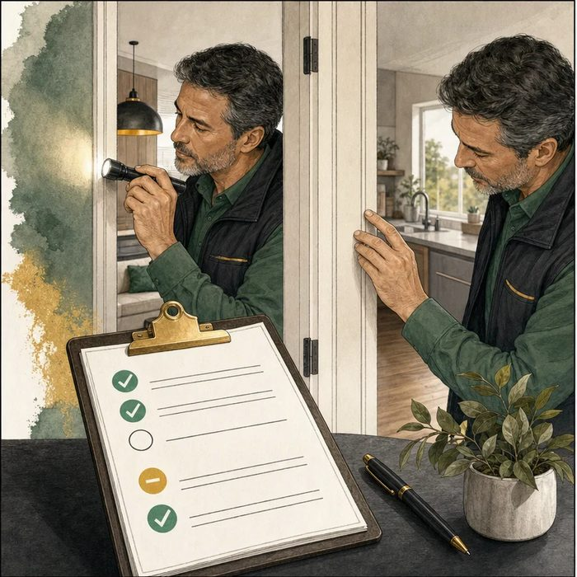
Illustration: The careful home inspector
1. What does the inspector check in more than one way?
________________________________________________________________________________
2. What does the inspector record even when nothing is wrong?
________________________________________________________________________________
3. Which observations would be facts, and which would be guesses?
________________________________________________________________________________

DISEASE LESSON 1 | RULES AND BIOLOGY MAPPING
2. Turn observations into rules

1. Rule 1: Inspect every relevant structure in a set order. Explain it in your own words.
________________________________________________________________________________
2. Rule 2: Use more than one sense when a problem may be hidden. Explain it in your own words.
________________________________________________________________________________
3. Rule 3: Record normal findings as well as abnormal findings. Explain it in your own words.
________________________________________________________________________________
Where the analogy stops: A newborn exam is not a house inspection. The analogy only models careful observation and documentation.

3. Map the rules onto the biomedical example
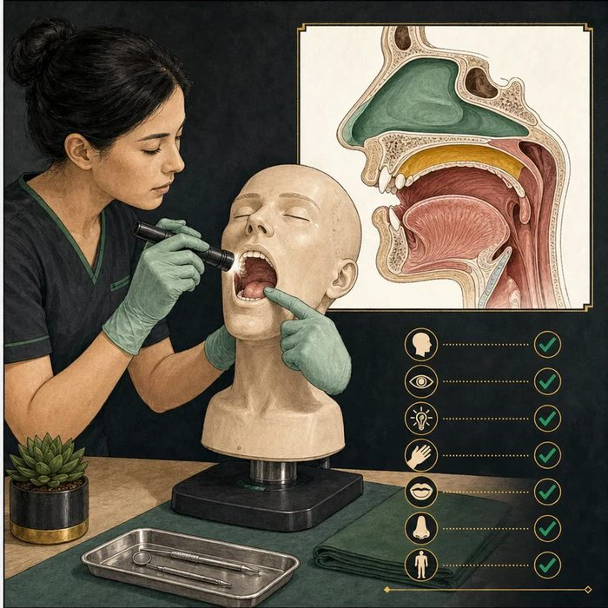
Biomedical teaching illustration: Map the inspection onto Mateo's newborn exam
Analogy step | Biology step | How the relationship stays the same
Look at the doorway | Inspect the lip and palate with a light | ________________________________
Feel for a hidden gap | Palpate the palate with a gloved finger | ________________________________
Record what is intact | Document the normal head-to-toe findings | ________________________________

DISEASE LESSON 1 | CASE FILE AND DECISION
4. Use the case evidence

ID | Finding supplied in the case | Why it matters
D01-E1 | The upper lip has a visible gap on the left side. | The lip finding is left-sided and unilateral.
D01-E2 | The palate gap is seen with a light and confirmed by palpation. | The palate finding is real and should not be missed by inspection alone.
D01-E3 | Breathing, tone, heart sounds, eyes, ears, hands, feet, and jaw size are otherwise unremarkable. | The chart must include important normal findings while the team keeps the cause open.

5. Make the clinical decision
You are the pediatrician in the delivery room. Mateo is breathing well. His parents ask what you found and what happens next.
A. Name the observed cleft, explain that a team and plan are available, and document the complete exam.
B. Name a genetic cause before the full examination is finished.
C. Use an obsolete label and focus only on appearance.
Decision. Which response will you give, and which two evidence IDs make it the safest choice?
________________________________________________________________________________
________________________________________________________________________________
Claim ceiling: You may describe the structural finding. You may not claim a genetic cause or final isolated-versus-syndromic classification yet.
Claim. State the choice you can defend.
________________________________________________________________________________
Evidence. Use these labeled IDs: D01-E2 + D01-E3.
________________________________________________________________________________
Reasoning. Explain why the evidence supports the claim and stays inside the claim ceiling.
________________________________________________________________________________
________________________________________________________________________________

DISEASE LESSON 1 | REDUCE, REFLECT, AND PREPARE
6. Reduce the lesson to one lasting idea

Take-home. Day-one cleft care begins with a complete exam and clear, respectful communication.
________________________________________________________________________________
________________________________________________________________________________
1. Why are both inspection and palpation needed?
________________________________________________________________________________
2. What can the team say now, and what must remain unknown?
________________________________________________________________________________

Glossary
Term | Plain-English definition
cleft | A split or gap left when two parts of the face grow toward each other but do not fully join before birth.
congenital | Present at birth, describing a condition that forms during development in the womb rather than appearing later in life.
newborn exam | A head-to-toe check a doctor does on a baby soon after birth to spot problems, including looking and feeling inside the mouth for a cleft.
palpation | Examining the body by feeling it with the hands to check the size, firmness, or shape of structures under the surface.
multidisciplinary team | A lesson term defined by the surrounding model and case evidence.

Next lesson unlock
We saw and named Mateo's cleft, but 'a cleft' is not precise enough for a chart or a surgical plan. Exactly which structures are split, on which side, and how completely? We need the team's shared language for describing it.
The journal links on the lesson page are optional. Everything required for this guided-notes set is already supplied here and in the case file.

