DEVELOPMENTAL DOMAIN | LESSON 20 OF 20 | WHOLE DEVELOPMENTAL TEAM (SYNTHESIS)

Mateo's Complete Developmental Story
Assembling everything we learned, what is the complete developmental story of Mateo's cleft, and what kind of cleft is it?
CARRY FORWARD  A rescue experiment supports a mechanism when restoring one step restores the outcome, but it is not yet a human treatment. | 10-YEAR TAKEAWAY  Mateo's cleft is best explained as a developmental pathway outcome with bounded evidence, not as one proven cause.

Cells differentiate | Development sculpts | Cells move | Development can go wrong

1. Observe the analogy before naming the biology
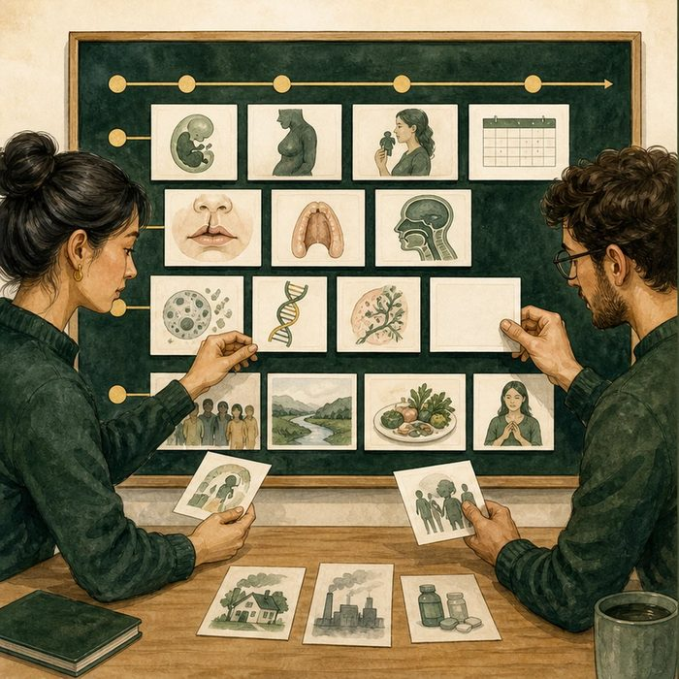
Illustration: An evidence board reconstructs a route without inventing a suspect
1. Which cards establish sequence?
________________________________________________________________________________
2. Which cards identify a failed checkpoint?
________________________________________________________________________________
3. What missing card prevents a one-cause conclusion?
________________________________________________________________________________

DEVELOPMENTAL LESSON 20 | RULES AND BIOLOGY MAPPING
2. Turn observations into rules

1. Rule 1: Build the story from ordered evidence. Explain it in your own words.
________________________________________________________________________________
2. Rule 2: Separate observed phenotype, supported mechanism, and unknown cause. Explain it in your own words.
________________________________________________________________________________
3. Rule 3: End with the strongest claim the evidence permits. Explain it in your own words.
________________________________________________________________________________
Where the analogy stops: A developmental case is not a crime, and families are never responsible for a congenital difference.

3. Map the rules onto the biomedical example
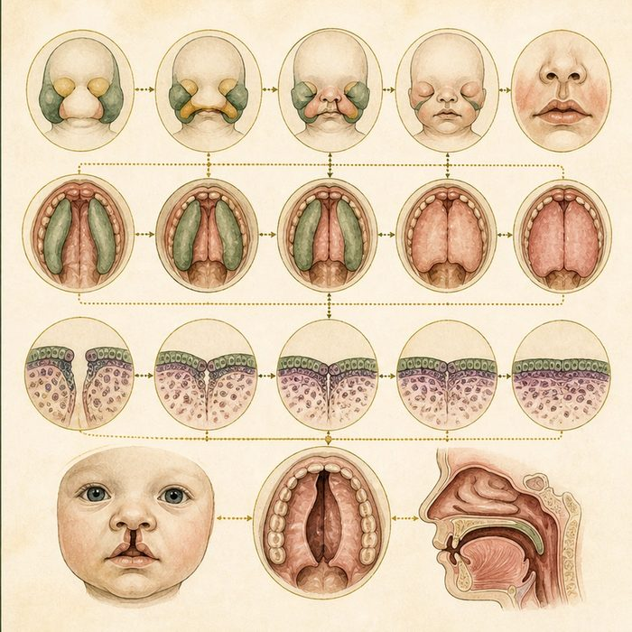
Biomedical teaching illustration: Assemble Mateo's complete developmental story
Analogy step | Biology step | How the relationship stays the same
Timeline cards | Human lip and palate windows | ________________________________
Route and checkpoint cards | Growth, movement, adhesion, and fusion evidence | ________________________________
Missing suspect card | No single proven gene or exposure in the composite file | ________________________________

DEVELOPMENTAL LESSON 20 | CASE FILE AND DECISION
4. Use the case evidence

ID | Finding supplied in the case | Why it matters
DEV20-E1 | Mateo has complete unilateral left cleft lip and palate with no broader anomaly pattern established in the composite file. | The phenotype is specific while the cause remains open.
DEV20-E2 | Lip and palate formation require ordered growth, cell movement, signaling, adhesion, and seam removal. | Several developmental checkpoints can contribute to the final pattern.
DEV20-E3 | The case file does not establish one causal variant, exposure, or syndrome. | The final explanation must remain multifactorial and bounded.

5. Make the clinical decision
You are the lead developmental biologist at the final case conference. The team must approve one paragraph for the family-facing case summary.
A. Describe the failed developmental outcomes and state that one cause is not established.
B. Name one gene as proven without a case result.
C. Say development offers no useful explanation.
Decision. Choose the summary and cite the phenotype evidence plus the uncertainty evidence.
________________________________________________________________________________
________________________________________________________________________________
Claim ceiling: You may synthesize the supported developmental pathway. You may not add a diagnosis, variant, or exposure absent from the case file.
Claim. State the choice you can defend.
________________________________________________________________________________
Evidence. Use these labeled IDs: DEV20-E1 + DEV20-E2.
________________________________________________________________________________
Reasoning. Explain why the evidence supports the claim and stays inside the claim ceiling.
________________________________________________________________________________
________________________________________________________________________________

DEVELOPMENTAL LESSON 20 | REDUCE, REFLECT, AND PREPARE
6. Reduce the lesson to one lasting idea

Take-home. Mateo's cleft is best explained as a developmental pathway outcome with bounded evidence, not as one proven cause.
________________________________________________________________________________
________________________________________________________________________________
1. Which parts of Mateo's developmental story are supported?
________________________________________________________________________________
2. Which causal claim must remain open for the next domain?
________________________________________________________________________________

Glossary
Term | Plain-English definition
synthesis | Building a molecule in the cell, as in protein synthesis (making a protein from mRNA).
isolated (nonsyndromic) | A cleft that occurs on its own, without other birth differences or a named syndrome accompanying it.
fusion failure | When tissue layers that should join during development do not merge, leaving a gap such as a cleft lip or palate.
multifactorial | Caused by several genes acting together with environmental factors, not by a single gene alone.
developmental story | The step-by-step account of how a structure forms over time, linking each early event to the final feature it produces.

Next lesson unlock
Mateo's cleft is an isolated, multifactorial failure of fusion in the weeks 4 to 12 window, with the rest of development normal. The developmental team now hands his fusion-failure story to the genetics, anatomical, and clinical teams. Do their stories agree with ours?
The journal links on the lesson page are optional. Everything required for this guided-notes set is already supplied here and in the case file.

