DEVELOPMENTAL DOMAIN | LESSON 19 OF 20 | DEVELOPMENTAL BIOLOGIST (RESCUE STRATEGIST)

If We Know the Window and the Signal, Could We Prevent a Cleft?
If we know the window and the missing signal, can we add it back and rescue a normal palate, and what does that result really promise for a human baby?
CARRY FORWARD  Researchers combine lineage labels, live imaging, and model organisms to turn hidden developmental events into visible evidence. | 10-YEAR TAKEAWAY  A rescue experiment supports a mechanism when restoring one step restores the outcome, but it is not yet a human treatment.

Cells differentiate | Development sculpts | Cells move | Development can go wrong

1. Observe the analogy before naming the biology
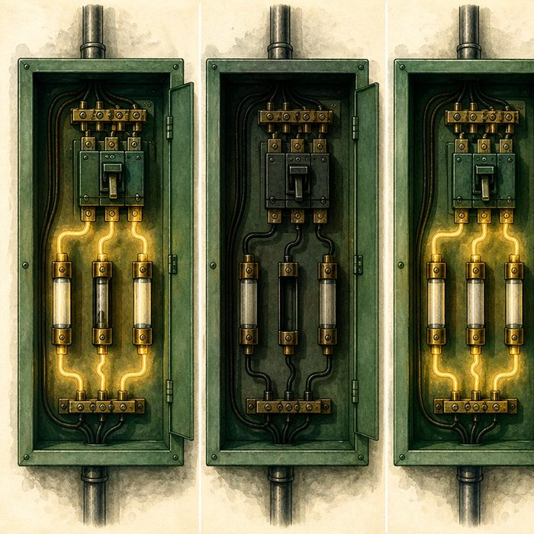
Illustration: Replace one fuse and watch one circuit return
1. What comparison shows that the replacement mattered?
________________________________________________________________________________
2. Why must all other conditions stay matched?
________________________________________________________________________________
3. Does restoring one circuit prove the whole building is safe?
________________________________________________________________________________

DEVELOPMENTAL LESSON 19 | RULES AND BIOLOGY MAPPING
2. Turn observations into rules

1. Rule 1: Compare control, disrupted, and rescued groups. Explain it in your own words.
________________________________________________________________________________
2. Rule 2: Restore the suspected step during the relevant window. Explain it in your own words.
________________________________________________________________________________
3. Rule 3: Mechanism evidence comes before treatment claims. Explain it in your own words.
________________________________________________________________________________
Where the analogy stops: Biological pathways have feedback and side effects that a simple fuse does not.

3. Map the rules onto the biomedical example
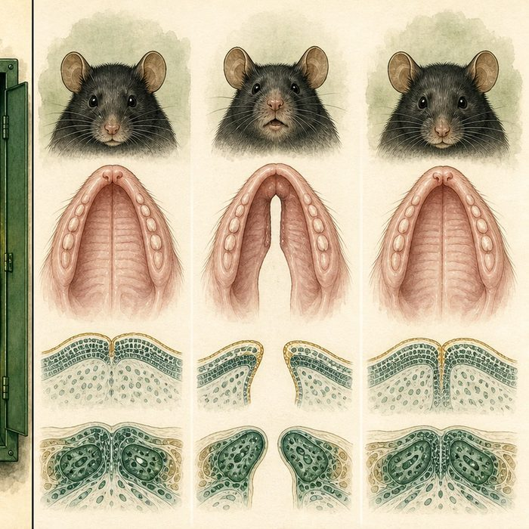
Biomedical teaching illustration: Interpret the Msx1-Bmp4 mouse rescue
Analogy step | Biology step | How the relationship stays the same
Working circuit | Control palate development | ________________________________
Blown fuse | Msx1-deficient growth pathway | ________________________________
Replacement restores power | Directed Bmp4 expression rescues the model phenotype | ________________________________

DEVELOPMENTAL LESSON 19 | CASE FILE AND DECISION
4. Use the case evidence

ID | Finding supplied in the case | Why it matters
DEV19-E1 | Msx1-deficient mice show reduced anterior palatal growth and cleft palate. | The mutant provides a defined disrupted pathway.
DEV19-E2 | Directed Bmp4 expression restored growth and fusion in the reported mouse model. | Restoring a downstream signal rescued the phenotype.
DEV19-E3 | The intervention was genetic and preclinical in mice. | The experiment is not a tested prenatal therapy for humans.

5. Make the clinical decision
You are briefing a translational research committee. A headline says the mouse rescue means cleft palate can now be prevented in human pregnancy.
A. Correct it to proof of mechanism in a specific mouse model.
B. Approve the human-treatment claim.
C. Reject the experiment as useless because it used mice.
Decision. Choose the accurate headline and cite both the rescue and translation-limit evidence.
________________________________________________________________________________
________________________________________________________________________________
Claim ceiling: You may state proof of mechanism in the model. You may not claim safety, timing, delivery, or effectiveness in humans.
Claim. State the choice you can defend.
________________________________________________________________________________
Evidence. Use these labeled IDs: DEV19-E1 + DEV19-E2.
________________________________________________________________________________
Reasoning. Explain why the evidence supports the claim and stays inside the claim ceiling.
________________________________________________________________________________
________________________________________________________________________________

DEVELOPMENTAL LESSON 19 | REDUCE, REFLECT, AND PREPARE
6. Reduce the lesson to one lasting idea

Take-home. A rescue experiment supports a mechanism when restoring one step restores the outcome, but it is not yet a human treatment.
________________________________________________________________________________
________________________________________________________________________________
1. What three groups make a rescue comparison strong?
________________________________________________________________________________
2. What human-treatment questions remain unanswered?
________________________________________________________________________________

Glossary
Term | Plain-English definition
rescue experiment | Adding a working gene back into a mutant to see if it restores the normal trait, which proves that gene was responsible.
gain-of-function | A mutation that gives a protein a new or stronger activity rather than weakening it, sometimes causing harm.
critical window | A lesson term defined by the surrounding model and case evidence.
preclinical | Research done in cells and animals to test safety and effect before a treatment is ever tried in people.
proof of mechanism | Evidence that a treatment actually acts on the biological target the way it was designed to, not just that it works.

Next lesson unlock
We can rescue a cleft in a mouse by adding back one signal, but only in the lab and only by editing the embryo's own genes. So we still owe Mateo one thing: the complete, honest developmental story of how his cleft actually happened, assembled from everything we learned.
The journal links on the lesson page are optional. Everything required for this guided-notes set is already supplied here and in the case file.

