DEVELOPMENTAL DOMAIN | LESSON 18 OF 20 | COMPARATIVE EMBRYOLOGIST

Watching Development Happen
How do we actually watch development go right or wrong?
CARRY FORWARD  The same DNA can produce different outcomes because gene activity and developmental context can differ. | 10-YEAR TAKEAWAY  Researchers combine lineage labels, live imaging, and model organisms to turn hidden developmental events into visible evidence.

Cells differentiate | Development sculpts | Cells move | Development can go wrong

1. Observe the analogy before naming the biology
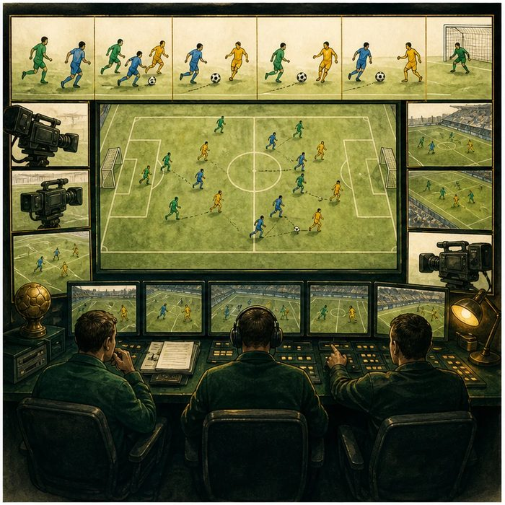
Illustration: Replay plus colored jerseys reveals the whole play
1. What can the replay show that the final score cannot?
________________________________________________________________________________
2. Why do colored jerseys matter when players cross paths?
________________________________________________________________________________
3. What question would require more than one camera angle?
________________________________________________________________________________

DEVELOPMENTAL LESSON 18 | RULES AND BIOLOGY MAPPING
2. Turn observations into rules

1. Rule 1: Time-resolved evidence reveals sequence. Explain it in your own words.
________________________________________________________________________________
2. Rule 2: Stable labels reveal cell lineage. Explain it in your own words.
________________________________________________________________________________
3. Rule 3: Different models and methods answer different questions. Explain it in your own words.
________________________________________________________________________________
Where the analogy stops: Imaging cells is limited by access, resolution, labels, and model differences.

3. Map the rules onto the biomedical example
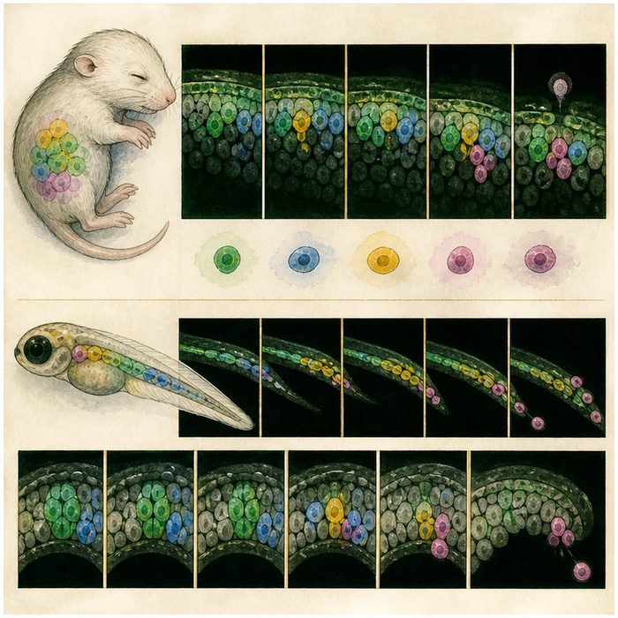
Biomedical teaching illustration: Choose a method to watch development
Analogy step | Biology step | How the relationship stays the same
Colored jersey | Genetic or fluorescent lineage label | ________________________________
Replay | Live imaging over time | ________________________________
Final score | Endpoint anatomy or histology | ________________________________

DEVELOPMENTAL LESSON 18 | CASE FILE AND DECISION
4. Use the case evidence

ID | Finding supplied in the case | Why it matters
DEV18-E1 | Lineage labels mark a cell population and its descendants. | They answer where cells came from and what they became.
DEV18-E2 | Live imaging records movement and cell behavior over time. | It can reveal order and timing.
DEV18-E3 | Mouse and zebrafish models share important developmental mechanisms but are not identical to humans. | Model choice sets a limit on transfer.

5. Make the clinical decision
You are choosing a method for a seam-removal study. The question is whether labeled seam cells die, leave the surface, or persist during the next six hours.
A. Use stable lineage labels with live imaging and cell-state markers.
B. Use only the adult skull endpoint.
C. Use one unlabeled still image.
Decision. Choose the method set and cite the evidence for both time and identity.
________________________________________________________________________________
________________________________________________________________________________
Claim ceiling: You may observe mechanism in the selected model. You may not assume every human embryo follows every model detail.
Claim. State the choice you can defend.
________________________________________________________________________________
Evidence. Use these labeled IDs: DEV18-E1 + DEV18-E2.
________________________________________________________________________________
Reasoning. Explain why the evidence supports the claim and stays inside the claim ceiling.
________________________________________________________________________________
________________________________________________________________________________

DEVELOPMENTAL LESSON 18 | REDUCE, REFLECT, AND PREPARE
6. Reduce the lesson to one lasting idea

Take-home. Researchers combine lineage labels, live imaging, and model organisms to turn hidden developmental events into visible evidence.
________________________________________________________________________________
________________________________________________________________________________
1. Which method adds cell identity?
________________________________________________________________________________
2. Which method adds sequence over time?
________________________________________________________________________________

Glossary
Term | Plain-English definition
model organism | A species, such as zebrafish or mouse, studied because its biology is similar enough to ours to teach us about human development and disease.
lineage labeling | A method that tags a starting cell with a permanent marker so all of its descendant cells can be tracked over time.
live imaging | Watching cells or tissues under a microscope as they move and change over time, instead of viewing a single fixed snapshot.
cell extrusion | A process where a sheet of cells squeezes out and removes one of its own cells, sealing the gap to keep the layer intact.
homology | Similarity between genes or structures in different species because they were inherited from a shared common ancestor.

Next lesson unlock
Model organisms plus live imaging let us watch each step of fusion and pin down which one failed. So a bold question: if we can see exactly which step fails and exactly when, could a scientist step in during the window and prevent a cleft?
The journal links on the lesson page are optional. Everything required for this guided-notes set is already supplied here and in the case file.

