DEVELOPMENTAL DOMAIN | LESSON 17 OF 20 | EPIGENETICIST

Same DNA, Different Outcome
How can identical DNA give two different outcomes, a fused palate or a cleft?
CARRY FORWARD  An environmental factor changes risk only when evidence links dose, timing, and mechanism, and risk is not destiny. | 10-YEAR TAKEAWAY  The same DNA can produce different outcomes because gene activity and developmental context can differ.

Cells differentiate | Development sculpts | Cells move | Development can go wrong

1. Observe the analogy before naming the biology
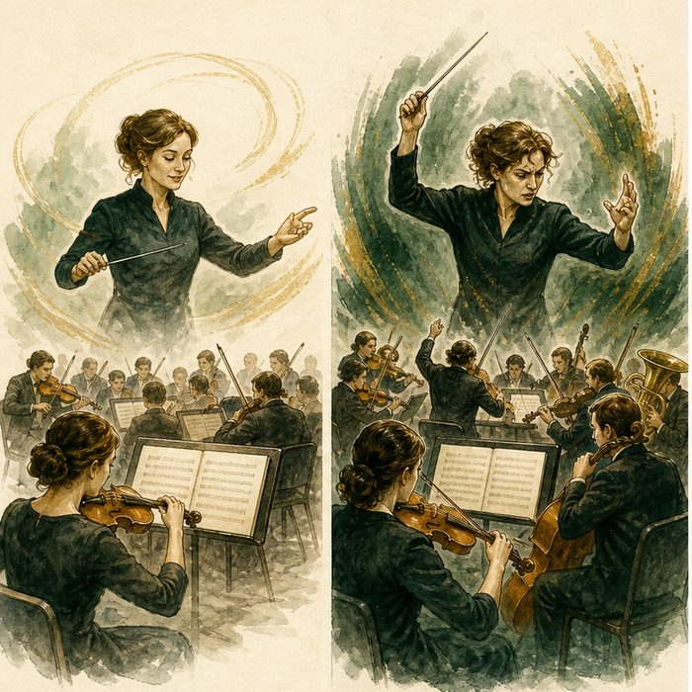
Illustration: The same music score can sound different under different controls
1. What stays the same in both performances?
________________________________________________________________________________
2. Which controls change how the score is used?
________________________________________________________________________________
3. Why does a changed performance not mean the notes were rewritten?
________________________________________________________________________________

DEVELOPMENTAL LESSON 17 | RULES AND BIOLOGY MAPPING
2. Turn observations into rules

1. Rule 1: DNA sequence and gene activity are not identical. Explain it in your own words.
________________________________________________________________________________
2. Rule 2: Regulators can change when or how strongly genes act. Explain it in your own words.
________________________________________________________________________________
3. Rule 3: Variable outcomes can reflect multiple interacting hits. Explain it in your own words.
________________________________________________________________________________
Where the analogy stops: Gene regulation is a molecular network, not a musical interpretation.

3. Map the rules onto the biomedical example
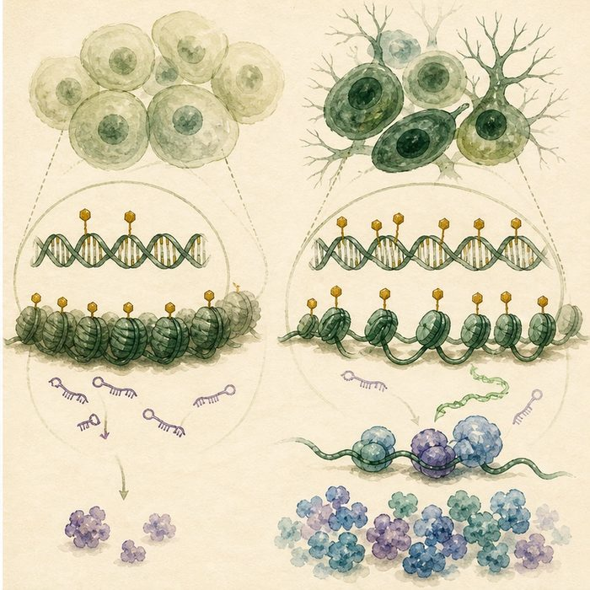
Biomedical teaching illustration: Separate DNA sequence from epigenetic regulation
Analogy step | Biology step | How the relationship stays the same
Written score | DNA sequence | ________________________________
Volume marks | DNA methylation and chromatin regulation | ________________________________
Conductor timing | MicroRNA and other post-transcriptional control | ________________________________

DEVELOPMENTAL LESSON 17 | CASE FILE AND DECISION
4. Use the case evidence

ID | Finding supplied in the case | Why it matters
DEV17-E1 | DNA methylation can change gene activity without changing the DNA letters. | Sequence and regulation are separate layers.
DEV17-E2 | MicroRNAs can reduce how much protein is made from target messages. | Post-transcriptional regulation can alter pathway output.
DEV17-E3 | Cleft penetrance can vary among people with similar genetic susceptibility. | A susceptibility variant does not force one outcome.

5. Make the clinical decision
You are comparing two siblings in a research model. Both carry the same susceptibility variant, but only one has a cleft. Their methylation profiles differ at developmental genes.
A. Propose regulation as one testable modifier while keeping other factors open.
B. Claim the methylation profile proves the only cause.
C. Claim identical variants must always produce identical anatomy.
Decision. Choose the testable explanation and cite sequence-versus-regulation evidence.
________________________________________________________________________________
________________________________________________________________________________
Claim ceiling: You may propose an epigenetic modifier. You may not convert an association into a single proven cause.
Claim. State the choice you can defend.
________________________________________________________________________________
Evidence. Use these labeled IDs: DEV17-E1 + DEV17-E2.
________________________________________________________________________________
Reasoning. Explain why the evidence supports the claim and stays inside the claim ceiling.
________________________________________________________________________________
________________________________________________________________________________

DEVELOPMENTAL LESSON 17 | REDUCE, REFLECT, AND PREPARE
6. Reduce the lesson to one lasting idea

Take-home. The same DNA can produce different outcomes because gene activity and developmental context can differ.
________________________________________________________________________________
________________________________________________________________________________
1. What can change without changing DNA letters?
________________________________________________________________________________
2. Why does a methylation difference not automatically prove cause?
________________________________________________________________________________

Glossary
Term | Plain-English definition
epigenetics | The study of chemical tags on DNA and its packaging that switch genes on or off without changing the underlying DNA sequence itself.
DNA methylation | A chemical tag added to DNA that can quiet a gene without changing its underlying sequence.
microRNA | A tiny RNA molecule that fine-tunes gene activity by binding messenger RNA and blocking it from being made into protein.
second hit | A second damaging change needed on top of an inherited one before a trait or disease appears, explaining why some carriers stay healthy.
penetrance | The fraction of people carrying a disease-linked genotype who actually show the trait.

Next lesson unlock
Epigenetic marks and tiny RNAs let identical DNA give different outcomes, and isolated clefting behaves like an additive, multifactorial trait. But we just reasoned from human DNA, mouse palates, and zebrafish cartilage at once. How do scientists actually watch development happen?
The journal links on the lesson page are optional. Everything required for this guided-notes set is already supplied here and in the case file.

