DEVELOPMENTAL DOMAIN | LESSON 16 OF 20 | TERATOLOGY LIAISON

When the Outside World Reaches the Embryo
Can the outside world change how the face forms, and if so, how strongly?
CARRY FORWARD  A developmental risk matters most when it acts during the short window for the process it can disrupt. | 10-YEAR TAKEAWAY  An environmental factor changes risk only when evidence links dose, timing, and mechanism, and risk is not destiny.

Cells differentiate | Development sculpts | Cells move | Development can go wrong

1. Observe the analogy before naming the biology

Illustration: Weather changes the chance of a delayed flight
1. Does a storm delay every flight?
________________________________________________________________________________
2. Why do timing and severity matter?
________________________________________________________________________________
3. What evidence separates association from a tested mechanism?
________________________________________________________________________________

DEVELOPMENTAL LESSON 16 | RULES AND BIOLOGY MAPPING
2. Turn observations into rules

1. Rule 1: A risk factor changes probability, not certainty. Explain it in your own words.
________________________________________________________________________________
2. Rule 2: Dose and timing shape the effect. Explain it in your own words.
________________________________________________________________________________
3. Rule 3: Association, animal mechanism, and human causation are different evidence levels. Explain it in your own words.
________________________________________________________________________________
Where the analogy stops: Embryonic development is not air travel, and personal blame has no place in risk interpretation.

3. Map the rules onto the biomedical example
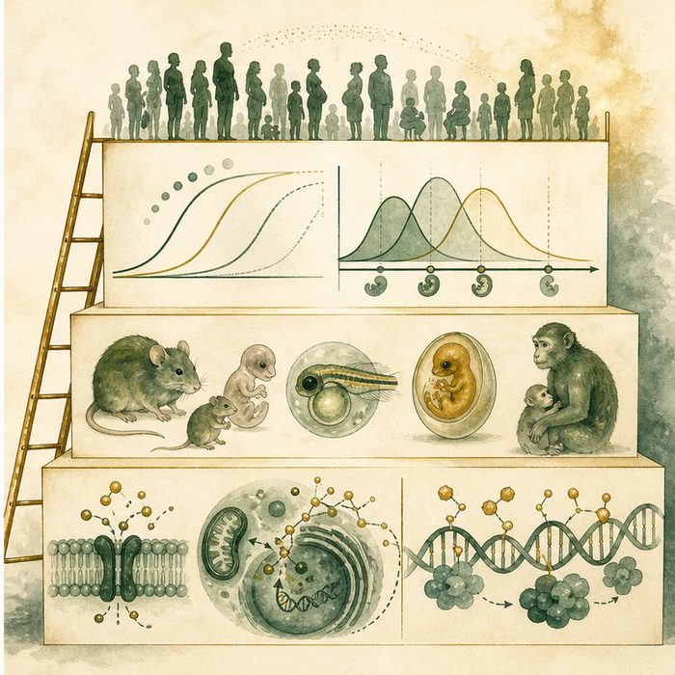
Biomedical teaching illustration: Grade evidence for folate, valproate, and other exposures
Analogy step | Biology step | How the relationship stays the same
Weather report | Observed association | ________________________________
Storm intensity and arrival | Dose and critical-window timing | ________________________________
Flight mechanics | Tested cellular or molecular mechanism | ________________________________

DEVELOPMENTAL LESSON 16 | CASE FILE AND DECISION
4. Use the case evidence

ID | Finding supplied in the case | Why it matters
DEV16-E1 | Some prenatal exposures are associated with higher cleft risk in populations. | Association can identify a factor worth studying.
DEV16-E2 | Valproate is a known teratogenic medication whose risks depend on exposure context and timing. | A specific factor can have biologically important prenatal effects.
DEV16-E3 | Most exposed pregnancies do not produce the same outcome, and many clefts occur without a known exposure. | Risk is probabilistic and multifactorial.

5. Make the clinical decision
You are writing a family-facing explanation for Mateo's chart. A parent asks whether one action definitely caused the cleft, but the case file contains no confirmed causal exposure.
A. Explain that risk factors change probability and no single cause is established here.
B. Assign blame without exposure evidence.
C. Say environmental factors can never affect development.
Decision. Choose the explanation and cite evidence about probability and case limits.
________________________________________________________________________________
________________________________________________________________________________
Claim ceiling: You may explain population risk and biological plausibility. You may not assign an unrecorded exposure or blame.
Claim. State the choice you can defend.
________________________________________________________________________________
Evidence. Use these labeled IDs: DEV16-E1 + DEV16-E2.
________________________________________________________________________________
Reasoning. Explain why the evidence supports the claim and stays inside the claim ceiling.
________________________________________________________________________________
________________________________________________________________________________

DEVELOPMENTAL LESSON 16 | REDUCE, REFLECT, AND PREPARE
6. Reduce the lesson to one lasting idea

Take-home. An environmental factor changes risk only when evidence links dose, timing, and mechanism, and risk is not destiny.
________________________________________________________________________________
________________________________________________________________________________
1. What three features make exposure evidence stronger?
________________________________________________________________________________
2. Why is risk factor more accurate than guaranteed cause?
________________________________________________________________________________

Glossary
Term | Plain-English definition
teratogen | An agent such as a drug, chemical, or infection that can disrupt development and cause birth differences if exposure happens during pregnancy.
critical window | A lesson term defined by the surrounding model and case evidence.
folate | A B vitamin the body needs to build DNA and new cells; taking enough before and in early pregnancy lowers the risk of cleft and neural tube defects.
valproate | A medication used for seizures and mood that raises the risk of birth defects, including cleft palate, when taken during pregnancy.
risk factor | Anything that raises a person's chance of developing a disease, such as smoking, family history, or high blood pressure, without guaranteeing it.

Next lesson unlock
Yes, the environment can tip the odds during the fusion window. But here is the puzzle: the same exposure can reach two embryos with the same DNA and only one of them clefts. How can identical DNA give different results?
The journal links on the lesson page are optional. Everything required for this guided-notes set is already supplied here and in the case file.

