DEVELOPMENTAL DOMAIN | LESSON 15 OF 20 | EMBRYOLOGIST (TIMING SPECIALIST)

Critical Timing Windows, When the Door Closes
Is there a moment after which a cleft can no longer be prevented, and the open structure stays open for good?
CARRY FORWARD  A cleft pattern narrows the failed developmental checkpoint, but it rarely identifies one unique cause. | 10-YEAR TAKEAWAY  A developmental risk matters most when it acts during the short window for the process it can disrupt.

Cells differentiate | Development sculpts | Cells move | Development can go wrong

1. Observe the analogy before naming the biology
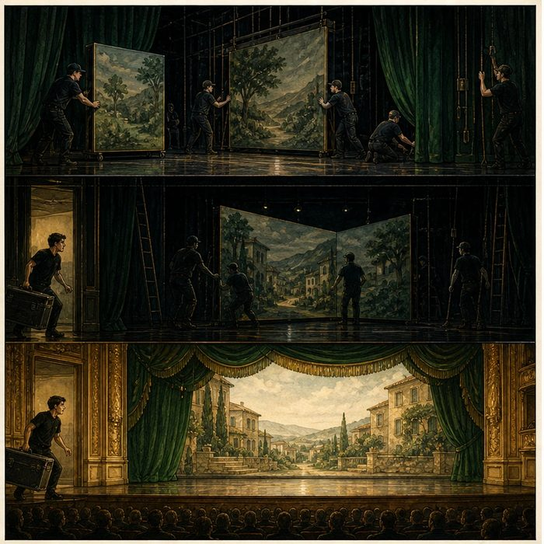
Illustration: A theater door closes after one scene change
1. Why can the scenery move only during the blackout?
________________________________________________________________________________
2. What happens if the crew arrives after the curtain opens?
________________________________________________________________________________
3. How could the same delay matter in one scene but not another?
________________________________________________________________________________

DEVELOPMENTAL LESSON 15 | RULES AND BIOLOGY MAPPING
2. Turn observations into rules

1. Rule 1: Some changes are possible only during a short interval. Explain it in your own words.
________________________________________________________________________________
2. Rule 2: Timing and target process must overlap. Explain it in your own words.
________________________________________________________________________________
3. Rule 3: After the window closes, later development builds on the existing structure. Explain it in your own words.
________________________________________________________________________________
Where the analogy stops: Biological windows can overlap and vary; they are not controlled by a stage clock.

3. Map the rules onto the biomedical example
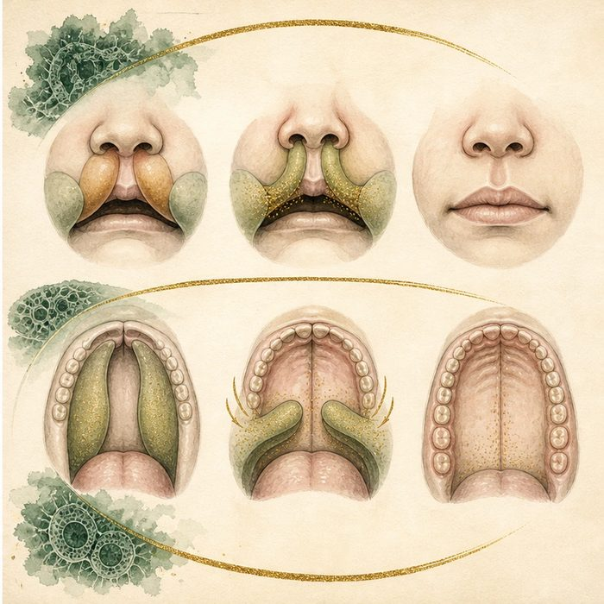
Biomedical teaching illustration: Compare lip and palate critical windows
Analogy step | Biology step | How the relationship stays the same
Blackout begins | Developmental process becomes possible | ________________________________
Scene change | Growth, elevation, or fusion event | ________________________________
Curtain opens | Critical window closes | ________________________________

DEVELOPMENTAL LESSON 15 | CASE FILE AND DECISION
4. Use the case evidence

ID | Finding supplied in the case | Why it matters
DEV15-E1 | Upper-lip fusion occurs earlier than completion of secondary-palate fusion. | The two structures have different timing windows.
DEV15-E2 | A disruption must overlap a sensitive process to affect that process directly. | Exposure timing is part of causal reasoning.
DEV15-E3 | After a cleft is established in utero, later normal growth does not automatically fuse the gap. | Subsequent development builds around the open structure.

5. Make the clinical decision
You are reviewing an exposure timeline without naming the exposure. Exposure A occurred after upper-lip closure but during palatal fusion. Exposure B occurred before both windows.
A. Prioritize A for a direct palate-window hypothesis, while keeping other explanations open.
B. Claim A directly caused Mateo's cleft lip.
C. Claim timing never matters.
Decision. Choose the timing hypothesis and cite the window evidence.
________________________________________________________________________________
________________________________________________________________________________
Claim ceiling: You may judge timing compatibility. You may not prove causation from timing alone.
Claim. State the choice you can defend.
________________________________________________________________________________
Evidence. Use these labeled IDs: DEV15-E1 + DEV15-E2.
________________________________________________________________________________
Reasoning. Explain why the evidence supports the claim and stays inside the claim ceiling.
________________________________________________________________________________
________________________________________________________________________________

DEVELOPMENTAL LESSON 15 | REDUCE, REFLECT, AND PREPARE
6. Reduce the lesson to one lasting idea

Take-home. A developmental risk matters most when it acts during the short window for the process it can disrupt.
________________________________________________________________________________
________________________________________________________________________________
1. What makes an exposure timing compatible with a developmental outcome?
________________________________________________________________________________
2. Why does compatible timing not prove causation?
________________________________________________________________________________

Glossary
Term | Plain-English definition
critical window | A lesson term defined by the surrounding model and case evidence.
lip fusion window | The brief stretch of early development when the facial processes must join to form the upper lip, around weeks four to seven.
palate fusion window | The limited stretch of embryo development when the palate shelves must rise and join; missing this window leaves a cleft palate.
irreversible | Describing a change or step that cannot be undone once it has happened, locking the outcome in place.

Next lesson unlock
We now know the face has narrow closure windows, and those windows are when it is most fragile. If the embryo is most vulnerable during these weeks, can something from outside the embryo reach in during the window and change whether the face forms correctly?
The journal links on the lesson page are optional. Everything required for this guided-notes set is already supplied here and in the case file.

