DEVELOPMENTAL DOMAIN | LESSON 14 OF 20 | DEVELOPMENTAL BIOLOGIST (FAILURE-POINT MAPPER)

Mapping the Failure, Which Step Breaks for a Cleft Lip Versus a Cleft Palate
If you are handed a specific cleft, can you read it backward to the one developmental step that failed?
CARRY FORWARD  IRF6-dependent periderm acts as a temporary non-stick surface that prevents the wrong oral tissues from adhering. | 10-YEAR TAKEAWAY  A cleft pattern narrows the failed developmental checkpoint, but it rarely identifies one unique cause.

Cells differentiate | Development sculpts | Cells move | Development can go wrong

1. Observe the analogy before naming the biology
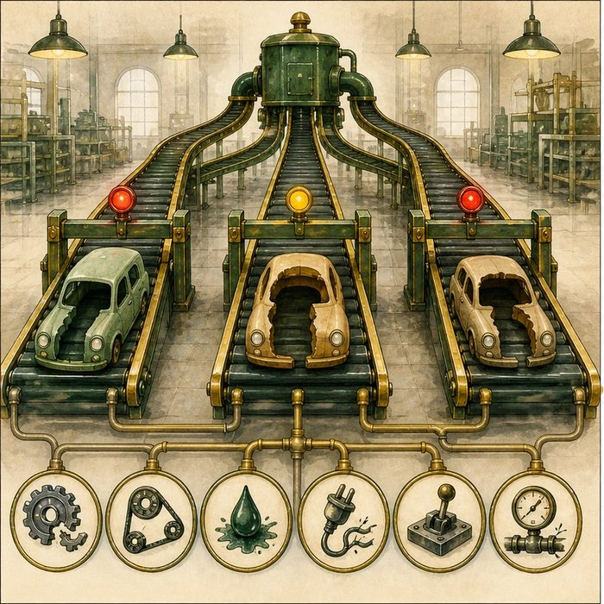
Illustration: A stopped assembly line reveals a checkpoint, not the culprit
1. Which station is the first place unfinished work appears?
________________________________________________________________________________
2. Can several failures stop the line at the same station?
________________________________________________________________________________
3. What extra evidence is needed to identify the cause?
________________________________________________________________________________

DEVELOPMENTAL LESSON 14 | RULES AND BIOLOGY MAPPING
2. Turn observations into rules

1. Rule 1: Work backward to the earliest failed checkpoint. Explain it in your own words.
________________________________________________________________________________
2. Rule 2: Different causes can create a similar endpoint. Explain it in your own words.
________________________________________________________________________________
3. Rule 3: Phenotype localizes a process better than a molecule. Explain it in your own words.
________________________________________________________________________________
Where the analogy stops: Development is a branching network, not a single conveyor belt.

3. Map the rules onto the biomedical example
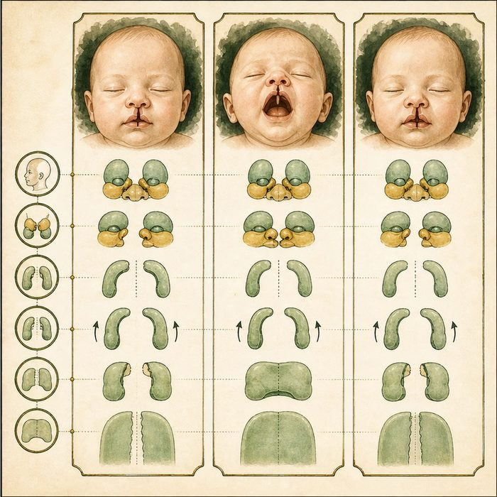
Biomedical teaching illustration: Read three cleft patterns backward
Analogy step | Biology step | How the relationship stays the same
Station before the stop | Last developmental step completed | ________________________________
Stopped station | Failed growth, movement, adhesion, or fusion checkpoint | ________________________________
Fault investigation | Genetic, environmental, and model evidence | ________________________________

DEVELOPMENTAL LESSON 14 | CASE FILE AND DECISION
4. Use the case evidence

ID | Finding supplied in the case | Why it matters
DEV14-E1 | Cleft lip points to an early upper-lip growth and fusion boundary. | The phenotype localizes an early facial checkpoint.
DEV14-E2 | Cleft palate can result from failed shelf growth, elevation, adhesion, or seam removal. | Several mechanisms share the palate endpoint.
DEV14-E3 | Mateo has both cleft lip and palate. | His pattern spans connected but distinguishable developmental events.

5. Make the clinical decision
You are triaging three cases for a developmental review board. Case A has cleft lip only. Case B has cleft palate only. Mateo has both.
A. Assign each pattern to the narrowest supported checkpoint list.
B. Assign one gene to each pattern from anatomy alone.
C. Treat all three patterns as the same developmental event.
Decision. Choose the triage method and explain why the palate list remains broader.
________________________________________________________________________________
________________________________________________________________________________
Claim ceiling: You may narrow checkpoints from anatomy. You may not assign one unique molecular cause from phenotype alone.
Claim. State the choice you can defend.
________________________________________________________________________________
Evidence. Use these labeled IDs: DEV14-E1 + DEV14-E2.
________________________________________________________________________________
Reasoning. Explain why the evidence supports the claim and stays inside the claim ceiling.
________________________________________________________________________________
________________________________________________________________________________

DEVELOPMENTAL LESSON 14 | REDUCE, REFLECT, AND PREPARE
6. Reduce the lesson to one lasting idea

Take-home. A cleft pattern narrows the failed developmental checkpoint, but it rarely identifies one unique cause.
________________________________________________________________________________
________________________________________________________________________________
1. Why does cleft palate have several possible checkpoints?
________________________________________________________________________________
2. What can phenotype support more strongly than it supports a specific gene?
________________________________________________________________________________

Glossary
Term | Plain-English definition
phenotype | The observable traits of an organism, such as appearance or function, that result from its genotype combined with environmental influences.
fusion failure | When tissue layers that should join during development do not merge, leaving a gap such as a cleft lip or palate.
patterning defect | A mistake in the body plan set early in development, where signals place or shape parts wrongly so a structure forms in the wrong arrangement.
isolated defect | A birth difference that occurs on its own, without other linked malformations or a broader syndrome accompanying it.

Next lesson unlock
We can now map which step failed and see that Mateo's looks like an isolated fusion failure. But mapping a failure is not fixing it. Each step happens in a narrow calendar window. Is there a moment after which the step can no longer be repaired, so the cleft becomes locked in?
The journal links on the lesson page are optional. Everything required for this guided-notes set is already supplied here and in the case file.

