DEVELOPMENTAL DOMAIN | LESSON 13 OF 20 | CELL BIOLOGIST (EPITHELIAL TEAM, GENETICS OVERLAP)

Periderm and IRF6, the Non-Stick Coating on the Embryo
What keeps the surfaces inside the mouth from sticking to the wrong neighbor, and what happens when that protection is missing?
CARRY FORWARD  Wnt-beta-catenin signaling can steer cranial progenitors toward dermal and bone fates while repressing cartilage fate. | 10-YEAR TAKEAWAY  IRF6-dependent periderm acts as a temporary non-stick surface that prevents the wrong oral tissues from adhering.

Cells differentiate | Development sculpts | Cells move | Development can go wrong

1. Observe the analogy before naming the biology
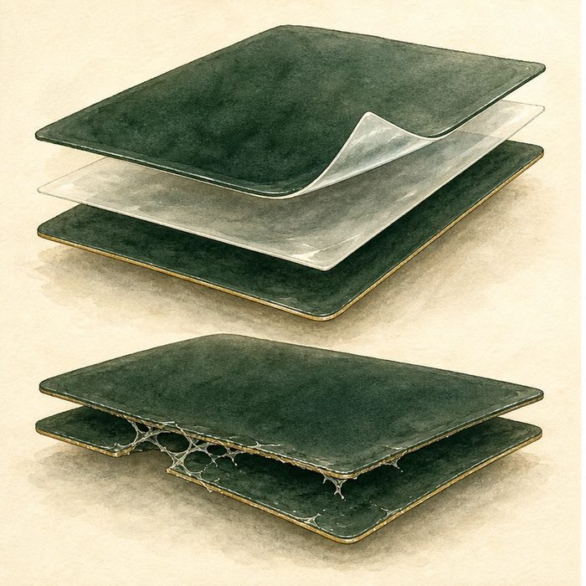
Illustration: Protective film keeps stacked labels from sticking early
1. Why is the protective layer temporary?
________________________________________________________________________________
2. What happens if the sticky surfaces meet too early?
________________________________________________________________________________
3. When should the protection be removed?
________________________________________________________________________________

DEVELOPMENTAL LESSON 13 | RULES AND BIOLOGY MAPPING
2. Turn observations into rules

1. Rule 1: A temporary surface layer can prevent wrong contacts. Explain it in your own words.
________________________________________________________________________________
2. Rule 2: Differentiation gives a cell layer a specialized function. Explain it in your own words.
________________________________________________________________________________
3. Rule 3: Loss of protection can create a mechanical block later. Explain it in your own words.
________________________________________________________________________________
Where the analogy stops: Periderm is a living epithelial layer with regulated genes, not plastic film.

3. Map the rules onto the biomedical example
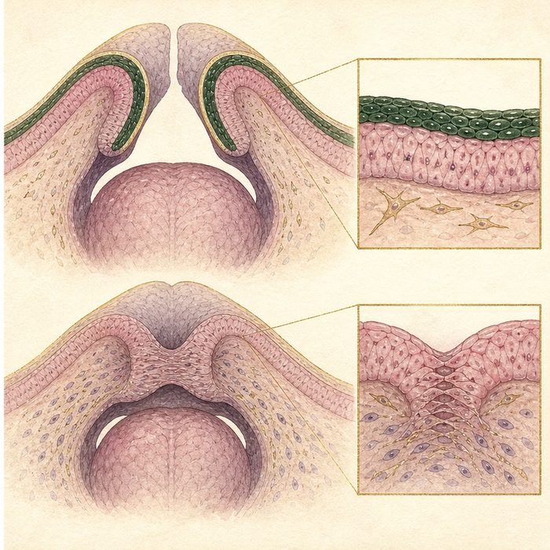
Biomedical teaching illustration: Connect IRF6, periderm, and oral adhesion
Analogy step | Biology step | How the relationship stays the same
Protective film | Periderm | ________________________________
Film-making instruction | IRF6-dependent differentiation | ________________________________
Labels stuck too early | Abnormal tongue-palate or oral epithelial adhesion | ________________________________

DEVELOPMENTAL LESSON 13 | CASE FILE AND DECISION
4. Use the case evidence

ID | Finding supplied in the case | Why it matters
DEV13-E1 | Periderm covers embryonic oral epithelial surfaces during key stages. | It provides a temporary specialized surface.
DEV13-E2 | Irf6-deficient mouse embryos have abnormal periderm differentiation. | IRF6 is required for normal protection in the model.
DEV13-E3 | Abnormal oral adhesions can block palatal shelf elevation. | A surface defect can create a later movement defect.

5. Make the clinical decision
You are explaining an Irf6 mutant image to a clinical genetics group. The shelves formed, but one shelf is attached to the tongue before elevation.
A. Trace the failure from periderm loss to abnormal adhesion to blocked elevation.
B. Say the shelf failed because it never existed.
C. Call every IRF6 variant a complete gene knockout.
Decision. Choose the causal sequence and cite the surface and movement evidence.
________________________________________________________________________________
________________________________________________________________________________
Claim ceiling: You may explain the knockout mechanism. You may not treat all human IRF6 variants as identical to a complete mouse knockout.
Claim. State the choice you can defend.
________________________________________________________________________________
Evidence. Use these labeled IDs: DEV13-E1 + DEV13-E2.
________________________________________________________________________________
Reasoning. Explain why the evidence supports the claim and stays inside the claim ceiling.
________________________________________________________________________________
________________________________________________________________________________

DEVELOPMENTAL LESSON 13 | REDUCE, REFLECT, AND PREPARE
6. Reduce the lesson to one lasting idea

Take-home. IRF6-dependent periderm acts as a temporary non-stick surface that prevents the wrong oral tissues from adhering.
________________________________________________________________________________
________________________________________________________________________________
1. What specialized job does periderm perform?
________________________________________________________________________________
2. How can a surface defect become a movement defect?
________________________________________________________________________________

Glossary
Term | Plain-English definition
periderm | A thin temporary outer cell layer of the embryo; if it sticks where it should not, the growing edges cannot fuse.
IRF6 | Interferon Regulatory Factor 6, a transcription factor needed by the skin-like cells that let the lip and palate fuse; a leading cleft gene.
intraoral adhesion | An abnormal band of tissue that connects structures inside the mouth that should be separate, sometimes seen with cleft conditions.
cell-autonomous | Describing an effect that plays out inside the very cell carrying the change, rather than in its neighbors.

Next lesson unlock
We now know which surfaces must stay apart and which must fuse, and which gene polices that. But clefts come in different forms: some only the lip, some only the palate, some both. Which exact step fails for a cleft lip versus a cleft palate?
The journal links on the lesson page are optional. Everything required for this guided-notes set is already supplied here and in the case file.

