DEVELOPMENTAL DOMAIN | LESSON 12 OF 20 | DEVELOPMENTAL BIOLOGIST (ATIT LAB COLLABORATION)

The Wnt/beta-catenin Master Switch, How a Face Cell Decides What NOT to Be
How does a single cranial cell decide whether to become bone, skin, or cartilage, and what is the off choice it has to actively avoid?
CARRY FORWARD  TGF-beta3 makes the palatal medial edge competent to complete adhesion and seam removal. | 10-YEAR TAKEAWAY  Wnt-beta-catenin signaling can steer cranial progenitors toward dermal and bone fates while repressing cartilage fate.

Cells differentiate | Development sculpts | Cells move | Development can go wrong

1. Observe the analogy before naming the biology
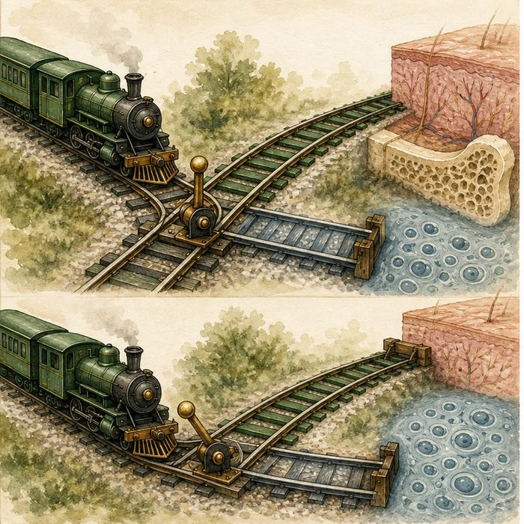
Illustration: A railway switch selects one track and closes another
1. How does opening one route affect the other route?
________________________________________________________________________________
2. What outcome would show that the switch is instructive?
________________________________________________________________________________
3. Why must the starting cells be comparable?
________________________________________________________________________________

DEVELOPMENTAL LESSON 12 | RULES AND BIOLOGY MAPPING
2. Turn observations into rules

1. Rule 1: Cell fate involves both activation and repression. Explain it in your own words.
________________________________________________________________________________
2. Rule 2: Removing a signal can reveal a default or competing fate. Explain it in your own words.
________________________________________________________________________________
3. Rule 3: Lineage labels show what the same progenitors become. Explain it in your own words.
________________________________________________________________________________
Where the analogy stops: Cell fate is controlled by interacting genes and signals, not one steel lever.

3. Map the rules onto the biomedical example
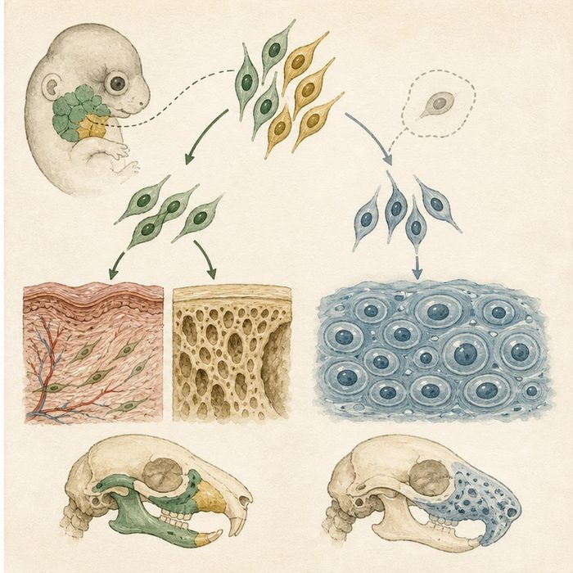
Biomedical teaching illustration: Map the Atit Lab beta-catenin experiment
Analogy step | Biology step | How the relationship stays the same
Train | A lineage-labeled cranial progenitor | ________________________________
Open dermis-bone track | Wnt-beta-catenin signaling | ________________________________
Wrong destination after switch loss | Cartilage at the expense of dermal and bone fates | ________________________________

DEVELOPMENTAL LESSON 12 | CASE FILE AND DECISION
4. Use the case evidence

ID | Finding supplied in the case | Why it matters
DEV12-E1 | Control cranial progenitors process Wnt-beta-catenin signaling during fate selection. | The pathway is active during the decision window.
DEV12-E2 | Conditional beta-catenin loss removes cranial dermis and bone in the tested region. | The pathway is required for those fates in that model.
DEV12-E3 | Lineage-labeled mutant cells form cartilage in their place. | The same progenitor population changed fate rather than simply disappearing.

5. Make the clinical decision
You are the student lead for an Atit Lab figure discussion. A classmate says the mutant has less dermis only because all labeled cells died.
A. Use labeled cartilage descendants to support a fate switch.
B. Agree that lineage labels cannot show descendants.
C. Claim Wnt controls every cell fate in the embryo.
Decision. Choose the strongest response and cite the evidence that rules against simple cell loss.
________________________________________________________________________________
________________________________________________________________________________
Claim ceiling: You may support an instructive Wnt role in the tested cranial lineage. You may not generalize to every tissue or developmental stage.
Claim. State the choice you can defend.
________________________________________________________________________________
Evidence. Use these labeled IDs: DEV12-E1 + DEV12-E2.
________________________________________________________________________________
Reasoning. Explain why the evidence supports the claim and stays inside the claim ceiling.
________________________________________________________________________________
________________________________________________________________________________

DEVELOPMENTAL LESSON 12 | REDUCE, REFLECT, AND PREPARE
6. Reduce the lesson to one lasting idea

Take-home. Wnt-beta-catenin signaling can steer cranial progenitors toward dermal and bone fates while repressing cartilage fate.
________________________________________________________________________________
________________________________________________________________________________
1. Which observation supports a fate switch?
________________________________________________________________________________
2. Why must the conclusion stay limited to the lineage and region tested?
________________________________________________________________________________

Glossary
Term | Plain-English definition
cell fate | A lesson term defined by the surrounding model and case evidence.
Wnt/beta-catenin | A lesson term defined by the surrounding model and case evidence.
default fate | The cell type or outcome a cell becomes automatically unless a specific signal redirects it onto a different path.
repression | The turning down or shutting off of a gene's activity so that less of its protein is made.

Next lesson unlock
We now see how cells choose their fate. But fusion happens at surfaces, and surfaces are dangerous: a sticky outer layer could glue the palate to the tongue by accident. So why do not the wrong surfaces stick together?
The journal links on the lesson page are optional. Everything required for this guided-notes set is already supplied here and in the case file.

