DEVELOPMENTAL DOMAIN | LESSON 11 OF 20 | MOLECULAR EMBRYOLOGIST

TGF-beta3, the Fusion Switch in the Medial Edge Epithelium
What is the master switch that lets two palate shelves fuse into one roof, and what happens if it never turns on?
CARRY FORWARD  Signals such as SHH, BMP, and FGF carry local instructions that coordinate growth, position, and cell fate. | 10-YEAR TAKEAWAY  TGF-beta3 makes the palatal medial edge competent to complete adhesion and seam removal.

Cells differentiate | Development sculpts | Cells move | Development can go wrong

1. Observe the analogy before naming the biology

Illustration: A temporary access code enables the final handoff
1. Why must the code work only at the handoff point?
________________________________________________________________________________
2. What happens if both teams arrive but the code fails?
________________________________________________________________________________
3. What result would show that arrival and fusion are separate steps?
________________________________________________________________________________

DEVELOPMENTAL LESSON 11 | RULES AND BIOLOGY MAPPING
2. Turn observations into rules

1. Rule 1: A late switch can control a specific transition. Explain it in your own words.
________________________________________________________________________________
2. Rule 2: Normal arrival does not guarantee successful joining. Explain it in your own words.
________________________________________________________________________________
3. Rule 3: A knockout can separate one step from earlier steps. Explain it in your own words.
________________________________________________________________________________
Where the analogy stops: TGF-beta3 is part of a molecular network, not a digital password.

3. Map the rules onto the biomedical example
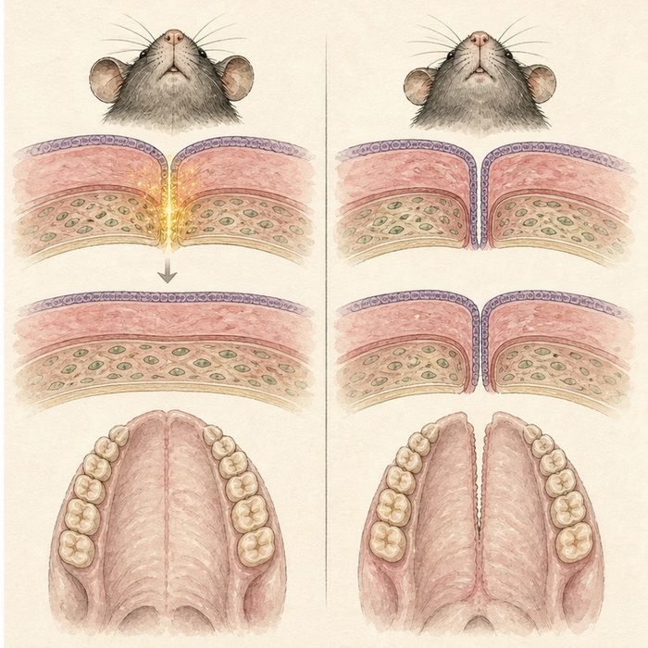
Biomedical teaching illustration: Read the Tgfb3 knockout result step by step
Analogy step | Biology step | How the relationship stays the same
Teams arrive | Palatal shelves elevate and meet | ________________________________
Access code activates | TGF-beta3 signaling in medial edge epithelium | ________________________________
Final handoff | Stable fusion and seam removal | ________________________________

DEVELOPMENTAL LESSON 11 | CASE FILE AND DECISION
4. Use the case evidence

ID | Finding supplied in the case | Why it matters
DEV11-E1 | In Tgfb3-null mouse embryos, palatal shelves can reach the midline. | Earlier growth and elevation can still occur.
DEV11-E2 | The shelves fail to complete normal adhesion and seam removal. | The defect is concentrated at the fusion transition.
DEV11-E3 | The result is cleft secondary palate in the model. | Failure of a late step can preserve a gap despite shelf contact.

5. Make the clinical decision
You are presenting a knockout figure at lab meeting. Both control and mutant shelves reach the midline, but only controls form continuous mesenchyme.
A. Place TGF-beta3 at the fusion and seam-removal step.
B. Place TGF-beta3 only at neural crest birth.
C. Claim the mutant shelves never formed.
Decision. Choose the step assignment and cite the matched contact evidence.
________________________________________________________________________________
________________________________________________________________________________
Claim ceiling: You may assign a required role in mouse palatal fusion. You may not claim every human cleft palate is caused by TGFB3.
Claim. State the choice you can defend.
________________________________________________________________________________
Evidence. Use these labeled IDs: DEV11-E1 + DEV11-E2.
________________________________________________________________________________
Reasoning. Explain why the evidence supports the claim and stays inside the claim ceiling.
________________________________________________________________________________
________________________________________________________________________________

DEVELOPMENTAL LESSON 11 | REDUCE, REFLECT, AND PREPARE
6. Reduce the lesson to one lasting idea

Take-home. TGF-beta3 makes the palatal medial edge competent to complete adhesion and seam removal.
________________________________________________________________________________
________________________________________________________________________________
1. Which earlier step still occurs in the knockout?
________________________________________________________________________________
2. What claim about human clefts would go beyond this mouse result?
________________________________________________________________________________

Glossary
Term | Plain-English definition
TGF-beta3 | A signaling protein essential for palate fusion; it drives the edge cells between the two palatal shelves to disappear so they can join.
medial edge epithelium (MEE) | The cell layer on the inner edge of each palatal shelf, which must be removed for the shelves to fuse into a single palate.
knockout | An organism or cell engineered to have a specific gene switched off, used to reveal what that gene normally does.
fusion competence | The readiness of two developing facial parts to join properly, including the right timing, signals, and surface cells, so they can merge into one.

Next lesson unlock
We found the switch that tells edge cells to fuse. But before any cell can be an edge cell, it first had to BECOME a particular kind of cell. How does a face cell decide whether to be bone, skin, or cartilage in the first place?
The journal links on the lesson page are optional. Everything required for this guided-notes set is already supplied here and in the case file.

