DEVELOPMENTAL DOMAIN | LESSON 10 OF 20 | MOLECULAR EMBRYOLOGIST

What Tells Tissues When and Where to Grow: The Signaling Centers SHH, BMP, FGF
What signals tell the palatal shelves how much to grow and where, and what happens to a shelf if a signal is missing?
CARRY FORWARD  True palatal fusion requires removal of the midline epithelial seam so mesenchyme becomes continuous. | 10-YEAR TAKEAWAY  Signals such as SHH, BMP, and FGF carry local instructions that coordinate growth, position, and cell fate.

Cells differentiate | Development sculpts | Cells move | Development can go wrong

1. Observe the analogy before naming the biology
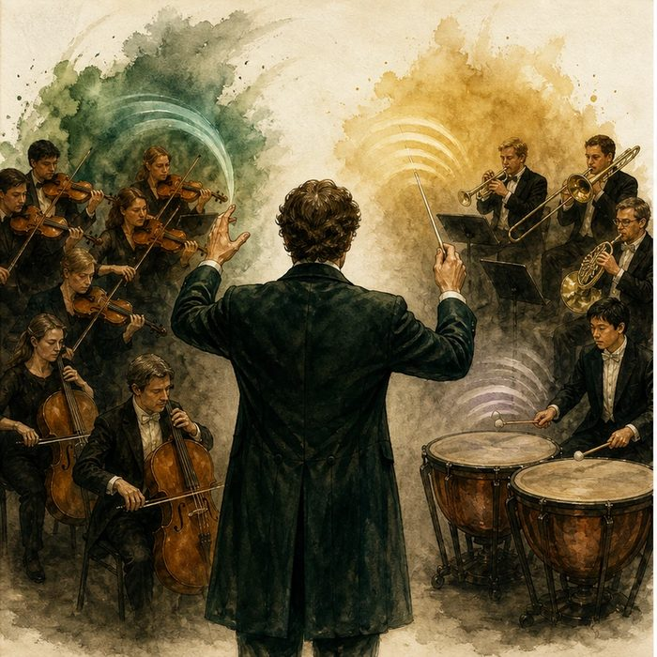
Illustration: An orchestra follows several section cues
1. Why does each section receive a different cue?
________________________________________________________________________________
2. What happens if one cue is missing but the others continue?
________________________________________________________________________________
3. How can timing and location change the meaning of the same cue?
________________________________________________________________________________

DEVELOPMENTAL LESSON 10 | RULES AND BIOLOGY MAPPING
2. Turn observations into rules

1. Rule 1: Development uses multiple signals at once. Explain it in your own words.
________________________________________________________________________________
2. Rule 2: Signals act on particular cells in particular places. Explain it in your own words.
________________________________________________________________________________
3. Rule 3: Removing one cue can change a specific process. Explain it in your own words.
________________________________________________________________________________
Where the analogy stops: Signaling networks include feedback and gradients, not a single conductor.

3. Map the rules onto the biomedical example
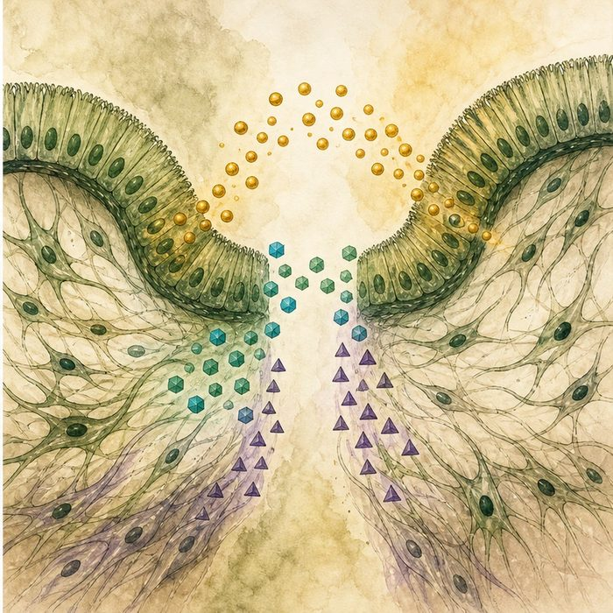
Biomedical teaching illustration: Map epithelial-mesenchymal cross-talk
Analogy step | Biology step | How the relationship stays the same
Conductor cue | A signaling molecule | ________________________________
Orchestra section | A responding cell population | ________________________________
Musical response | Growth, patterning, or differentiation | ________________________________

DEVELOPMENTAL LESSON 10 | CASE FILE AND DECISION
4. Use the case evidence

ID | Finding supplied in the case | Why it matters
DEV10-E1 | SHH is produced in palatal epithelium and influences nearby mesenchyme. | Signal source and target can be different tissues.
DEV10-E2 | BMP and FGF pathways help regulate shelf growth and regional identity. | Several pathways coordinate the process.
DEV10-E3 | Changing a pathway in a model can alter proliferation or shape in specific shelf regions. | Signal effects depend on place and time.

5. Make the clinical decision
You are interpreting a pathway-inhibition experiment. A drug blocks SHH response only in palatal mesenchyme, and anterior shelf proliferation drops.
A. Conclude that mesenchymal SHH response supports regional growth in this model.
B. Conclude that SHH is the only signal in palate development.
C. Conclude that Mateo received the same drug.
Decision. Choose the bounded conclusion and cite source-target and growth evidence.
________________________________________________________________________________
________________________________________________________________________________
Claim ceiling: You may infer a pathway role in the model and tissue tested. You may not erase other pathways or transfer exposure to Mateo.
Claim. State the choice you can defend.
________________________________________________________________________________
Evidence. Use these labeled IDs: DEV10-E1 + DEV10-E2.
________________________________________________________________________________
Reasoning. Explain why the evidence supports the claim and stays inside the claim ceiling.
________________________________________________________________________________
________________________________________________________________________________

DEVELOPMENTAL LESSON 10 | REDUCE, REFLECT, AND PREPARE
6. Reduce the lesson to one lasting idea

Take-home. Signals such as SHH, BMP, and FGF carry local instructions that coordinate growth, position, and cell fate.
________________________________________________________________________________
________________________________________________________________________________
1. What are the source and target in epithelial-mesenchymal cross-talk?
________________________________________________________________________________
2. Why does one inhibitor result not prove that only one signal matters?
________________________________________________________________________________

Glossary
Term | Plain-English definition
signaling molecule | A chemical messenger released by one cell that travels to another cell and triggers a specific response.
signaling center | A small group of cells in a developing embryo that releases signals telling nearby cells how to grow and what to become.
SHH (Sonic hedgehog) | A signaling molecule that tells cells their position during development and helps pattern the face, limbs, and brain.
BMP | Bone morphogenetic protein, a signaling molecule that tells cells where to form bone, cartilage, and other tissues during development.
FGF | Fibroblast growth factor, a signaling molecule that drives cells to grow and divide while shaping developing tissues.
epithelial-mesenchymal cross-talk | Back-and-forth chemical signaling between surface epithelial cells and underlying mesenchyme cells that guides how tissues grow and form.

Next lesson unlock
SHH, BMP, and FGF tell the shelves how much to grow and where, and a missing signal gives a too-small or mis-grown shelf. But growing is not the same as joining: a shelf can grow, elevate, and meet its partner and STILL not fuse. At the last step the two touching shelves must commit to becoming one, and a specific signal flips that switch. What is the master switch for palate fusion? We chase that next time.
The journal links on the lesson page are optional. Everything required for this guided-notes set is already supplied here and in the case file.

