DEVELOPMENTAL DOMAIN | LESSON 9 OF 20 | CELL BIOLOGIST

What Happens to the Wall Between the Shelves: Seam Removal, EMT versus Apoptosis
What happens to the wall of seam cells so the palate becomes one continuous tissue, and how sure are scientists about the answer?
CARRY FORWARD  After elevation, the medial edges must recognize, adhere to, and align with one another before fusion can continue. | 10-YEAR TAKEAWAY  True palatal fusion requires removal of the midline epithelial seam so mesenchyme becomes continuous.

Cells differentiate | Development sculpts | Cells move | Development can go wrong

1. Observe the analogy before naming the biology
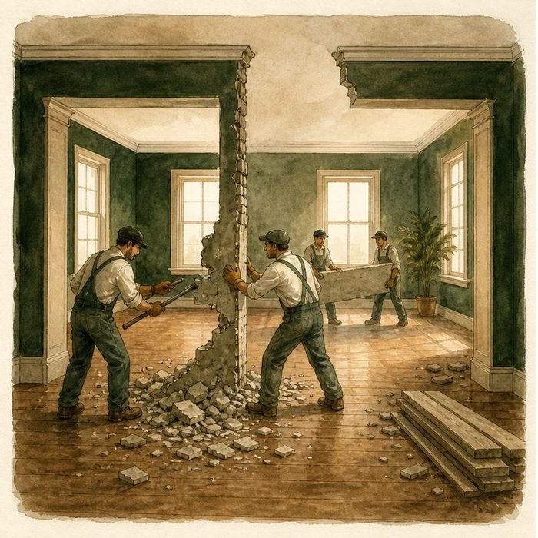
Illustration: Remove the temporary wall after two rooms connect
1. Why was the temporary wall useful at first?
________________________________________________________________________________
2. What must disappear for the rooms to become one space?
________________________________________________________________________________
3. Which observations could distinguish demolition from wall movement?
________________________________________________________________________________

DEVELOPMENTAL LESSON 9 | RULES AND BIOLOGY MAPPING
2. Turn observations into rules

1. Rule 1: A temporary boundary can guide joining. Explain it in your own words.
________________________________________________________________________________
2. Rule 2: The boundary must be removed for continuity. Explain it in your own words.
________________________________________________________________________________
3. Rule 3: Competing cell mechanisms require direct evidence. Explain it in your own words.
________________________________________________________________________________
Where the analogy stops: Seam cells can die, extrude, or change behavior. They are not bricks.

3. Map the rules onto the biomedical example
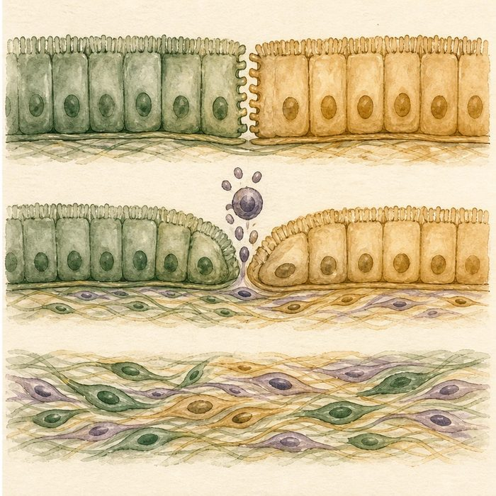
Biomedical teaching illustration: Test what happens to midline seam cells
Analogy step | Biology step | How the relationship stays the same
Temporary center wall | Midline epithelial seam | ________________________________
Remove wall material | Apoptosis or cell extrusion | ________________________________
One continuous room | Mesenchymal confluence across the palate | ________________________________

DEVELOPMENTAL LESSON 9 | CASE FILE AND DECISION
4. Use the case evidence

ID | Finding supplied in the case | Why it matters
DEV09-E1 | A midline epithelial seam forms after the shelves adhere. | The seam is a normal temporary stage.
DEV09-E2 | Seam cells are removed through processes that include apoptosis and extrusion. | Cell loss helps eliminate the barrier.
DEV09-E3 | Lineage labeling tests whether seam cells remain, move, or change identity. | Mechanism requires tracking, not appearance alone.

5. Make the clinical decision
You are choosing an experiment to test seam removal. A still image shows no seam at the endpoint, but the team disagrees about what happened to the seam cells.
A. Use lineage labeling plus time-resolved cell-death and extrusion markers.
B. Use the endpoint image alone to prove one mechanism.
C. Assume all seam cells became bone.
Decision. Choose the experiment and explain why the endpoint image is not enough.
________________________________________________________________________________
________________________________________________________________________________
Claim ceiling: You may distinguish supported cell-removal mechanisms. You may not force all seam loss into one mechanism without tracking evidence.
Claim. State the choice you can defend.
________________________________________________________________________________
Evidence. Use these labeled IDs: DEV09-E1 + DEV09-E2.
________________________________________________________________________________
Reasoning. Explain why the evidence supports the claim and stays inside the claim ceiling.
________________________________________________________________________________
________________________________________________________________________________

DEVELOPMENTAL LESSON 9 | REDUCE, REFLECT, AND PREPARE
6. Reduce the lesson to one lasting idea

Take-home. True palatal fusion requires removal of the midline epithelial seam so mesenchyme becomes continuous.
________________________________________________________________________________
________________________________________________________________________________
1. What final tissue state shows true fusion?
________________________________________________________________________________
2. Why is lineage labeling stronger than one endpoint image for testing seam-cell fate?
________________________________________________________________________________

Glossary
Term | Plain-English definition
midline epithelial seam (MES) | The thin line of surface cells formed when the two palate shelves meet, which must break down so the palate can fully fuse.
epithelial-to-mesenchymal transition (EMT) | A change where a settled, sheet-bound epithelial cell loosens its bonds and becomes a mobile, crawling mesenchymal cell.
apoptosis | Programmed, controlled cell death that the body uses on purpose, including to clear the seam between two tissues during palate fusion.
cell extrusion | A process where a sheet of cells squeezes out and removes one of its own cells, sealing the gap to keep the layer intact.
lineage labeling | A method that tags a starting cell with a permanent marker so all of its descendant cells can be tracked over time.

Next lesson unlock
The seam is removed, by mechanisms scientists are still working out, so the palate becomes one continuous tissue. But the seam cells clear at exactly the right time and place, and the shelves grew the right amount and stuck only where they should. Something must be telling the tissue when and where to grow, stick, and clear. What is that signal, and where does it come from? We chase that next time.
The journal links on the lesson page are optional. Everything required for this guided-notes set is already supplied here and in the case file.

