DEVELOPMENTAL DOMAIN | LESSON 8 OF 20 | HISTOLOGIST

Two Shelves Become One Roof: Adhesion, the Medial Edge Epithelium, and the Seam
How do the touching edges of two separate shelves become a single, joined roof?
CARRY FORWARD  Palatal shelves must rapidly elevate above the tongue, and jaw-tongue geometry can block that movement. | 10-YEAR TAKEAWAY  After elevation, the medial edges must recognize, adhere to, and align with one another before fusion can continue.

Cells differentiate | Development sculpts | Cells move | Development can go wrong

1. Observe the analogy before naming the biology
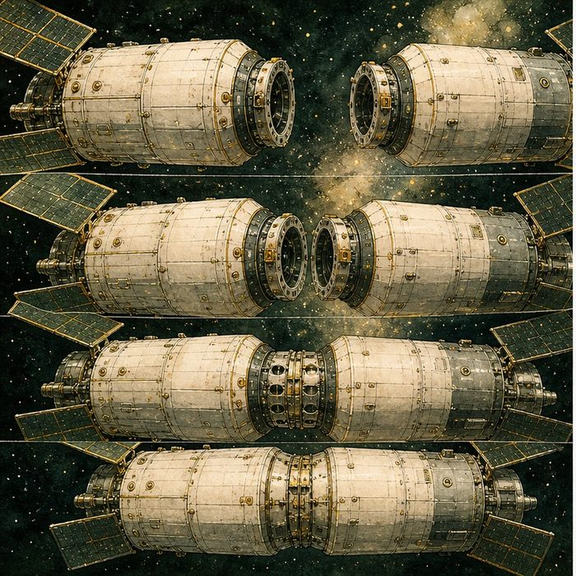
Illustration: A docking spacecraft needs matching ports
1. What must match before docking begins?
________________________________________________________________________________
2. How is touching different from locking?
________________________________________________________________________________
3. What prevents the wrong surfaces from attaching?
________________________________________________________________________________

DEVELOPMENTAL LESSON 8 | RULES AND BIOLOGY MAPPING
2. Turn observations into rules

1. Rule 1: Contact requires the correct surfaces. Explain it in your own words.
________________________________________________________________________________
2. Rule 2: Alignment must come before stable adhesion. Explain it in your own words.
________________________________________________________________________________
3. Rule 3: Surface identity can permit or prevent sticking. Explain it in your own words.
________________________________________________________________________________
Where the analogy stops: Cells use changing proteins and behaviors, not metal docking latches.

3. Map the rules onto the biomedical example
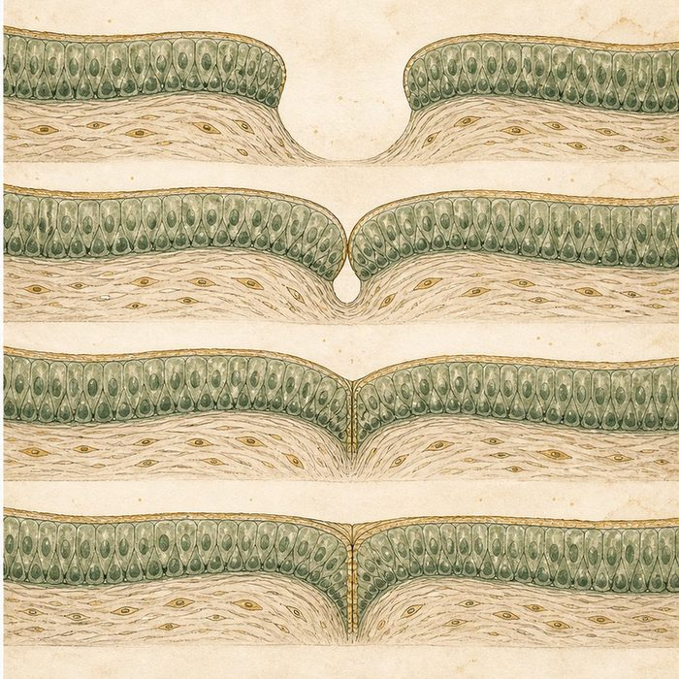
Biomedical teaching illustration: Zoom in on the medial edge epithelium
Analogy step | Biology step | How the relationship stays the same
Matching docking ports | Opposing medial edge epithelia | ________________________________
Initial contact | Shelf apposition at the midline | ________________________________
Docking lock | Adhesion and midline epithelial seam formation | ________________________________

DEVELOPMENTAL LESSON 8 | CASE FILE AND DECISION
4. Use the case evidence

ID | Finding supplied in the case | Why it matters
DEV08-E1 | Elevated shelves grow toward one another at the midline. | Correct position creates the opportunity for contact.
DEV08-E2 | The medial edge epithelia make contact and adhere. | A specific surface interaction begins fusion.
DEV08-E3 | Contact creates a midline epithelial seam. | The first joined state still contains an epithelial wall.

5. Make the clinical decision
You are scoring palate explants after 24 hours in culture. One pair touches but separates with gentle handling. Another pair forms a stable midline seam.
A. Score the first as contact without stable adhesion and the second as adhesion.
B. Score both as complete fusion.
C. Ignore the seam because touching is always enough.
Decision. Choose the scoring rule and cite the evidence that separates contact from adhesion.
________________________________________________________________________________
________________________________________________________________________________
Claim ceiling: You may score contact and adhesion. You may not call mesenchymal fusion complete while the seam remains.
Claim. State the choice you can defend.
________________________________________________________________________________
Evidence. Use these labeled IDs: DEV08-E1 + DEV08-E2.
________________________________________________________________________________
Reasoning. Explain why the evidence supports the claim and stays inside the claim ceiling.
________________________________________________________________________________
________________________________________________________________________________

DEVELOPMENTAL LESSON 8 | REDUCE, REFLECT, AND PREPARE
6. Reduce the lesson to one lasting idea

Take-home. After elevation, the medial edges must recognize, adhere to, and align with one another before fusion can continue.
________________________________________________________________________________
________________________________________________________________________________
1. How is apposition different from adhesion?
________________________________________________________________________________
2. Why is a midline seam not yet the final continuous palate?
________________________________________________________________________________

Glossary
Term | Plain-English definition
adhesion | The way cells stick to each other and to the matrix around them using surface proteins, holding tissues together and guiding how they move.
medial edge epithelium (MEE) | The cell layer on the inner edge of each palatal shelf, which must be removed for the shelves to fuse into a single palate.
midline epithelial seam (MES) | The thin line of surface cells formed when the two palate shelves meet, which must break down so the palate can fully fuse.
periderm | A thin temporary outer cell layer of the embryo; if it sticks where it should not, the growing edges cannot fuse.
midline | The imaginary center line of the body; many facial structures form by growing toward and meeting at it.

Next lesson unlock
The shelves adhere at their medial edges and form one seam down the midline. But the roof is not truly finished: a wall of epithelial cells, the seam, still runs through it. If that wall stays, the two sides are not really one piece. What happens to that wall of cells? We chase that next time, and the answer turns out to be a real scientific argument.
The journal links on the lesson page are optional. Everything required for this guided-notes set is already supplied here and in the case file.

