DEVELOPMENTAL DOMAIN | LESSON 7 OF 20 | DEVELOPMENTAL BIOLOGIST

Getting Above the Tongue: Palatal Shelf Elevation
How do two downward-pointing shelves move to a horizontal position above the tongue, and what can stop them?
CARRY FORWARD  The secondary palate begins as paired shelves whose cell growth must create enough tissue to reach the midline. | 10-YEAR TAKEAWAY  Palatal shelves must rapidly elevate above the tongue, and jaw-tongue geometry can block that movement.

Cells differentiate | Development sculpts | Cells move | Development can go wrong

1. Observe the analogy before naming the biology
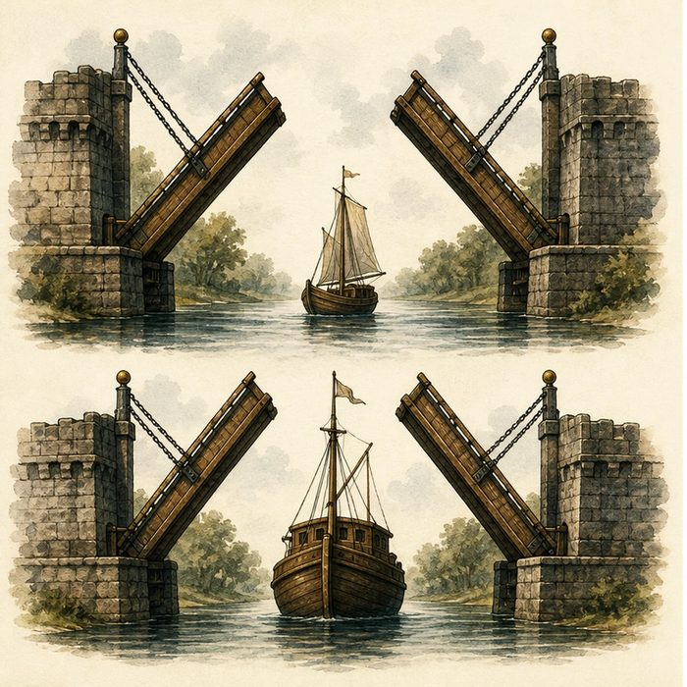
Illustration: Drawbridges rotate only after a boat clears
1. What blocks the bridge before the boat clears?
________________________________________________________________________________
2. Which movement changes the bridge from vertical to horizontal?
________________________________________________________________________________
3. Could intact bridge parts still fail to meet?
________________________________________________________________________________

DEVELOPMENTAL LESSON 7 | RULES AND BIOLOGY MAPPING
2. Turn observations into rules

1. Rule 1: A structure may need room before it can move. Explain it in your own words.
________________________________________________________________________________
2. Rule 2: Shape change can be rapid and coordinated. Explain it in your own words.
________________________________________________________________________________
3. Rule 3: A mechanical block can cause failure without missing parts. Explain it in your own words.
________________________________________________________________________________
Where the analogy stops: Palatal elevation is driven by tissue forces and growth, not hinges.

3. Map the rules onto the biomedical example
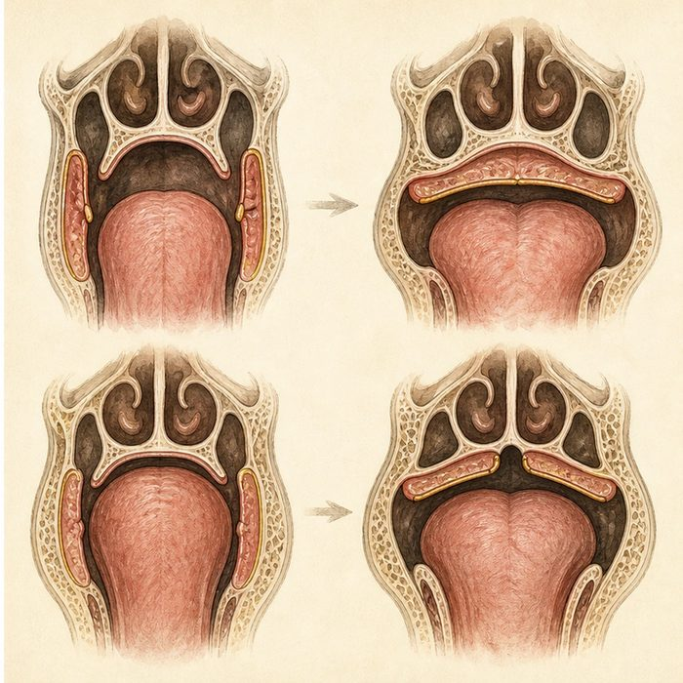
Biomedical teaching illustration: Use jaw and tongue position to explain shelf elevation
Analogy step | Biology step | How the relationship stays the same
Boat clears the channel | Tongue descends as jaw space increases | ________________________________
Bridge leaf rotates | Palatal shelf elevates | ________________________________
Blocked bridge | Small jaw and high tongue can prevent elevation | ________________________________

DEVELOPMENTAL LESSON 7 | CASE FILE AND DECISION
4. Use the case evidence

ID | Finding supplied in the case | Why it matters
DEV07-E1 | Palatal shelves first grow vertically beside the tongue. | Their early position is not the final roof position.
DEV07-E2 | The shelves elevate to a horizontal position above the tongue. | Movement is required before midline contact.
DEV07-E3 | A small jaw can keep the tongue high and mechanically block elevation. | Geometry can cause cleft palate even when shelves exist.

5. Make the clinical decision
You are reviewing two fetal MRI teaching diagrams. Diagram A shows shelves present but vertical beside a high tongue. Diagram B shows shelves horizontal above the tongue.
A. Identify elevation failure in A and completed elevation in B.
B. Call both diagrams identical because shelves are present.
C. Diagnose a named syndrome from shelf position alone.
Decision. Choose the comparison and cite the evidence that separates presence from position.
________________________________________________________________________________
________________________________________________________________________________
Claim ceiling: You may identify a mechanical elevation problem. You may not assign a syndrome without the full clinical pattern.
Claim. State the choice you can defend.
________________________________________________________________________________
Evidence. Use these labeled IDs: DEV07-E1 + DEV07-E2.
________________________________________________________________________________
Reasoning. Explain why the evidence supports the claim and stays inside the claim ceiling.
________________________________________________________________________________
________________________________________________________________________________

DEVELOPMENTAL LESSON 7 | REDUCE, REFLECT, AND PREPARE
6. Reduce the lesson to one lasting idea

Take-home. Palatal shelves must rapidly elevate above the tongue, and jaw-tongue geometry can block that movement.
________________________________________________________________________________
________________________________________________________________________________
1. What changes between the vertical and horizontal shelf stages?
________________________________________________________________________________
2. How can jaw size affect the palate without removing shelf tissue?
________________________________________________________________________________

Glossary
Term | Plain-English definition
elevation | The developmental step where the palatal shelves lift from a downward position up to horizontal so they can meet above the tongue.
horizontal | Lying flat and level, side to side; the palatal shelves must swing into a horizontal position above the tongue before they can fuse.
vertical | Running up and down, along the head-to-foot direction, as opposed to side to side or front to back.
hyaluronan | A large sugar molecule of the extracellular matrix that holds water and gives tissues like the developing palate their springy, hydrated structure.
Pierre Robin sequence | A chain of features starting with a small lower jaw, which pushes the tongue back and blocks the airway and often comes with a cleft palate.

Next lesson unlock
The shelves remodel and rise above the tongue once the tongue drops and the head widens. But now the two horizontal shelves sit almost edge to edge at the midline, still separate. What actually lets two separate edges of tissue become one continuous roof? We chase that next time.
The journal links on the lesson page are optional. Everything required for this guided-notes set is already supplied here and in the case file.

