DEVELOPMENTAL DOMAIN | LESSON 6 OF 20 | EMBRYOLOGIST

How the Palate Begins: Secondary Palatal Shelf Outgrowth
Where does the back of the palate come from, and what makes it grow?
CARRY FORWARD  Upper-lip closure requires growth, contact, and stable fusion at the maxillary-medial nasal boundary. | 10-YEAR TAKEAWAY  The secondary palate begins as paired shelves whose cell growth must create enough tissue to reach the midline.

Cells differentiate | Development sculpts | Cells move | Development can go wrong

1. Observe the analogy before naming the biology

Illustration: Two stage platforms extend toward the center
1. What determines whether the platforms can meet?
________________________________________________________________________________
2. What would a short platform leave at the center?
________________________________________________________________________________
3. Why must both sides be measured?
________________________________________________________________________________

DEVELOPMENTAL LESSON 6 | RULES AND BIOLOGY MAPPING
2. Turn observations into rules

1. Rule 1: Growth creates the material needed for contact. Explain it in your own words.
________________________________________________________________________________
2. Rule 2: Paired structures must reach a shared target. Explain it in your own words.
________________________________________________________________________________
3. Rule 3: A rescue can test whether missing growth caused the gap. Explain it in your own words.
________________________________________________________________________________
Where the analogy stops: Palatal shelves are living tissues with patterned growth, not mechanical platforms.

3. Map the rules onto the biomedical example
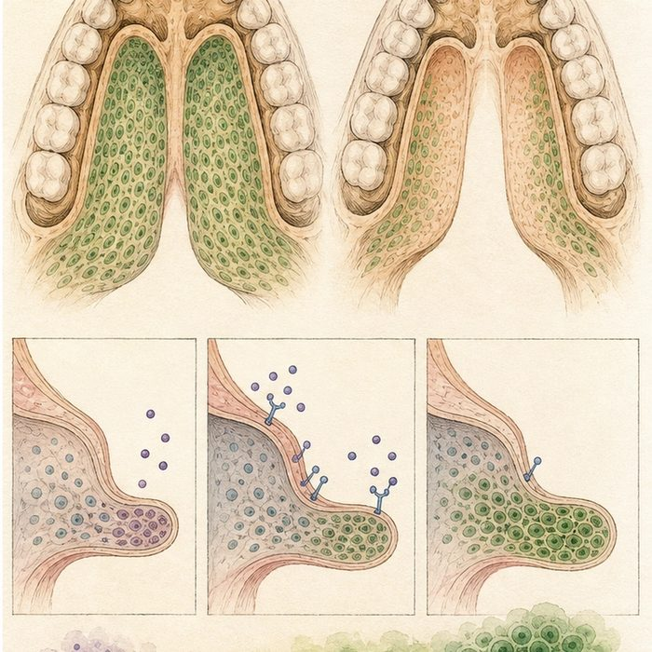
Biomedical teaching illustration: Connect cell proliferation to palatal shelf length
Analogy step | Biology step | How the relationship stays the same
Extend the platform | Mesenchymal cell proliferation | ________________________________
Reach center stage | Shelf contact at the midline | ________________________________
Restore the extension motor | BMP4 rescue in an Msx1-deficient mouse model | ________________________________

DEVELOPMENTAL LESSON 6 | CASE FILE AND DECISION
4. Use the case evidence

ID | Finding supplied in the case | Why it matters
DEV06-E1 | Secondary palatal shelves grow from the inner sides of the maxillary regions. | The palate begins as paired outgrowths.
DEV06-E2 | Reduced mesenchymal proliferation can leave shelves too small to meet. | Cell number and shelf size are connected.
DEV06-E3 | Directed Bmp4 expression rescued palatal growth and fusion in an Msx1-deficient mouse model. | The experiment supports a growth mechanism in that model.

5. Make the clinical decision
You are choosing the readout for a palatal-growth experiment. Control and mutant embryos are collected before shelf elevation. You can measure only one primary outcome.
A. Measure shelf size and mesenchymal proliferation on both sides.
B. Measure newborn speech before fusion occurs.
C. Claim human prevention from the mouse embryos.
Decision. Choose the primary outcome and cite the evidence linking cell growth to shelf size.
________________________________________________________________________________
________________________________________________________________________________
Claim ceiling: You may test a growth mechanism in the model. You may not claim a proven human treatment.
Claim. State the choice you can defend.
________________________________________________________________________________
Evidence. Use these labeled IDs: DEV06-E1 + DEV06-E2.
________________________________________________________________________________
Reasoning. Explain why the evidence supports the claim and stays inside the claim ceiling.
________________________________________________________________________________
________________________________________________________________________________

DEVELOPMENTAL LESSON 6 | REDUCE, REFLECT, AND PREPARE
6. Reduce the lesson to one lasting idea

Take-home. The secondary palate begins as paired shelves whose cell growth must create enough tissue to reach the midline.
________________________________________________________________________________
________________________________________________________________________________
1. How can lower proliferation change shelf contact?
________________________________________________________________________________
2. What does the Bmp4 rescue support, and what does it not prove?
________________________________________________________________________________

Glossary
Term | Plain-English definition
secondary palate | A lesson term defined by the surrounding model and case evidence.
palatal shelf | One of two tissue ledges in the embryo that swing up from beside the tongue to horizontal and meet at the midline to form the roof of the mouth.
maxillary process | A paired bulge of embryo tissue that grows toward the midline to form the upper jaw, cheeks, and sides of the upper lip.
mesenchyme | Loose, unsettled cells in a watery matrix that can crawl and later become bone, cartilage, or connective tissue.
proliferation | The rapid increase in cell number as cells repeatedly grow and divide, building or repairing tissue.

Next lesson unlock
The palate begins as two shelves that grow downward beside the tongue. But those shelves point straight down, with the tongue sitting between them. How do two downward shelves end up as one flat roof above the tongue? We chase that next time.
The journal links on the lesson page are optional. Everything required for this guided-notes set is already supplied here and in the case file.

