DEVELOPMENTAL DOMAIN | LESSON 5 OF 20 | EMBRYOLOGIST

How and When Does the Upper Lip Close?
Which blocks must merge and fuse to close the upper lip, and when does this happen?
CARRY FORWARD  Face-building cells must travel in organized streams to the right destination before they can build the right structure. | 10-YEAR TAKEAWAY  Upper-lip closure requires growth, contact, and stable fusion at the maxillary-medial nasal boundary.

Cells differentiate | Development sculpts | Cells move | Development can go wrong

1. Observe the analogy before naming the biology
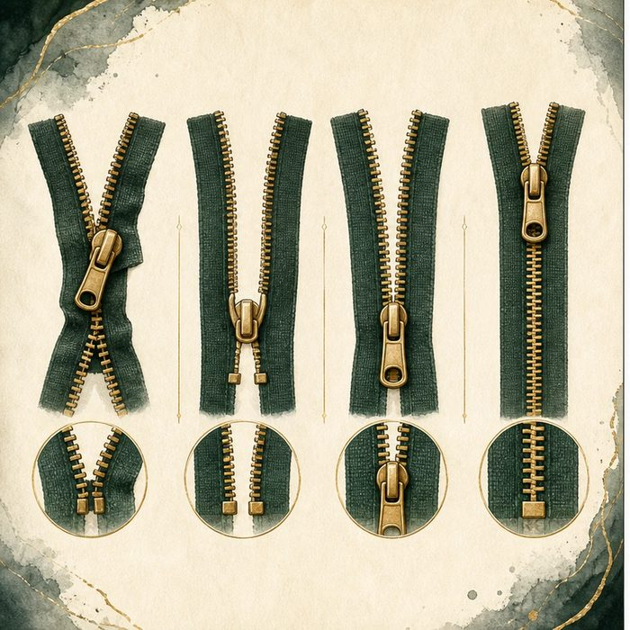
Illustration: Two zipper halves must align before they close
1. What must happen before the zipper can close?
________________________________________________________________________________
2. How could alignment fail even if both halves exist?
________________________________________________________________________________
3. What evidence would separate missing material from failed closure?
________________________________________________________________________________

DEVELOPMENTAL LESSON 5 | RULES AND BIOLOGY MAPPING
2. Turn observations into rules

1. Rule 1: Parts must first grow into range. Explain it in your own words.
________________________________________________________________________________
2. Rule 2: Correct contact must precede stable joining. Explain it in your own words.
________________________________________________________________________________
3. Rule 3: A gap can result from failure at more than one step. Explain it in your own words.
________________________________________________________________________________
Where the analogy stops: Tissues remodel and fuse through cell behavior, not metal teeth.

3. Map the rules onto the biomedical example
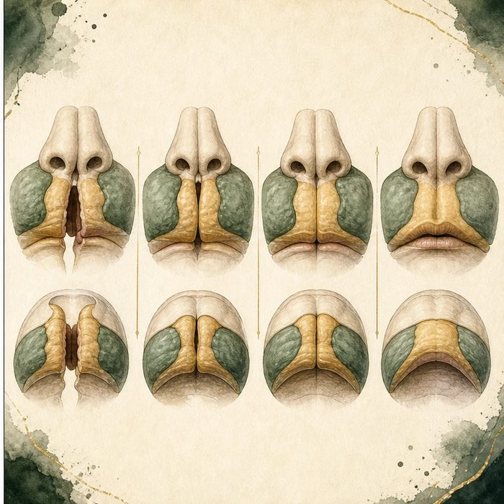
Biomedical teaching illustration: Name the three steps in upper-lip closure
Analogy step | Biology step | How the relationship stays the same
Bring zipper halves together | Prominence growth | ________________________________
Align the teeth | Correct tissue contact | ________________________________
Pull the slider | Stable epithelial remodeling and fusion | ________________________________

DEVELOPMENTAL LESSON 5 | CASE FILE AND DECISION
4. Use the case evidence

ID | Finding supplied in the case | Why it matters
DEV05-E1 | Upper-lip tissues must grow into contact during the early facial window. | Distance is a developmental variable.
DEV05-E2 | The maxillary prominence meets the medial nasal region at the lip boundary. | The contact must occur at the correct neighbor.
DEV05-E3 | The joined surface must remodel into continuous tissue. | Touching alone is not the completed lip.

5. Make the clinical decision
You are annotating a developmental animation for the family conference. The animation shows both tissue blocks present but never making stable contact on the left.
A. Label a failed growth/contact/fusion sequence at the left lip boundary.
B. Label a secondary palate elevation failure only.
C. Claim the tissue blocks were never present.
Decision. Choose the label that fits the animation and cite the boundary evidence.
________________________________________________________________________________
________________________________________________________________________________
Claim ceiling: You may identify the failed morphologic sequence. You may not identify a gene from the animation alone.
Claim. State the choice you can defend.
________________________________________________________________________________
Evidence. Use these labeled IDs: DEV05-E1 + DEV05-E2.
________________________________________________________________________________
Reasoning. Explain why the evidence supports the claim and stays inside the claim ceiling.
________________________________________________________________________________
________________________________________________________________________________

DEVELOPMENTAL LESSON 5 | REDUCE, REFLECT, AND PREPARE
6. Reduce the lesson to one lasting idea

Take-home. Upper-lip closure requires growth, contact, and stable fusion at the maxillary-medial nasal boundary.
________________________________________________________________________________
________________________________________________________________________________
1. What three steps must occur before the lip is continuous?
________________________________________________________________________________
2. Why does contact alone not prove successful fusion?
________________________________________________________________________________

Glossary
Term | Plain-English definition
fusion | When two growing tissue edges meet at the midline and join into one continuous structure, as the lip and palate do during development.
primary palate | A lesson term defined by the surrounding model and case evidence.
intermaxillary segment | The central facial block formed in the embryo that gives rise to the philtrum of the lip, the front gum, and the primary palate.
philtrum | The vertical groove in the middle of the upper lip, bordered by two ridges, that forms where facial parts fuse during development.
incisive foramen | A small opening in the roof of the mouth just behind the front teeth that marks the boundary between the primary and secondary palate.
cleft lip | A birth difference where the upper lip does not fully fuse before birth, leaving a gap or split that can reach toward the nose.

Next lesson unlock
The upper lip closes at about weeks 4 to 6, forming the lip and the small front triangle of palate. But that triangle is only the front of the roof of the mouth. Behind the incisive foramen, the palate is still wide open. So the next question is: how does the palate begin? We chase that next time.
The journal links on the lesson page are optional. Everything required for this guided-notes set is already supplied here and in the case file.

