DEVELOPMENTAL DOMAIN | LESSON 4 OF 20 | NEURAL CREST CELL BIOLOGIST

How Do the Face-Building Cells Get to the Right Place?
How do cranial neural crest cells travel from the neural folds to the right facial blocks, and why does taking the correct route matter?
CARRY FORWARD  Cranial neural crest cells leave the neural folds as flexible builders that can become several craniofacial tissues. | 10-YEAR TAKEAWAY  Face-building cells must travel in organized streams to the right destination before they can build the right structure.

Cells differentiate | Development sculpts | Cells move | Development can go wrong

1. Observe the analogy before naming the biology
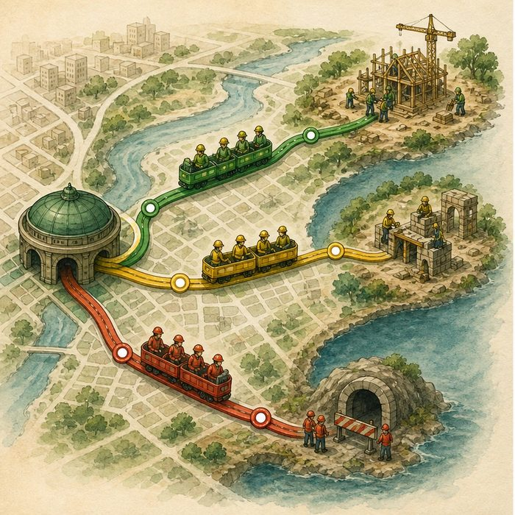
Illustration: Transit lines carry different crews to different stations
1. Why are the routes separated?
________________________________________________________________________________
2. What happens if a crew exits at the wrong station?
________________________________________________________________________________
3. What information must a route provide besides direction?
________________________________________________________________________________

DEVELOPMENTAL LESSON 4 | RULES AND BIOLOGY MAPPING
2. Turn observations into rules

1. Rule 1: Movement is organized, not random. Explain it in your own words.
________________________________________________________________________________
2. Rule 2: Destination affects what a cell can build. Explain it in your own words.
________________________________________________________________________________
3. Rule 3: Too few arrivals can leave a structure small or missing. Explain it in your own words.
________________________________________________________________________________
Where the analogy stops: Migrating cells respond to molecular cues rather than reading a transit map.

3. Map the rules onto the biomedical example
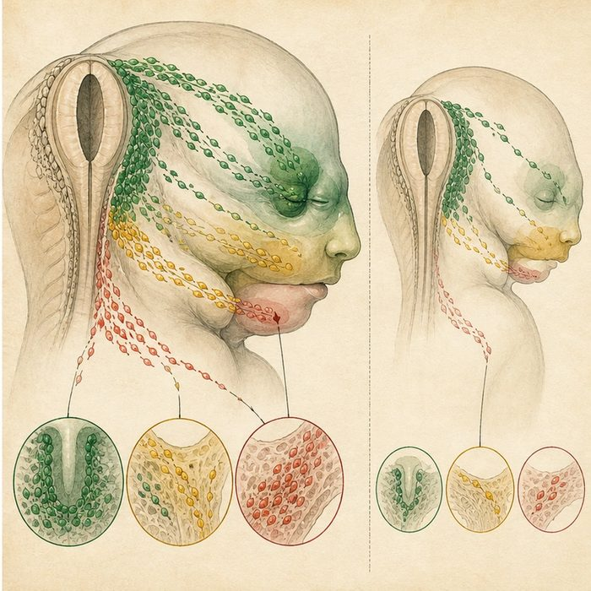
Biomedical teaching illustration: Trace neural crest streams into facial regions
Analogy step | Biology step | How the relationship stays the same
Transit line | Migratory stream | ________________________________
Station | Frontonasal region or pharyngeal arch | ________________________________
Crew shortage | Hypoplasia after reduced cell arrival | ________________________________

DEVELOPMENTAL LESSON 4 | CASE FILE AND DECISION
4. Use the case evidence

ID | Finding supplied in the case | Why it matters
DEV04-E1 | Cranial neural crest cells migrate in reproducible streams. | Their movement has spatial organization.
DEV04-E2 | Different streams enter the frontonasal region and pharyngeal arches. | Route and destination are linked.
DEV04-E3 | Reduced neural crest survival or migration can cause facial hypoplasia. | Cell number at the destination affects growth.

5. Make the clinical decision
You are reviewing a lineage-tracing image from a mouse embryo. One labeled stream reaches the first pharyngeal arch, while a second group stalls near the neural tube.
A. Predict reduced tissue contribution in the stalled group's destination.
B. Predict no effect because cell position never matters.
C. Claim the image proves a specific human diagnosis.
Decision. Choose the defensible prediction and cite the route and cell-number evidence.
________________________________________________________________________________
________________________________________________________________________________
Claim ceiling: You may predict a developmental consequence in the model. You may not diagnose Mateo from one animal image.
Claim. State the choice you can defend.
________________________________________________________________________________
Evidence. Use these labeled IDs: DEV04-E1 + DEV04-E2.
________________________________________________________________________________
Reasoning. Explain why the evidence supports the claim and stays inside the claim ceiling.
________________________________________________________________________________
________________________________________________________________________________

DEVELOPMENTAL LESSON 4 | REDUCE, REFLECT, AND PREPARE
6. Reduce the lesson to one lasting idea

Take-home. Face-building cells must travel in organized streams to the right destination before they can build the right structure.
________________________________________________________________________________
________________________________________________________________________________
1. How is an organized stream different from random movement?
________________________________________________________________________________
2. What could happen if too few cells reach a facial destination?
________________________________________________________________________________

Glossary
Term | Plain-English definition
migration | The active movement of cells from one location to another, essential during development, wound healing, and the spread of cancer.
pharyngeal arch (branchial arch) | One of the ridged blocks of embryo tissue along the future neck that give rise to the jaw, face, and throat structures.
frontonasal process | An early facial swelling above the mouth that grows into the forehead, the bridge and tip of the nose, and the middle of the upper lip.
migratory stream | An organized flow of cells, such as neural crest cells, traveling together along a set path to where they will build a structure.
mesenchyme | Loose, unsettled cells in a watery matrix that can crawl and later become bone, cartilage, or connective tissue.
hypoplasia | Underdevelopment of a tissue or organ from too few cells, leaving it smaller or less complete than normal.

Next lesson unlock
The face-building cells ride organized streams into the frontonasal process and the first arch, filling the prominences. But the lip is still open: the blocks have arrived and grown, yet they sit next to one another as separate pieces. So the next question is: how and when do those separate blocks actually close to make a lip? We chase that next time.
The journal links on the lesson page are optional. Everything required for this guided-notes set is already supplied here and in the case file.

