DEVELOPMENTAL DOMAIN | LESSON 3 OF 20 | NEURAL CREST CELL BIOLOGIST

Where Do the Cells That Build the Face Come From?
Where in the early embryo are the face-building cells born, and how do they get free to start their journey?
CARRY FORWARD  The face forms when named tissue prominences grow into position and join specific neighbors. | 10-YEAR TAKEAWAY  Cranial neural crest cells leave the neural folds as flexible builders that can become several craniofacial tissues.

Cells differentiate | Development sculpts | Cells move | Development can go wrong

1. Observe the analogy before naming the biology

Illustration: Students leave one school for specialized apprenticeships
1. What do the travelers share before they choose a workshop?
________________________________________________________________________________
2. What changes when they leave the starting building?
________________________________________________________________________________
3. Why must their options remain open during the journey?
________________________________________________________________________________

DEVELOPMENTAL LESSON 3 | RULES AND BIOLOGY MAPPING
2. Turn observations into rules

1. Rule 1: A starting population can share one origin. Explain it in your own words.
________________________________________________________________________________
2. Rule 2: Cells change behavior before they move. Explain it in your own words.
________________________________________________________________________________
3. Rule 3: Signals at the destination help narrow cell fate. Explain it in your own words.
________________________________________________________________________________
Where the analogy stops: Cells do not choose careers. The analogy models shared origin and later specialization.

3. Map the rules onto the biomedical example
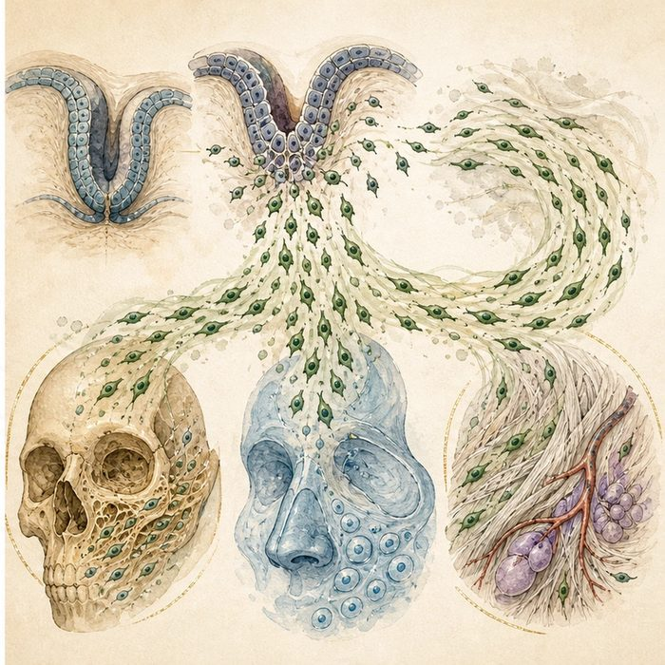
Biomedical teaching illustration: Follow cranial neural crest cells from neural fold to facial mesenchyme
Analogy step | Biology step | How the relationship stays the same
Leave the school | Delaminate from the neural folds | ________________________________
Change travel behavior | Undergo epithelial-to-mesenchymal transition | ________________________________
Enter a workshop | Differentiate within craniofacial destinations | ________________________________

DEVELOPMENTAL LESSON 3 | CASE FILE AND DECISION
4. Use the case evidence

ID | Finding supplied in the case | Why it matters
DEV03-E1 | Cranial neural crest cells arise near the closing neural folds. | They share an early origin before entering the face.
DEV03-E2 | They undergo EMT and delamination before migration. | They must loosen epithelial attachments and become mobile.
DEV03-E3 | Their descendants form much craniofacial bone, cartilage, and connective tissue. | Their early state supports several later fates.

5. Make the clinical decision
You are explaining lineage tracing to a new lab intern. The intern claims every facial bone cell began as a mature bone cell at the neural fold.
A. Correct the claim: mobile multipotent neural crest cells specialize later.
B. Agree that mature bone cells migrate from the neural fold.
C. Claim all facial tissues come from one mature cell type.
Decision. Choose the correction and cite evidence for both mobility and later specialization.
________________________________________________________________________________
________________________________________________________________________________
Claim ceiling: You may describe lineage potential. You may not claim that every craniofacial tissue comes only from neural crest.
Claim. State the choice you can defend.
________________________________________________________________________________
Evidence. Use these labeled IDs: DEV03-E1 + DEV03-E2.
________________________________________________________________________________
Reasoning. Explain why the evidence supports the claim and stays inside the claim ceiling.
________________________________________________________________________________
________________________________________________________________________________

DEVELOPMENTAL LESSON 3 | REDUCE, REFLECT, AND PREPARE
6. Reduce the lesson to one lasting idea

Take-home. Cranial neural crest cells leave the neural folds as flexible builders that can become several craniofacial tissues.
________________________________________________________________________________
________________________________________________________________________________
1. What changes during EMT?
________________________________________________________________________________
2. Why is multipotent more accurate than mature bone cell for an early neural crest cell?
________________________________________________________________________________

Glossary
Term | Plain-English definition
neural crest cell | A migrating embryonic cell type that leaves the forming spinal cord and builds much of the face, skull, and many other tissues.
neural fold | The two raised ridges of the early embryo that rise up and fuse along the midline to form the neural tube, source of the brain and spinal cord.
delamination | When a cell loosens from a sheet of connected cells and leaves to crawl on its own.
epithelial-to-mesenchymal transition (EMT) | A change where a settled, sheet-bound epithelial cell loosens its bonds and becomes a mobile, crawling mesenchymal cell.
multipotent | Able to become several different cell types, but not every type in the body.
mesenchyme | Loose, unsettled cells in a watery matrix that can crawl and later become bone, cartilage, or connective tissue.

Next lesson unlock
The face-building cells are born at the top of the embryo, near the brain, and break free by delamination. But the prominences they need to fill sit far away around the mouth and jaw. So the next question is: how do these cells travel from the neural folds to the right facial blocks? We chase that next time.
The journal links on the lesson page are optional. Everything required for this guided-notes set is already supplied here and in the case file.

