DEVELOPMENTAL DOMAIN | LESSON 2 OF 20 | EMBRYOLOGIST

Which Building Blocks Must Fuse to Make a Lip and Palate?
What are the building blocks of the face, and which ones must fuse to form a normal upper lip?
CARRY FORWARD  The lip and palate form in short, ordered windows, so timing narrows where a developmental change began. | 10-YEAR TAKEAWAY  The face forms when named tissue prominences grow into position and join specific neighbors.

Cells differentiate | Development sculpts | Cells move | Development can go wrong

1. Observe the analogy before naming the biology
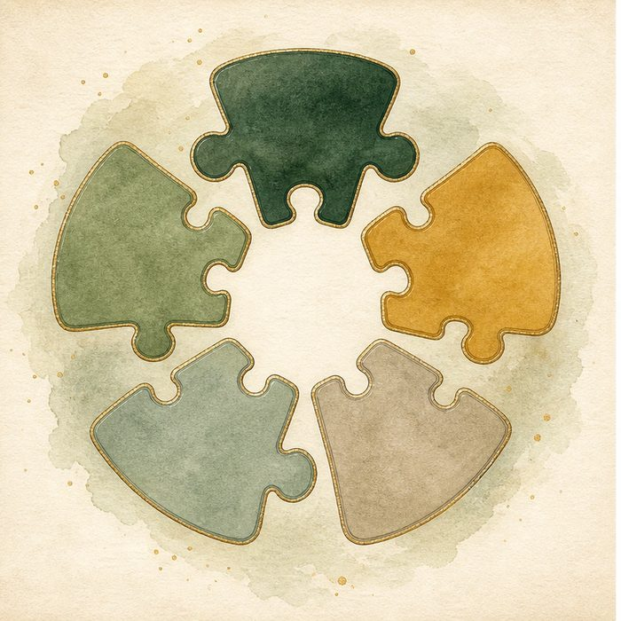
Illustration: Five puzzle pieces with only certain neighbors
1. Which pieces can touch because their edges face one another?
________________________________________________________________________________
2. Which piece contributes to the center of the final picture?
________________________________________________________________________________
3. How could the final gap reveal which meeting failed?
________________________________________________________________________________

DEVELOPMENTAL LESSON 2 | RULES AND BIOLOGY MAPPING
2. Turn observations into rules

1. Rule 1: Position limits which parts can meet. Explain it in your own words.
________________________________________________________________________________
2. Rule 2: Each part contributes specific final structures. Explain it in your own words.
________________________________________________________________________________
3. Rule 3: A gap can identify a failed neighbor relationship. Explain it in your own words.
________________________________________________________________________________
Where the analogy stops: Facial tissues grow and change shape, unlike rigid puzzle pieces.

3. Map the rules onto the biomedical example
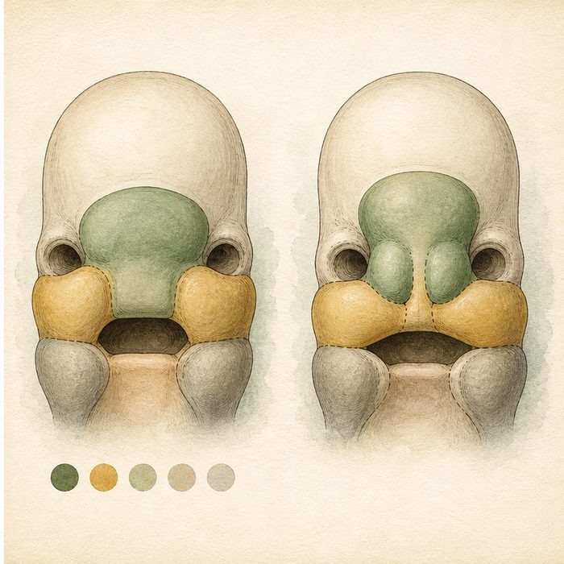
Biomedical teaching illustration: Map the five prominences to the upper lip
Analogy step | Biology step | How the relationship stays the same
Center puzzle piece | Frontonasal prominence and medial nasal regions | ________________________________
Side pieces | Paired maxillary prominences | ________________________________
Finished seam | Upper lip and primary palate junctions | ________________________________

DEVELOPMENTAL LESSON 2 | CASE FILE AND DECISION
4. Use the case evidence

ID | Finding supplied in the case | Why it matters
DEV02-E1 | One frontonasal, two maxillary, and two mandibular prominences surround the early mouth. | The five prominences are the starting blocks of the face.
DEV02-E2 | The maxillary prominence must meet the medial nasal region to build the upper lip. | A failed meeting at this boundary can produce cleft lip.
DEV02-E3 | The mandibular prominences mainly form lower-face structures. | They are not the direct lip-fusion boundary in Mateo's cleft.

5. Make the clinical decision
You are labeling a surgical teaching model for the cleft team. Only three labels can be placed on the model before the family teaching visit.
A. Label the maxillary and medial nasal meeting as the key upper-lip boundary.
B. Label the mandibular midline as Mateo's upper-lip failure.
C. Label every prominence as making the same structure.
Decision. Choose the useful label set and defend it with two evidence cards.
________________________________________________________________________________
________________________________________________________________________________
Claim ceiling: You may name the tissue boundary involved in lip formation. You may not name the molecular cause yet.
Claim. State the choice you can defend.
________________________________________________________________________________
Evidence. Use these labeled IDs: DEV02-E1 + DEV02-E2.
________________________________________________________________________________
Reasoning. Explain why the evidence supports the claim and stays inside the claim ceiling.
________________________________________________________________________________
________________________________________________________________________________

DEVELOPMENTAL LESSON 2 | REDUCE, REFLECT, AND PREPARE
6. Reduce the lesson to one lasting idea

Take-home. The face forms when named tissue prominences grow into position and join specific neighbors.
________________________________________________________________________________
________________________________________________________________________________
1. Which two named regions meet to form the upper lip?
________________________________________________________________________________
2. Why are the mandibular prominences not the best answer for Mateo's upper-lip cleft?
________________________________________________________________________________

Glossary
Term | Plain-English definition
facial prominence | One of the five swellings of tissue (one frontonasal, two maxillary, two mandibular) that grow toward the midline and fuse to build the face.
frontonasal prominence | A bulge of tissue in the early embryo's face that gives rise to the forehead, bridge of the nose, and middle of the upper lip.
maxillary process | A paired bulge of embryo tissue that grows toward the midline to form the upper jaw, cheeks, and sides of the upper lip.
mandibular process | The paired early facial swellings below the mouth that grow toward each other to form the lower jaw and chin.
medial nasal process | A pair of inner embryonic tissue bulges that merge to form the center of the upper lip, the philtrum, and the tip of the nose.
lateral nasal process | A swelling on each side of the developing face that forms the outer wing of the nostril during early facial growth.
stomodeum | The shallow pit on the front of the early embryo that becomes the opening of the mouth as the face takes shape.

Next lesson unlock
We named the blocks that must fuse. But each prominence is packed with cells that grow and migrate, and we have not asked where those cells come from. So the next question is: where do the cells that build these facial blocks actually originate? We chase that next time.
The journal links on the lesson page are optional. Everything required for this guided-notes set is already supplied here and in the case file.

