DEVELOPMENTAL DOMAIN | LESSON 1 OF 20 | EMBRYOLOGIST

When Could Mateo's Cleft Have Happened?
During which weeks of development does the face form, and when could a cleft like Mateo's have started?
CARRY FORWARD  A structural finding describes what is present now; development asks when and how that structure formed. | 10-YEAR TAKEAWAY  The lip and palate form in short, ordered windows, so timing narrows where a developmental change began.

Cells differentiate | Development sculpts | Cells move | Development can go wrong

1. Observe the analogy before naming the biology

Illustration: A construction calendar with locked phases
1. Which jobs must happen before the next phase can begin?
________________________________________________________________________________
2. What happens if one crew arrives after its phase closes?
________________________________________________________________________________
3. Which clues could identify when a finished bridge problem began?
________________________________________________________________________________

DEVELOPMENTAL LESSON 1 | RULES AND BIOLOGY MAPPING
2. Turn observations into rules

1. Rule 1: Development follows an ordered sequence. Explain it in your own words.
________________________________________________________________________________
2. Rule 2: Each structure has a limited building window. Explain it in your own words.
________________________________________________________________________________
3. Rule 3: A final defect can point back to an earlier missed step. Explain it in your own words.
________________________________________________________________________________
Where the analogy stops: An embryo is not built by crews. The analogy models sequence and timing only.

3. Map the rules onto the biomedical example
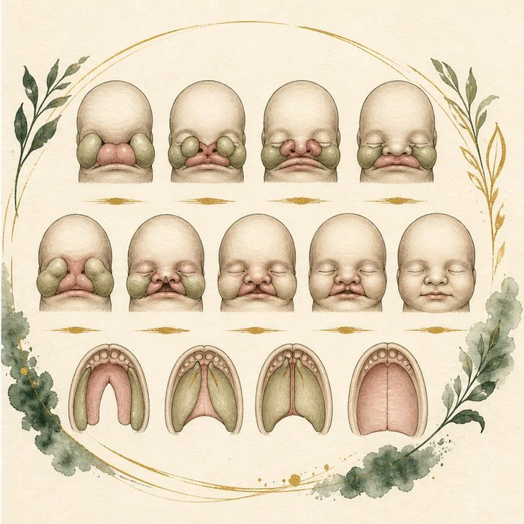
Biomedical teaching illustration: Place lip and palate formation on the human timeline
Analogy step | Biology step | How the relationship stays the same
Foundation phase | Facial prominences form | ________________________________
Support phase | Upper lip structures merge and fuse | ________________________________
Roadway phase | Palatal shelves grow, elevate, and fuse | ________________________________

DEVELOPMENTAL LESSON 1 | CASE FILE AND DECISION
4. Use the case evidence

ID | Finding supplied in the case | Why it matters
DEV01-E1 | The upper lip normally joins during approximately weeks 4 to 7. | Mateo's cleft lip began during an early facial fusion window.
DEV01-E2 | Secondary palate development starts near week 6 and fusion is normally complete by about week 12. | Mateo's cleft palate began during a later, overlapping window.
DEV01-E3 | A newborn cleft is the visible result of an earlier developmental event. | The delivery-room appearance does not give the exact day or cause.

5. Make the clinical decision
You are the developmental biologist at Mateo's case conference. The team asks whether the cleft started during birth, late pregnancy, or early facial development.
A. Place the origin in the early lip and palate formation windows.
B. Place the origin during delivery.
C. Claim one exact day from appearance alone.
Decision. Choose the timeline statement and cite the two evidence cards that set its limits.
________________________________________________________________________________
________________________________________________________________________________
Claim ceiling: You may identify developmental windows. You may not identify an exact day or cause from the cleft pattern alone.
Claim. State the choice you can defend.
________________________________________________________________________________
Evidence. Use these labeled IDs: DEV01-E1 + DEV01-E2.
________________________________________________________________________________
Reasoning. Explain why the evidence supports the claim and stays inside the claim ceiling.
________________________________________________________________________________
________________________________________________________________________________

DEVELOPMENTAL LESSON 1 | REDUCE, REFLECT, AND PREPARE
6. Reduce the lesson to one lasting idea

Take-home. The lip and palate form in short, ordered windows, so timing narrows where a developmental change began.
________________________________________________________________________________
________________________________________________________________________________
1. Which window is earlier, lip closure or completion of palatal fusion?
________________________________________________________________________________
2. Why can the newborn exam not reveal one exact developmental day?
________________________________________________________________________________

Glossary
Term | Plain-English definition
embryo | The developing human from about week 3 to week 8, when most organs and the face first take shape.
craniofacial development | The set of steps in the embryo that shape the skull and face, including how facial swellings grow and fuse into lips, palate, and jaw.
gestational week | A way of counting how far along a pregnancy is, measured in weeks from the start of the mother's last menstrual period.
fusion | When two growing tissue edges meet at the midline and join into one continuous structure, as the lip and palate do during development.
critical window | A lesson term defined by the surrounding model and case evidence.

Next lesson unlock
We answered today's question: Mateo's cleft started in a window between about week 4 and week 12. But if a cleft is a fusion that did not happen, then which exact building blocks of the face were supposed to grow toward each other and fuse? We chase that next time.
The journal links on the lesson page are optional. Everything required for this guided-notes set is already supplied here and in the case file.

