ANATOMICAL DOMAIN | LESSON 20 OF 20 | WHOLE CRANIOFACIAL TEAM (DOMAIN REPORT)

Mateo's Complete Anatomical and Surgical Story
When we assemble Mateo's whole anatomical and surgical picture, what exactly does he have, and how do we know it is that and not something larger?
CARRY FORWARD  Cleft care is a coordinated timeline because each specialty acts when anatomy, function, and development make its decision useful. | 10-YEAR TAKEAWAY  A complete anatomical story can define structures, functions, repairs, and uncertainties while leaving treatment comparisons open to experiment.

Cells differentiate | Development sculpts | Cells move | Development can go wrong

1. Observe the analogy before naming the biology
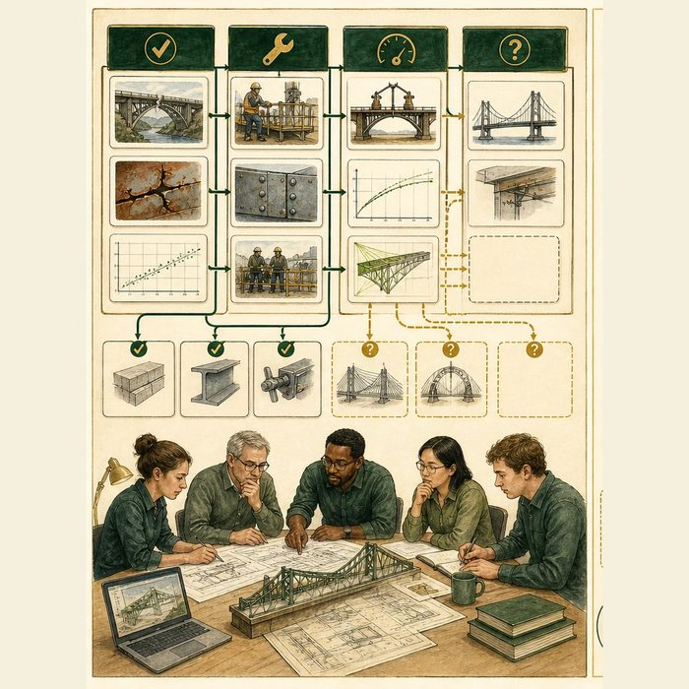
Illustration: A final systems report separates verified faults, completed repairs, and tests still needed
1. Which statements are direct observations?
________________________________________________________________________________
2. Which outcomes were measured after repair?
________________________________________________________________________________
3. Which choices still need comparison data?
________________________________________________________________________________

ANATOMICAL LESSON 20 | RULES AND BIOLOGY MAPPING
2. Turn observations into rules

1. Rule 1: Separate observed anatomy from inferred cause. Explain it in your own words.
________________________________________________________________________________
2. Rule 2: Link each repair to a functional target and measured outcome. Explain it in your own words.
________________________________________________________________________________
3. Rule 3: Name remaining uncertainties as researchable questions. Explain it in your own words.
________________________________________________________________________________
Where the analogy stops: A person's health story includes goals, experience, access, and quality of life beyond a technical report.

3. Map the rules onto the biomedical example
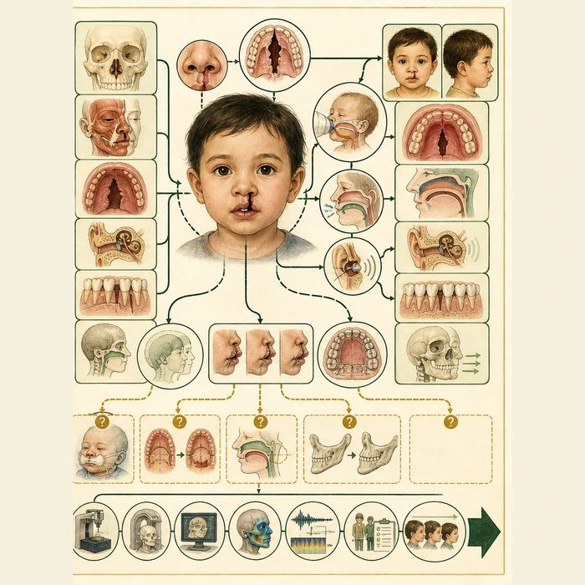
Biomedical teaching illustration: Present Mateo's evidence-bounded anatomical synthesis
Analogy step | Biology step | How the relationship stays the same
Verified fault | Supplied anatomical finding | ________________________________
Repair and performance test | Intervention and measured function | ________________________________
Open comparison | Experimental-design question | ________________________________

ANATOMICAL LESSON 20 | CASE FILE AND DECISION
4. Use the case evidence

ID | Finding supplied in the case | Why it matters
ANA20-E1 | The composite anatomy supports a complete unilateral left cleft lip, alveolus, and palate with a Veau III palate component. | The structural classification is well supported.
ANA20-E2 | No supplied extra-anatomical pattern establishes a syndrome, and Genetics did not provide a patient-specific molecular cause. | The safest summary is isolated-appearing and evidence-bounded.
ANA20-E3 | Several care choices still have competing techniques or uncertain long-term outcomes, including molding, palate protocols, VPI revision, and jaw advancement. | The next domain can turn these uncertainties into testable comparisons.

5. Make the clinical decision
You are the lead craniofacial surgeon at the final case conference. The team must choose between a confident but overclaimed summary and an evidence-bounded report with open research questions.
A. Present the supported anatomy, functional consequences, staged care, and named uncertainties.
B. Claim one gene, one surgical cause, and one best technique without evidence.
C. Avoid any conclusion because some questions remain open.
Decision. Choose the final report and cite classification, claim limit, and one open comparison.
________________________________________________________________________________
________________________________________________________________________________
Claim ceiling: You may synthesize the complete supplied anatomical story. You may not add a syndrome, molecular diagnosis, guaranteed outcome, or universal best operation.
Claim. State the choice you can defend.
________________________________________________________________________________
Evidence. Use these labeled IDs: ANA20-E1 + ANA20-E2.
________________________________________________________________________________
Reasoning. Explain why the evidence supports the claim and stays inside the claim ceiling.
________________________________________________________________________________
________________________________________________________________________________

ANATOMICAL LESSON 20 | REDUCE, REFLECT, AND PREPARE
6. Reduce the lesson to one lasting idea

Take-home. A complete anatomical story can define structures, functions, repairs, and uncertainties while leaving treatment comparisons open to experiment.
________________________________________________________________________________
________________________________________________________________________________
1. What anatomical label is supported?
________________________________________________________________________________
2. Which uncertainty should become an experiment?
________________________________________________________________________________

Glossary
Term | Plain-English definition
isolated cleft | A cleft of the lip or palate that occurs on its own, without other birth differences or a recognized syndrome.
nonsyndromic | Describing a condition, such as a cleft, that occurs on its own without a set of other linked birth differences.
Veau III | A cleft classification for a complete one-sided cleft running through the lip, gum, and both the hard and soft palate.
form-repair-consequence | A way of thinking through cleft cases by asking how the structure formed, how it is repaired, and what long-term effects follow.
domain synthesis | Pulling findings from many separate areas of knowledge together into one coherent picture or argument.

Next lesson unlock
The anatomical and surgical team has finished its report. But isolated and nonsyndromic is the anatomy's verdict, not the whole answer. The clinical team can describe the lifelong care, the genetics team can ask why the cleft formed at all, and the developmental team can show the moment fusion failed. We hand them our complete form-repair-consequence picture, and every team's story points to the same conclusion.
The journal links on the lesson page are optional. Everything required for this guided-notes set is already supplied here and in the case file.

