ANATOMICAL DOMAIN | LESSON 19 OF 20 | LEAD CRANIOFACIAL SURGEON (TEAM COORDINATOR)

Who Does What, and When: Mateo's Care Timeline
When does each specialist act for a child like Mateo, and why is each step timed to a specific age?
CARRY FORWARD  A fistula is a tissue opening, while velopharyngeal insufficiency is a moving-valve problem; each needs different evidence and treatment planning. | 10-YEAR TAKEAWAY  Cleft care is a coordinated timeline because each specialty acts when anatomy, function, and development make its decision useful.

Cells differentiate | Development sculpts | Cells move | Development can go wrong

1. Observe the analogy before naming the biology
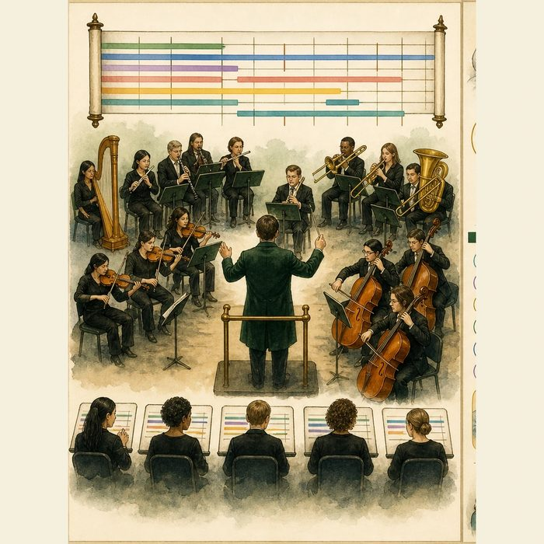
Illustration: An orchestra follows one score, but different sections enter at different times
1. Why do all sections need the same score?
________________________________________________________________________________
2. What happens if one section enters too early?
________________________________________________________________________________
3. Which signals tell a section when to act?
________________________________________________________________________________

ANATOMICAL LESSON 19 | RULES AND BIOLOGY MAPPING
2. Turn observations into rules

1. Rule 1: Coordinate around the patient's developmental stage. Explain it in your own words.
________________________________________________________________________________
2. Rule 2: Assign each decision to the right discipline. Explain it in your own words.
________________________________________________________________________________
3. Rule 3: Keep surveillance running between procedures. Explain it in your own words.
________________________________________________________________________________
Where the analogy stops: Cleft care is shared decision-making with a patient and family, not a performance controlled by one conductor.

3. Map the rules onto the biomedical example
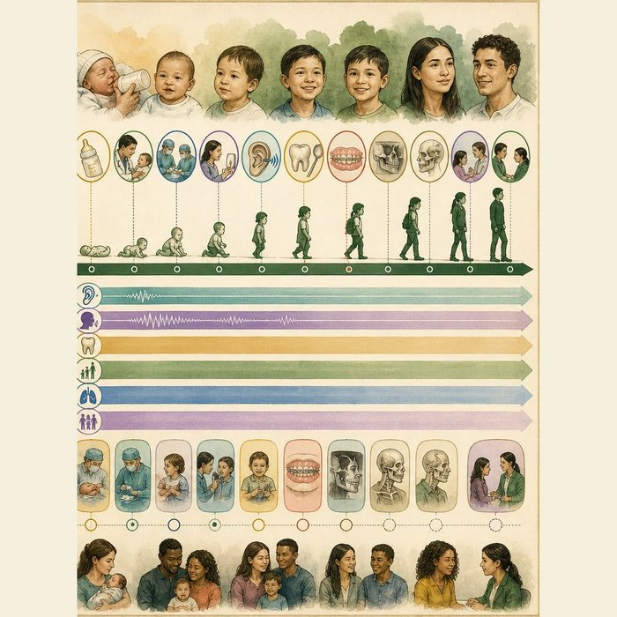
Biomedical teaching illustration: Build Mateo's coordinated care timeline
Analogy step | Biology step | How the relationship stays the same
Shared score | Interdisciplinary care plan | ________________________________
Section entrance | Age and development-linked specialty action | ________________________________
Ongoing rhythm | Longitudinal hearing, speech, dental, growth, and psychosocial surveillance | ________________________________

ANATOMICAL LESSON 19 | CASE FILE AND DECISION
4. Use the case evidence

ID | Finding supplied in the case | Why it matters
ANA19-E1 | Mateo needs feeding and hearing support in infancy before definitive dental or jaw procedures. | Some needs are immediate while others depend on later development.
ANA19-E2 | Lip and palate repair, speech review, grafting, orthodontics, jaw, and nasal decisions have different developmental triggers. | Sequence prevents conflicting or premature care.
ANA19-E3 | ACPA recommends interdisciplinary coordination, family participation, and long-term outcome monitoring. | The team plan must remain shared and revisable.

5. Make the clinical decision
You are the cleft-team care coordinator. A new family receives six separate specialty plans with conflicting dates and no owner for surveillance.
A. Create one shared timeline with responsible roles, triggers, and follow-up measures.
B. Let every specialty schedule independently.
C. List surgeries only and omit hearing, speech, dental, and family support.
Decision. Choose the coordination plan and place five supplied milestones in order.
________________________________________________________________________________
________________________________________________________________________________
Claim ceiling: You may build the composite educational timeline. You may not imply that every patient needs every procedure.
Claim. State the choice you can defend.
________________________________________________________________________________
Evidence. Use these labeled IDs: ANA19-E1 + ANA19-E2.
________________________________________________________________________________
Reasoning. Explain why the evidence supports the claim and stays inside the claim ceiling.
________________________________________________________________________________
________________________________________________________________________________

ANATOMICAL LESSON 19 | REDUCE, REFLECT, AND PREPARE
6. Reduce the lesson to one lasting idea

Take-home. Cleft care is a coordinated timeline because each specialty acts when anatomy, function, and development make its decision useful.
________________________________________________________________________________
________________________________________________________________________________
1. Why is one shared timeline safer than separate specialty calendars?
________________________________________________________________________________
2. Which needs require surveillance between surgeries?
________________________________________________________________________________

Glossary
Term | Plain-English definition
multidisciplinary team | A lesson term defined by the surrounding model and case evidence.
staged care | A treatment plan delivered in planned steps across years, matching each procedure to the right point in a child's growth.
mixed dentition | The childhood stage when baby teeth and permanent teeth are present in the mouth at the same time.
skeletal maturity | How fully the bones have grown and hardened, used to decide when jaw growth is finished enough for certain surgeries.
surveillance | The ongoing, systematic collection and analysis of health data to detect disease early, track its trends, and trigger a timely public health response.

Next lesson unlock
We can now lay every step out in order. But putting them in order means we have assembled the entire anatomical and surgical picture, from the first finding at birth to the last revision in the teens, and we have never once been handed a diagnosis. What is Mateo's complete anatomical and surgical story, told as one piece, and what does the whole picture finally tell us about what he has? We answer that next time.
The journal links on the lesson page are optional. Everything required for this guided-notes set is already supplied here and in the case file.

