ANATOMICAL DOMAIN | LESSON 18 OF 20 | CRANIOFACIAL SURGEON (SECONDARY-SURGERY SEAT)

When a Repair Falls Short: Fistula and VPI Revision
What are the two main ways a palate repair falls short, and how does the surgeon fix each one?
CARRY FORWARD  A unilateral cleft can distort nasal cartilage, base, and septum, so nose care addresses breathing and symmetry across growth. | 10-YEAR TAKEAWAY  A fistula is a tissue opening, while velopharyngeal insufficiency is a moving-valve problem; each needs different evidence and treatment planning.

Cells differentiate | Development sculpts | Cells move | Development can go wrong

1. Observe the analogy before naming the biology
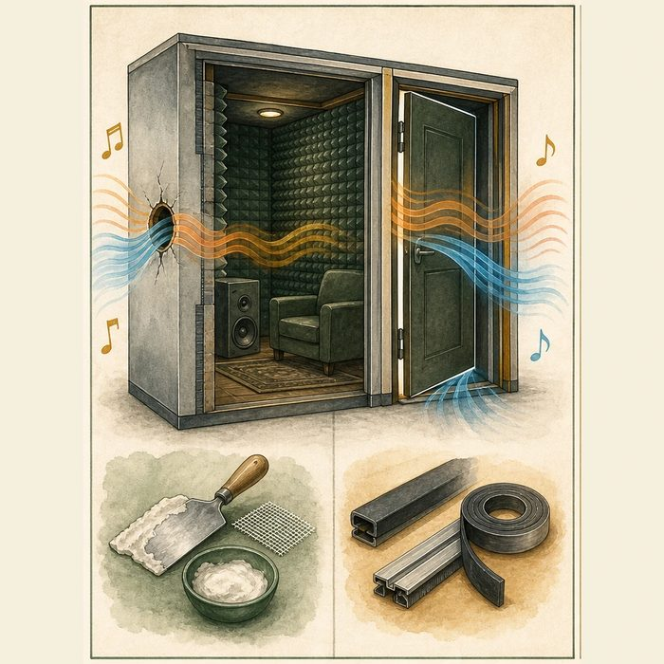
Illustration: A room can leak through a hole or through a door that does not close
1. Which leak is visible when nothing moves?
________________________________________________________________________________
2. Which leak appears only during door action?
________________________________________________________________________________
3. Why would patching the wrong site fail?
________________________________________________________________________________

ANATOMICAL LESSON 18 | RULES AND BIOLOGY MAPPING
2. Turn observations into rules

1. Rule 1: Distinguish a static opening from dynamic closure failure. Explain it in your own words.
________________________________________________________________________________
2. Rule 2: Measure symptoms and function before revision. Explain it in your own words.
________________________________________________________________________________
3. Rule 3: Balance speech improvement against added scar and airway risk. Explain it in your own words.
________________________________________________________________________________
Where the analogy stops: Speech and swallowing involve coordinated living tissues, not a soundproof room.

3. Map the rules onto the biomedical example
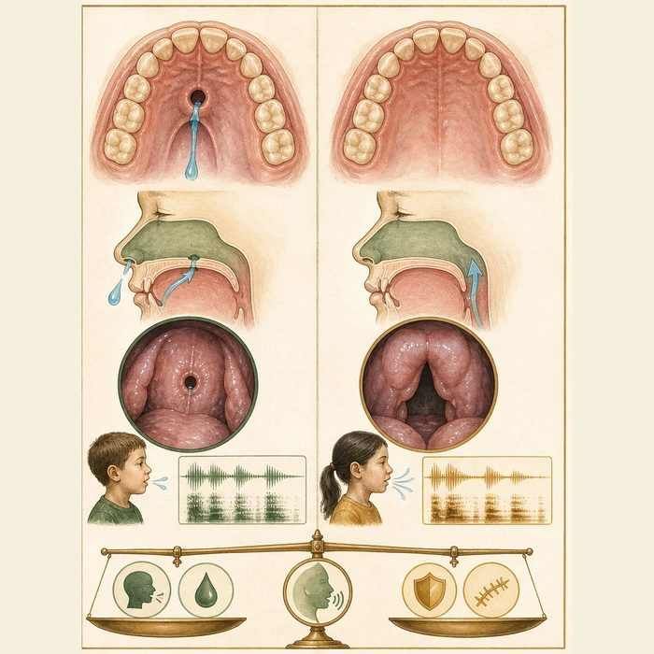
Biomedical teaching illustration: Differentiate fistula from VPI in two postoperative files
Analogy step | Biology step | How the relationship stays the same
Wall hole | Palatal fistula | ________________________________
Leaky door | Velopharyngeal insufficiency | ________________________________
Sound and airflow test | Speech assessment and imaging or endoscopy | ________________________________

ANATOMICAL LESSON 18 | CASE FILE AND DECISION
4. Use the case evidence

ID | Finding supplied in the case | Why it matters
ANA18-E1 | Case A has a visible opening in the repaired hard palate and liquid escape through the nose. | This supports a symptomatic fistula.
ANA18-E2 | Case B has no palatal hole but consistent hypernasality and a gap during speech endoscopy. | This supports velopharyngeal insufficiency.
ANA18-E3 | Secondary surgery can add scar and affect airway; speech surgery does not erase learned compensatory articulation. | Revision must be individualized and may still require speech therapy.

5. Make the clinical decision
You are triaging two postoperative referrals. One student wants to give the same patch procedure to both case files.
A. Separate fistula closure planning from VPI evaluation and airway-aware speech planning.
B. Use the same repair because both involve nasal escape.
C. Treat structural VPI with blowing exercises alone.
Decision. Choose the correct triage and cite one differentiating finding per case.
________________________________________________________________________________
________________________________________________________________________________
Claim ceiling: You may distinguish the supplied mechanisms and next evaluations. You may not select a real revision procedure.
Claim. State the choice you can defend.
________________________________________________________________________________
Evidence. Use these labeled IDs: ANA18-E1 + ANA18-E2.
________________________________________________________________________________
Reasoning. Explain why the evidence supports the claim and stays inside the claim ceiling.
________________________________________________________________________________
________________________________________________________________________________

ANATOMICAL LESSON 18 | REDUCE, REFLECT, AND PREPARE
6. Reduce the lesson to one lasting idea

Take-home. A fistula is a tissue opening, while velopharyngeal insufficiency is a moving-valve problem; each needs different evidence and treatment planning.
________________________________________________________________________________
________________________________________________________________________________
1. Which finding supports a fistula?
________________________________________________________________________________
2. Why can speech therapy not close a structural VPI gap?
________________________________________________________________________________

Glossary
Term | Plain-English definition
palatal fistula | A small hole that reopens in the roof of the mouth after cleft palate repair, sometimes letting food or air leak into the nose.
velopharyngeal insufficiency (VPI) | When the soft palate cannot fully close off the nose from the mouth during speech, letting air escape and making speech sound nasal.
pharyngeal flap | A surgery that builds a tissue bridge at the back of the throat to reduce air escaping through the nose during speech.
sphincter pharyngoplasty | A surgery that narrows the opening between the throat and nose so the palate can close it during speech, reducing nasal air leak.
hypernasal speech | Speech that sounds overly nasal because air leaks into the nose when the soft palate cannot fully close off the mouth from the nasal passage.

Next lesson unlock
We answered what goes wrong after repair and how it is fixed. But Mateo has now seen the surgeon, the orthodontist, the speech-language pathologist, the ENT, and more, across many years. Who does what, and when, across his whole childhood, so nothing is missed and nothing is repeated? We chase that next time.
The journal links on the lesson page are optional. Everything required for this guided-notes set is already supplied here and in the case file.

