ANATOMICAL DOMAIN | LESSON 17 OF 20 | CRANIOFACIAL SURGEON (RHINOPLASTY SEAT)

The Cleft Nose and Its Repair
How does a unilateral cleft distort the nose, on the outside and on the inside, and when do we do the definitive repair?
CARRY FORWARD  Severe maxillary retrusion may require moving the upper jaw, but the choice between methods depends on severity, growth, stability, burden, airway, and speech. | 10-YEAR TAKEAWAY  A unilateral cleft can distort nasal cartilage, base, and septum, so nose care addresses breathing and symmetry across growth.

Cells differentiate | Development sculpts | Cells move | Development can go wrong

1. Observe the analogy before naming the biology
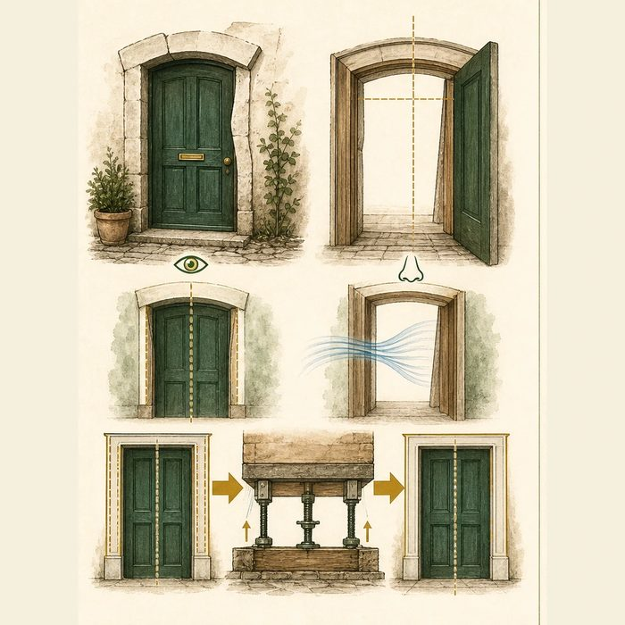
Illustration: A doorway can look uneven and also narrow the path through it
1. Which problem changes appearance?
________________________________________________________________________________
2. Which problem limits passage?
________________________________________________________________________________
3. Why might changing the wall below alter the doorway above?
________________________________________________________________________________

ANATOMICAL LESSON 17 | RULES AND BIOLOGY MAPPING
2. Turn observations into rules

1. Rule 1: Assess external form and internal airway separately. Explain it in your own words.
________________________________________________________________________________
2. Rule 2: Coordinate nasal and jaw sequence. Explain it in your own words.
________________________________________________________________________________
3. Rule 3: Reserve definitive reshaping until growth and major jaw movement are settled. Explain it in your own words.
________________________________________________________________________________
Where the analogy stops: Nasal airflow and cartilage mechanics are more complex than a rigid doorway.

3. Map the rules onto the biomedical example
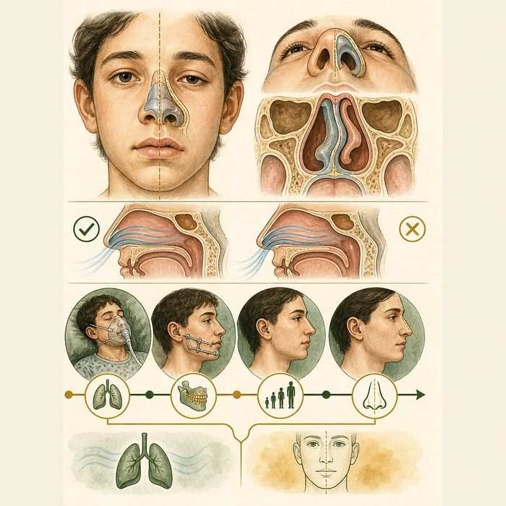
Biomedical teaching illustration: Map the cleft nose inside and out
Analogy step | Biology step | How the relationship stays the same
Uneven frame | Alar and nasal-base asymmetry | ________________________________
Narrow passage | Septal deviation and airway obstruction | ________________________________
Moving wall below | Orthognathic change before definitive rhinoplasty | ________________________________

ANATOMICAL LESSON 17 | CASE FILE AND DECISION
4. Use the case evidence

ID | Finding supplied in the case | Why it matters
ANA17-E1 | Mateo's left alar base is displaced and the nostrils are asymmetric. | The unilateral cleft affects external nasal form.
ANA17-E2 | The supplied nasal examination shows septal deviation and greater resistance on one side. | The case includes a breathing concern, not appearance alone.
ANA17-E3 | ACPA recommends waiting until skeletal maturity for definitive septorhinoplasty and usually completing indicated orthognathic surgery first. | Growth and jaw sequence can change the final nasal plan.

5. Make the clinical decision
You are the adolescent cleft-nose team lead. Mateo requests definitive nasal surgery but is also scheduled for maxillary advancement next year.
A. Treat urgent airway needs as indicated and plan definitive septorhinoplasty after jaw surgery and skeletal maturity.
B. Complete definitive nasal reshaping first without coordinating jaw movement.
C. Discuss appearance only and ignore breathing.
Decision. Choose the sequence and cite airway plus timing evidence.
________________________________________________________________________________
________________________________________________________________________________
Claim ceiling: You may explain the educational sequence. You may not decide a real patient's nasal procedure or timing.
Claim. State the choice you can defend.
________________________________________________________________________________
Evidence. Use these labeled IDs: ANA17-E1 + ANA17-E2.
________________________________________________________________________________
Reasoning. Explain why the evidence supports the claim and stays inside the claim ceiling.
________________________________________________________________________________
________________________________________________________________________________

ANATOMICAL LESSON 17 | REDUCE, REFLECT, AND PREPARE
6. Reduce the lesson to one lasting idea

Take-home. A unilateral cleft can distort nasal cartilage, base, and septum, so nose care addresses breathing and symmetry across growth.
________________________________________________________________________________
________________________________________________________________________________
1. Which internal structure can narrow airflow?
________________________________________________________________________________
2. Why does definitive nasal surgery often follow jaw surgery?
________________________________________________________________________________

Glossary
Term | Plain-English definition
cleft nasal deformity | The change in nose shape that comes with a cleft lip, including a flattened, widened nostril and a leaning nasal tip on the cleft side.
nasal septum | The wall of cartilage and bone running down the middle of the nose that separates it into left and right airways.
septal deviation | A bending or shift of the nasal septum away from the midline, which can narrow one airway and affect breathing.
columella | The thin strip of tissue between the two nostrils that connects the nasal tip to the upper lip and helps hold the nose's shape.
septorhinoplasty | Surgery that reshapes the nose and straightens the inner wall (septum) between the nostrils to improve appearance and breathing.

Next lesson unlock
We have now repaired lip, palate, bite, and nose. But some repairs do not fully hold. A hole can reopen in the roof of the mouth, and even a closed palate can let air leak into the nose during speech. What goes wrong after repair, and how is it fixed? We chase that next time.
The journal links on the lesson page are optional. Everything required for this guided-notes set is already supplied here and in the case file.

