ANATOMICAL DOMAIN | LESSON 16 OF 20 | CRANIOFACIAL SURGEON (ORTHOGNATHIC SEAT)

Correcting the Bite and the Midface
How do we correct a retruded cleft midface and an underbite once a child has nearly finished growing?
CARRY FORWARD  Cleft-related midface undergrowth can reflect both underlying anatomy and treatment history, so scar alone should not be treated as a proven single cause. | 10-YEAR TAKEAWAY  Severe maxillary retrusion may require moving the upper jaw, but the choice between methods depends on severity, growth, stability, burden, airway, and speech.

Cells differentiate | Development sculpts | Cells move | Development can go wrong

1. Observe the analogy before naming the biology
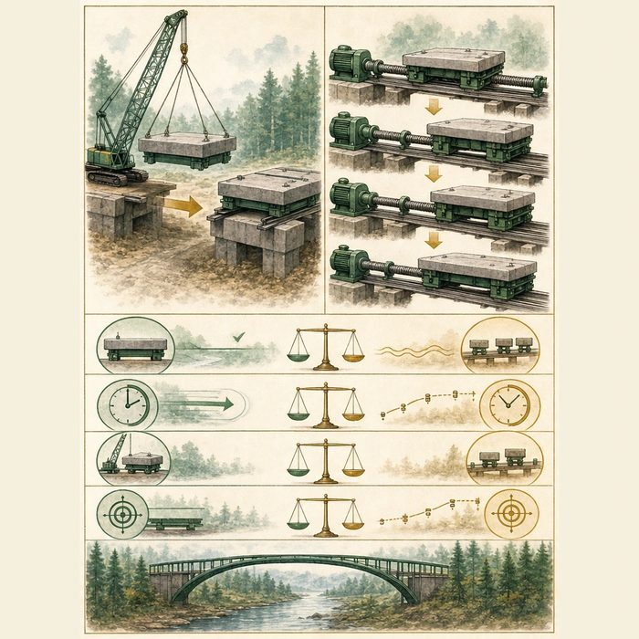
Illustration: Reposition a heavy platform in one move or advance it in small steps
1. Which method completes movement at once?
________________________________________________________________________________
2. Which method spreads change over time?
________________________________________________________________________________
3. What tradeoffs must be compared besides distance?
________________________________________________________________________________

ANATOMICAL LESSON 16 | RULES AND BIOLOGY MAPPING
2. Turn observations into rules

1. Rule 1: Match method to severity and growth status. Explain it in your own words.
________________________________________________________________________________
2. Rule 2: Compare stability and patient burden. Explain it in your own words.
________________________________________________________________________________
3. Rule 3: Recheck airway and velopharyngeal speech before and after movement. Explain it in your own words.
________________________________________________________________________________
Where the analogy stops: Jaw surgery changes living bone and soft tissue and requires individualized planning, not generic platform mechanics.

3. Map the rules onto the biomedical example
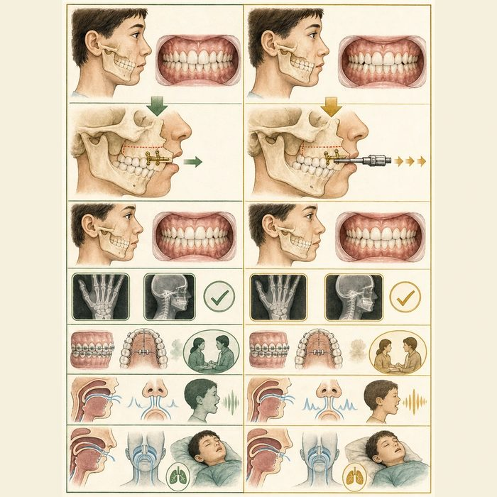
Biomedical teaching illustration: Compare Le Fort I advancement with distraction
Analogy step | Biology step | How the relationship stays the same
Single crane move | Conventional Le Fort I advancement | ________________________________
Small repeated steps | Distraction osteogenesis | ________________________________
Platform alignment | Occlusion and midface position | ________________________________

ANATOMICAL LESSON 16 | CASE FILE AND DECISION
4. Use the case evidence

ID | Finding supplied in the case | Why it matters
ANA16-E1 | Mateo's adolescent records show a significant anterior crossbite and maxillary retrusion not corrected by orthodontics alone. | A skeletal correction is a reasonable team discussion.
ANA16-E2 | He is near skeletal maturity in the composite scenario. | Definitive jaw positioning can be considered after growth assessment.
ANA16-E3 | Advancing the maxilla can change velopharyngeal relationships and hypernasality risk; comparative evidence does not establish one best method for every cleft patient. | Speech, airway, stability, and burden belong in method selection.

5. Make the clinical decision
You are the craniofacial surgery conference chair. Mateo needs a 7 mm maxillary advancement, has stable airway testing, and has a history of repaired VPI that is currently controlled.
A. Compare conventional advancement and distraction with orthodontic, speech, and airway input.
B. Choose a method from distance alone and skip speech assessment.
C. Perform definitive surgery before checking growth status.
Decision. Choose the conference process and cite skeletal plus speech-risk evidence.
________________________________________________________________________________
________________________________________________________________________________
Claim ceiling: You may identify decision variables. You may not select a real operation without full imaging, examination, and shared decision-making.
Claim. State the choice you can defend.
________________________________________________________________________________
Evidence. Use these labeled IDs: ANA16-E1 + ANA16-E2.
________________________________________________________________________________
Reasoning. Explain why the evidence supports the claim and stays inside the claim ceiling.
________________________________________________________________________________
________________________________________________________________________________

ANATOMICAL LESSON 16 | REDUCE, REFLECT, AND PREPARE
6. Reduce the lesson to one lasting idea

Take-home. Severe maxillary retrusion may require moving the upper jaw, but the choice between methods depends on severity, growth, stability, burden, airway, and speech.
________________________________________________________________________________
________________________________________________________________________________
1. How does distraction differ from conventional advancement?
________________________________________________________________________________
2. Why should speech be checked before jaw surgery?
________________________________________________________________________________

Glossary
Term | Plain-English definition
orthognathic surgery | Surgery that repositions the upper or lower jaw bones to correct alignment of the bite and the face.
Le Fort I osteotomy | A surgery that cuts the upper jaw horizontally above the teeth so it can be moved into a better position and fixed in place.
distraction osteogenesis | A surgical technique that slowly pulls two cut bone ends apart a little each day so new bone grows to fill the widening gap.
Class III malocclusion | A bite where the lower teeth and jaw sit too far forward of the upper teeth, often seen when the midface is underdeveloped.
skeletal maturity | How fully the bones have grown and hardened, used to decide when jaw growth is finished enough for certain surgeries.

Next lesson unlock
We answered how the bite and midface are corrected. But the nose sits on that midface, and even after the jaw moves forward, Mateo's nose is still asymmetric and partly blocked. How is the cleft nose itself affected, and how is it repaired? We chase that next time.
The journal links on the lesson page are optional. Everything required for this guided-notes set is already supplied here and in the case file.

