ANATOMICAL DOMAIN | LESSON 15 OF 20 | ORTHODONTIST (GROWTH AND OCCLUSION SEAT)

Why the Repaired Midface Grows Backward
Why does a repaired cleft maxilla grow poorly forward, and what does that do to the shape of Mateo's face and the way his teeth meet?
CARRY FORWARD  Alveolar graft timing follows dental development, usually before the adjacent permanent canine erupts, so living bone can support tooth movement. | 10-YEAR TAKEAWAY  Cleft-related midface undergrowth can reflect both underlying anatomy and treatment history, so scar alone should not be treated as a proven single cause.

Cells differentiate | Development sculpts | Cells move | Development can go wrong

1. Observe the analogy before naming the biology
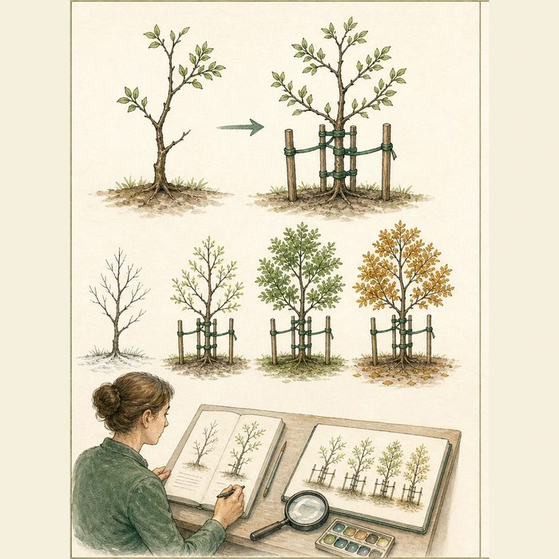
Illustration: A young tree's shape reflects both its starting form and the ties placed around it
1. Which feature existed before the ties?
________________________________________________________________________________
2. How could the ties change later direction?
________________________________________________________________________________
3. What comparison would separate the two influences?
________________________________________________________________________________

ANATOMICAL LESSON 15 | RULES AND BIOLOGY MAPPING
2. Turn observations into rules

1. Rule 1: Separate baseline anatomy from treatment exposure. Explain it in your own words.
________________________________________________________________________________
2. Rule 2: Measure growth over time. Explain it in your own words.
________________________________________________________________________________
3. Rule 3: Use cautious language when evidence cannot isolate one cause. Explain it in your own words.
________________________________________________________________________________
Where the analogy stops: Facial growth involves sutures, bone remodeling, muscles, teeth, and treatment, not plant growth.

3. Map the rules onto the biomedical example
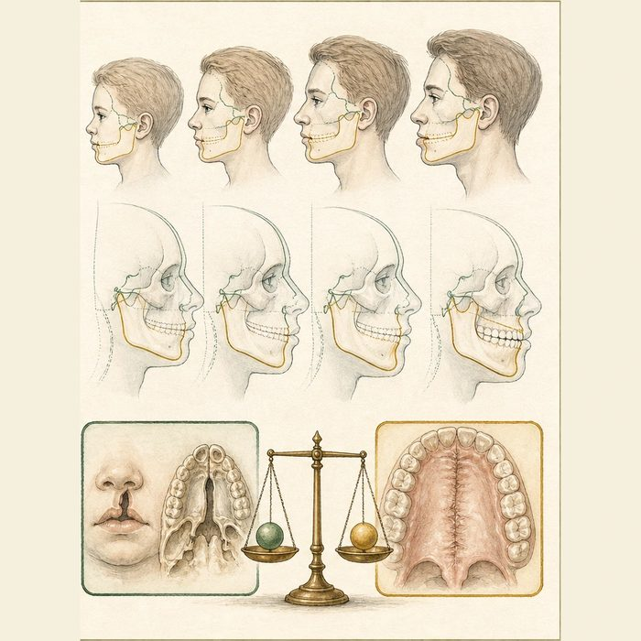
Biomedical teaching illustration: Interpret Mateo's developing Class III relationship
Analogy step | Biology step | How the relationship stays the same
Starting branch pattern | Intrinsic cleft-related growth pattern | ________________________________
Support ties | Surgical scar and treatment history | ________________________________
Serial photographs | Longitudinal cephalometric growth records | ________________________________

ANATOMICAL LESSON 15 | CASE FILE AND DECISION
4. Use the case evidence

ID | Finding supplied in the case | Why it matters
ANA15-E1 | Mateo's serial records show the maxilla falling behind the mandible during growth. | The result is midface flattening and anterior crossbite.
ANA15-E2 | Cleft anatomy and primary surgery both precede the later growth pattern. | More than one plausible contributor is present.
ANA15-E3 | Systematic reviews find conflicting or limited evidence that one palate-repair technique determines facial growth. | Scar effects should be discussed without claiming one proven single pathway.

5. Make the clinical decision
You are presenting Mateo's growth conference. A teammate says the palate scar alone definitely caused every millimeter of maxillary retrusion.
A. Report the observed growth pattern and identify both intrinsic and treatment-related contributors.
B. Assign all growth change to scar without comparison evidence.
C. Deny that treatment could influence growth.
Decision. Choose the interpretation and cite longitudinal plus evidence-limit cards.
________________________________________________________________________________
________________________________________________________________________________
Claim ceiling: You may describe association and plausible contributors. You may not assign a single cause from this composite record.
Claim. State the choice you can defend.
________________________________________________________________________________
Evidence. Use these labeled IDs: ANA15-E1 + ANA15-E2.
________________________________________________________________________________
Reasoning. Explain why the evidence supports the claim and stays inside the claim ceiling.
________________________________________________________________________________
________________________________________________________________________________

ANATOMICAL LESSON 15 | REDUCE, REFLECT, AND PREPARE
6. Reduce the lesson to one lasting idea

Take-home. Cleft-related midface undergrowth can reflect both underlying anatomy and treatment history, so scar alone should not be treated as a proven single cause.
________________________________________________________________________________
________________________________________________________________________________
1. What bite pattern can maxillary retrusion create?
________________________________________________________________________________
2. Why is scar alone an overclaim?
________________________________________________________________________________

Glossary
Term | Plain-English definition
maxilla | The paired upper jaw bone that forms the front of the hard palate, holds the upper teeth, and shapes the middle of the face.
maxillary hypoplasia | Underdevelopment of the upper jaw, leaving the midface small or set back, a frequent late issue after cleft repair.
midface retrusion | A backward position of the middle of the face relative to the forehead and lower jaw, often following cleft palate repair.
Class III malocclusion | A bite where the lower teeth and jaw sit too far forward of the upper teeth, often seen when the midface is underdeveloped.
palatal scar | Scar tissue left on the roof of the mouth after cleft palate surgery, which can restrict upper-jaw growth over time.

Next lesson unlock
We found out why Mateo's midface grows backward and ends up flat, leaving an underbite as a teenager. We can name the problem, but we have not fixed it: the lip, palate, and gum graft are all done, yet his upper jaw still sits too far back. How do we correct the bite and midface later? We chase that next time.
The journal links on the lesson page are optional. Everything required for this guided-notes set is already supplied here and in the case file.

