ANATOMICAL DOMAIN | LESSON 14 OF 20 | ORAL SURGEON (ALVEOLAR BONE GRAFT SEAT)

Filling the Bony Gap in the Gum Ridge
How and when do we fill the bony gap in Mateo's gum ridge so a tooth has a home, and what does the timing have to do with success?
CARRY FORWARD  An alveolar cleft interrupts bone where teeth develop, so tooth position, shape, number, and eruption must be followed over time. | 10-YEAR TAKEAWAY  Alveolar graft timing follows dental development, usually before the adjacent permanent canine erupts, so living bone can support tooth movement.

Cells differentiate | Development sculpts | Cells move | Development can go wrong

1. Observe the analogy before naming the biology
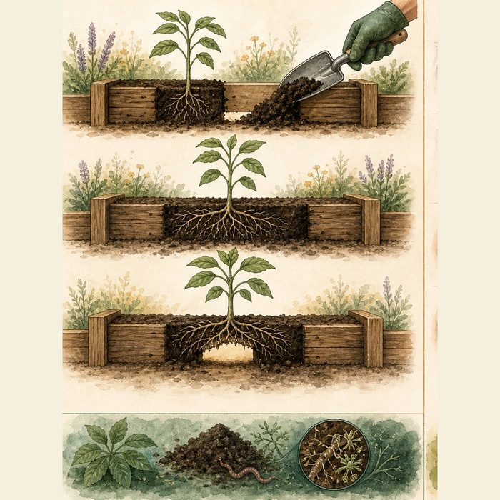
Illustration: Build a soil bridge before roots need to cross it
1. Why must the bridge exist before the roots arrive?
________________________________________________________________________________
2. What evidence shows the plant is ready?
________________________________________________________________________________
3. Why is a calendar age only an estimate?
________________________________________________________________________________

ANATOMICAL LESSON 14 | RULES AND BIOLOGY MAPPING
2. Turn observations into rules

1. Rule 1: Use developmental stage as the trigger. Explain it in your own words.
________________________________________________________________________________
2. Rule 2: Provide living bone continuity before tooth movement. Explain it in your own words.
________________________________________________________________________________
3. Rule 3: Coordinate orthodontics, surgery, and oral hygiene. Explain it in your own words.
________________________________________________________________________________
Where the analogy stops: Bone graft incorporation and tooth eruption are biological processes more complex than roots crossing soil.

3. Map the rules onto the biomedical example
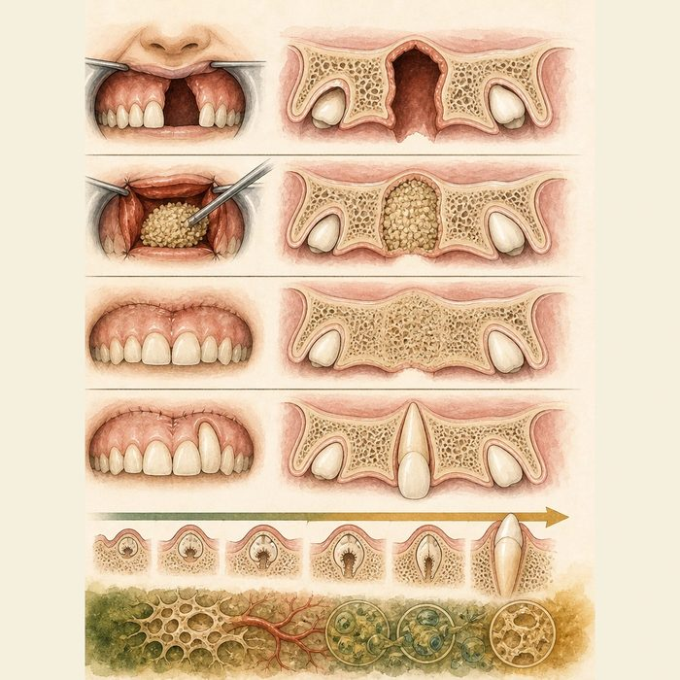
Biomedical teaching illustration: Choose the graft window from dental evidence
Analogy step | Biology step | How the relationship stays the same
Soil bridge | Alveolar bone graft | ________________________________
Young roots | Developing canine root | ________________________________
Garden preparation | Orthodontic alignment and oral hygiene | ________________________________

ANATOMICAL LESSON 14 | CASE FILE AND DECISION
4. Use the case evidence

ID | Finding supplied in the case | Why it matters
ANA14-E1 | Mateo's alveolar cleft remains open after primary lip and palate repair. | The upper jaw segments need bony continuity if teeth will move through the site.
ANA14-E2 | His adjacent canine has not erupted and its root is developing on the supplied image. | The dental stage supports pre-eruption planning.
ANA14-E3 | ACPA states that graft timing should be based on dental development with orthodontist input, commonly before permanent teeth in the cleft region erupt. | A fixed age cutoff is less accurate than tooth stage.

5. Make the clinical decision
You are the orthodontist-surgeon conference lead. Mateo is eight, has completed pre-graft expansion, has good oral hygiene, and the adjacent canine is unerupted with developing root.
A. Advance to team evaluation for secondary alveolar bone grafting now.
B. Wait until after the canine fully erupts because age alone controls timing.
C. Graft without orthodontic or dental coordination.
Decision. Choose the planning decision and cite dental stage plus preparation evidence.
________________________________________________________________________________
________________________________________________________________________________
Claim ceiling: You may choose the educational planning window. You may not schedule or select a donor site for a real patient.
Claim. State the choice you can defend.
________________________________________________________________________________
Evidence. Use these labeled IDs: ANA14-E1 + ANA14-E2.
________________________________________________________________________________
Reasoning. Explain why the evidence supports the claim and stays inside the claim ceiling.
________________________________________________________________________________
________________________________________________________________________________

ANATOMICAL LESSON 14 | REDUCE, REFLECT, AND PREPARE
6. Reduce the lesson to one lasting idea

Take-home. Alveolar graft timing follows dental development, usually before the adjacent permanent canine erupts, so living bone can support tooth movement.
________________________________________________________________________________
________________________________________________________________________________
1. Which developmental event usually guides graft timing?
________________________________________________________________________________
2. Why must orthodontics and surgery coordinate?
________________________________________________________________________________

Glossary
Term | Plain-English definition
alveolar bone graft (ABG) | A surgery that fills the bony gap in the upper gum of a cleft patient with transplanted bone, usually before the adult canine teeth erupt.
iliac crest | The curved upper rim of the hip bone, a common spot for surgeons to harvest bone for grafts such as alveolar repair.
cancellous bone | The light, spongy inner bone made of a honeycomb mesh of struts that holds marrow and gives strength without heavy weight.
mixed dentition | The childhood stage when baby teeth and permanent teeth are present in the mouth at the same time.
canine eruption | The moment a permanent canine tooth breaks through the gum into the mouth, a milestone surgeons time bone grafts around in cleft care.
graft success | When transplanted tissue, such as a bone graft into a cleft, takes hold, gets blood supply, and heals into the surrounding tissue.

Next lesson unlock
We rebuilt the bone of Mateo's gum ridge and gave his canine a home. But the graft reminded us of something bigger: its timing did not change whether he might need later jaw surgery, because the whole upper jaw it sits on has been growing poorly all along. How does a repaired cleft change facial growth, and what does that do to his bite? We chase that next time.
The journal links on the lesson page are optional. Everything required for this guided-notes set is already supplied here and in the case file.

