ANATOMICAL DOMAIN | LESSON 13 OF 20 | ORTHODONTIST

The Cleft Runs Through the Teeth
When a cleft cuts through the gum ridge, which teeth go missing or grow wrong, and can we predict it from how big the cleft is?
CARRY FORWARD  Cleft-palate muscle anatomy can impair Eustachian tube opening, so hearing needs repeated surveillance even after a normal newborn screen. | 10-YEAR TAKEAWAY  An alveolar cleft interrupts bone where teeth develop, so tooth position, shape, number, and eruption must be followed over time.

Cells differentiate | Development sculpts | Cells move | Development can go wrong

1. Observe the analogy before naming the biology
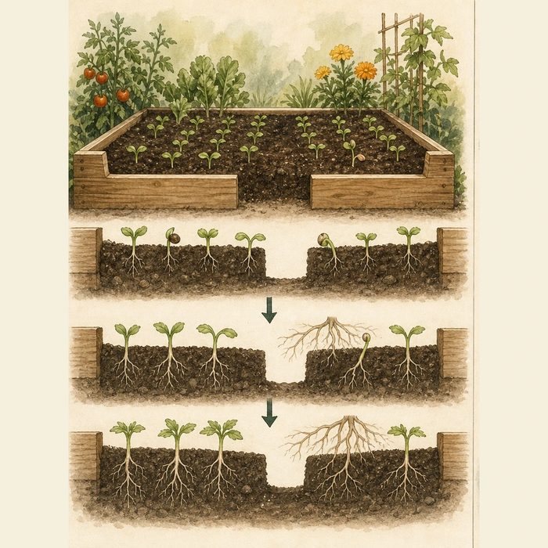
Illustration: A missing section of garden bed changes where plants can root and emerge
1. Which seeds sit closest to the missing soil?
________________________________________________________________________________
2. How could the gap change position as well as number?
________________________________________________________________________________
3. Why must the gardener wait to see how growth unfolds?
________________________________________________________________________________

ANATOMICAL LESSON 13 | RULES AND BIOLOGY MAPPING
2. Turn observations into rules

1. Rule 1: Locate teeth relative to the cleft. Explain it in your own words.
________________________________________________________________________________
2. Rule 2: Track development and eruption over time. Explain it in your own words.
________________________________________________________________________________
3. Rule 3: Do not predict one tooth outcome from cleft width alone. Explain it in your own words.
________________________________________________________________________________
Where the analogy stops: Teeth form through specialized developmental tissues and are not plants in soil.

3. Map the rules onto the biomedical example
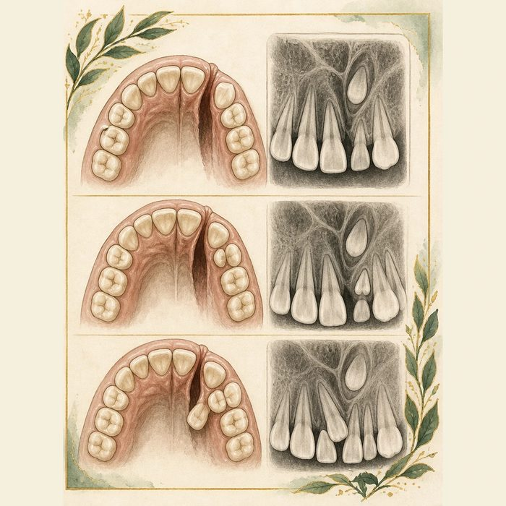
Biomedical teaching illustration: Map teeth beside Mateo's alveolar cleft
Analogy step | Biology step | How the relationship stays the same
Bed gap | Alveolar bone cleft | ________________________________
Nearest seed | Maxillary lateral incisor | ________________________________
Later emergence | Permanent canine eruption | ________________________________

ANATOMICAL LESSON 13 | CASE FILE AND DECISION
4. Use the case evidence

ID | Finding supplied in the case | Why it matters
ANA13-E1 | Mateo's cleft crosses the left alveolar ridge between anterior tooth regions. | Bone continuity is absent where teeth need support.
ANA13-E2 | The supplied dental image shows an absent or malformed lateral incisor beside the cleft. | Teeth next to the cleft commonly show number, shape, or position differences.
ANA13-E3 | The permanent canine is developing above the cleft region. | Its stage will help time future orthodontic and graft planning.

5. Make the clinical decision
You are the pediatric dentist at Mateo's school-age team visit. A parent asks whether the missing lateral incisor means the canine will definitely fail to erupt.
A. Explain the observed tooth finding and continue imaging-based eruption planning.
B. Guarantee canine failure from one missing tooth.
C. Ignore the alveolar cleft until adulthood.
Decision. Choose the counseling statement and cite the dental map plus its uncertainty.
________________________________________________________________________________
________________________________________________________________________________
Claim ceiling: You may describe supplied tooth development. You may not predict an individual eruption outcome without serial clinical imaging.
Claim. State the choice you can defend.
________________________________________________________________________________
Evidence. Use these labeled IDs: ANA13-E1 + ANA13-E2.
________________________________________________________________________________
Reasoning. Explain why the evidence supports the claim and stays inside the claim ceiling.
________________________________________________________________________________
________________________________________________________________________________

ANATOMICAL LESSON 13 | REDUCE, REFLECT, AND PREPARE
6. Reduce the lesson to one lasting idea

Take-home. An alveolar cleft interrupts bone where teeth develop, so tooth position, shape, number, and eruption must be followed over time.
________________________________________________________________________________
________________________________________________________________________________
1. Which tooth is commonly affected near an alveolar cleft?
________________________________________________________________________________
2. Why are serial dental images useful?
________________________________________________________________________________

Glossary
Term | Plain-English definition
alveolus | A tiny air sac at the end of an airway in the lung where oxygen enters the blood and carbon dioxide leaves it across a thin wall.
alveolar cleft | A gap in the bony tooth-bearing ridge of the upper jaw, where the bone failed to join during development.
dentition | The arrangement and condition of all the teeth in the mouth, including their number, type, and position in the jaws.
hypodontia | A developmental condition in which one or a few teeth never form, leaving permanent gaps in the dental arch.
lateral incisor | The second tooth from the midline on each side of the upper jaw, often missing or malformed near an alveolar cleft.
supernumerary tooth | An extra tooth beyond the normal count, which can appear near a cleft and crowd or block the regular teeth.

Next lesson unlock
We found that the cleft leaves a gap in the bone of the gum ridge and disturbs the teeth there. But a tooth needs bone to erupt into, and Mateo's bone has a gap. How do we fill that bony gap so a tooth has a home and the gum arch is continuous again? We chase that next time.
The journal links on the lesson page are optional. Everything required for this guided-notes set is already supplied here and in the case file.

