ANATOMICAL DOMAIN | LESSON 12 OF 20 | ENT AND AUDIOLOGIST

Why Cleft Children Get So Many Ear Infections
Why do almost all children born with a cleft palate get repeated ear fluid, even when their ears looked fine at birth?
CARRY FORWARD  Clear oral speech needs a moving velopharyngeal valve that closes the nasal path for pressure sounds and opens it for nasal sounds. | 10-YEAR TAKEAWAY  Cleft-palate muscle anatomy can impair Eustachian tube opening, so hearing needs repeated surveillance even after a normal newborn screen.

Cells differentiate | Development sculpts | Cells move | Development can go wrong

1. Observe the analogy before naming the biology
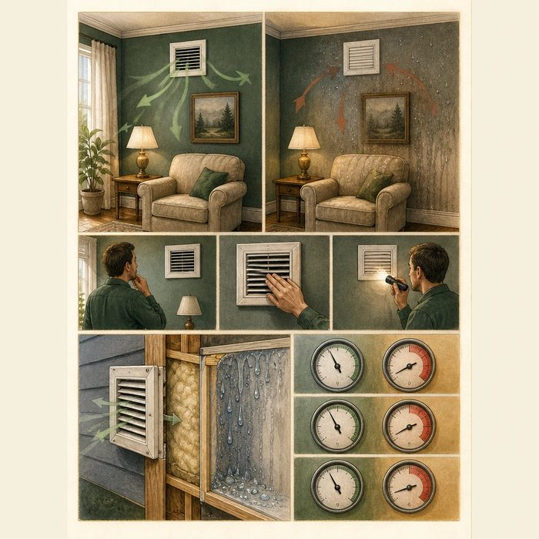
Illustration: A room needs a working pressure-equalizing vent
1. What happens when the vent cannot open?
________________________________________________________________________________
2. Why might a first inspection look normal?
________________________________________________________________________________
3. Which repeated measurements would reveal the problem?
________________________________________________________________________________

ANATOMICAL LESSON 12 | RULES AND BIOLOGY MAPPING
2. Turn observations into rules

1. Rule 1: Connect the tube to the muscle that helps open it. Explain it in your own words.
________________________________________________________________________________
2. Rule 2: Separate newborn screening from later middle-ear status. Explain it in your own words.
________________________________________________________________________________
3. Rule 3: Monitor hearing and middle-ear function over time. Explain it in your own words.
________________________________________________________________________________
Where the analogy stops: Middle-ear disease has multiple contributors, and the Eustachian tube is not a simple building vent.

3. Map the rules onto the biomedical example
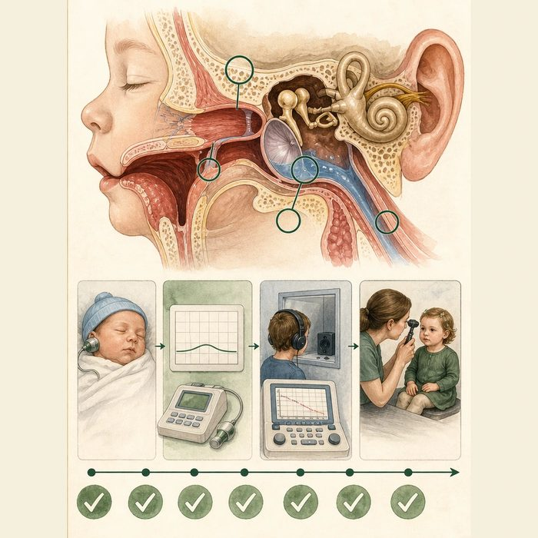
Biomedical teaching illustration: Follow palate muscles to the middle ear
Analogy step | Biology step | How the relationship stays the same
Pressure vent | Eustachian tube | ________________________________
Vent opener | Tensor veli palatini and related mechanics | ________________________________
Condensation | Middle-ear effusion | ________________________________

ANATOMICAL LESSON 12 | CASE FILE AND DECISION
4. Use the case evidence

ID | Finding supplied in the case | Why it matters
ANA12-E1 | Children with cleft palate have increased risk for Eustachian tube dysfunction and middle-ear disease. | The risk continues beyond the newborn period.
ANA12-E2 | Mateo passed a newborn hearing screen. | That screen does not predict every later conductive hearing problem.
ANA12-E3 | ACPA recommends regular ear examination and ongoing audiology surveillance, with tube decisions based on clinical evaluation. | Monitoring is routine; a procedure is individualized.

5. Make the clinical decision
You are the cleft-team audiologist. Mateo passed his newborn screen, but at nine months has flat tympanograms and persistent middle-ear fluid.
A. Refer for coordinated ENT and audiology management and continue surveillance.
B. Discharge him because the newborn screen was normal.
C. Promise that palate repair alone will end every ear problem.
Decision. Choose the next step and cite anatomy plus longitudinal evidence.
________________________________________________________________________________
________________________________________________________________________________
Claim ceiling: You may identify surveillance and referral needs. You may not prescribe tubes or antibiotics without the treating clinicians' evaluation.
Claim. State the choice you can defend.
________________________________________________________________________________
Evidence. Use these labeled IDs: ANA12-E1 + ANA12-E2.
________________________________________________________________________________
Reasoning. Explain why the evidence supports the claim and stays inside the claim ceiling.
________________________________________________________________________________
________________________________________________________________________________

ANATOMICAL LESSON 12 | REDUCE, REFLECT, AND PREPARE
6. Reduce the lesson to one lasting idea

Take-home. Cleft-palate muscle anatomy can impair Eustachian tube opening, so hearing needs repeated surveillance even after a normal newborn screen.
________________________________________________________________________________
________________________________________________________________________________
1. Why can hearing change after a passed newborn screen?
________________________________________________________________________________
2. Which two systems should be monitored repeatedly?
________________________________________________________________________________

Glossary
Term | Plain-English definition
Eustachian tube | A lesson term defined by the surrounding model and case evidence.
tensor veli palatini | A lesson term defined by the surrounding model and case evidence.
middle ear | The air-filled space behind the eardrum holding three tiny bones that pass sound vibrations inward to the inner ear.
otitis media with effusion (OME) | A buildup of fluid behind the eardrum without active infection, common in cleft palate and able to muffle hearing.
conductive hearing loss | A lesson term defined by the surrounding model and case evidence.
tympanostomy tube | A tiny tube surgically placed in the eardrum to drain fluid and relieve repeated ear infections, common in children with clefts.

Next lesson unlock
We followed the cleft into speech and now into the ears, and each time the same abnormal muscles explain the trouble. But Mateo's cleft also runs straight through the gum ridge, the very bone where his upper teeth are forming. What does the cleft do to his teeth? We chase that next time.
The journal links on the lesson page are optional. Everything required for this guided-notes set is already supplied here and in the case file.

