ANATOMICAL DOMAIN | LESSON 11 OF 20 | SPEECH-LANGUAGE PATHOLOGIST

How Palate Repair Lets a Child Speak
Why does repairing the roof of the mouth decide whether a child speaks clearly or sounds like air is leaking out the nose?
CARRY FORWARD  Cleft surgery timing balances present safety, early function, future growth, and family readiness rather than following one magic date. | 10-YEAR TAKEAWAY  Clear oral speech needs a moving velopharyngeal valve that closes the nasal path for pressure sounds and opens it for nasal sounds.

Cells differentiate | Development sculpts | Cells move | Development can go wrong

1. Observe the analogy before naming the biology

Illustration: A railway switch sends airflow down the correct track
1. When must one route close?
________________________________________________________________________________
2. Why should the other route remain available sometimes?
________________________________________________________________________________
3. What signal would reveal a leaky switch?
________________________________________________________________________________

ANATOMICAL LESSON 11 | RULES AND BIOLOGY MAPPING
2. Turn observations into rules

1. Rule 1: Speech uses controlled airflow, not complete permanent closure. Explain it in your own words.
________________________________________________________________________________
2. Rule 2: Pressure consonants need oral pressure. Explain it in your own words.
________________________________________________________________________________
3. Rule 3: Resonance and nasal emission reveal valve performance. Explain it in your own words.
________________________________________________________________________________
Where the analogy stops: Speech depends on the brain, hearing, articulation, language, and learned motor patterns as well as anatomy.

3. Map the rules onto the biomedical example
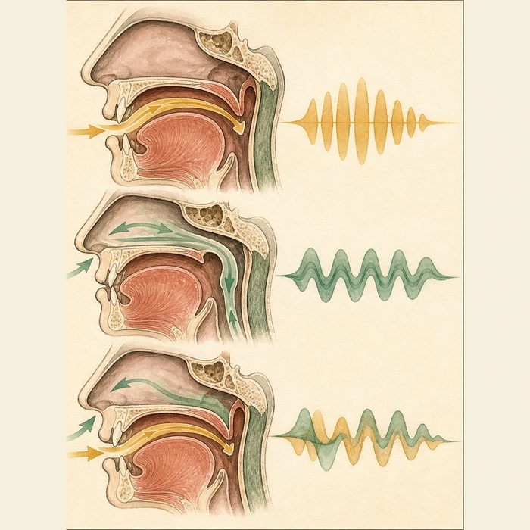
Biomedical teaching illustration: Trace airflow during oral and nasal sounds
Analogy step | Biology step | How the relationship stays the same
Track switch | Velum and pharyngeal walls | ________________________________
Oral tunnel | Oral airflow for pressure sounds | ________________________________
Nasal tunnel | Nasal resonance for m, n, and ng | ________________________________

ANATOMICAL LESSON 11 | CASE FILE AND DECISION
4. Use the case evidence

ID | Finding supplied in the case | Why it matters
ANA11-E1 | Mateo's repaired soft palate contains a reconstructed levator sling. | The velum has the anatomy needed to elevate, but function must be measured.
ANA11-E2 | A speech sample shows pressure consonants with no consistent nasal emission. | The supplied sample supports effective closure during those sounds.
ANA11-E3 | Speech assessment includes resonance, nasal emission, articulation, and intelligibility. | One sound or one appearance cannot define the whole speech outcome.

5. Make the clinical decision
You are the cleft-team speech-language pathologist. Mateo produces clear pressure consonants but a trainee says the nose should be sealed for every sound.
A. Explain controlled closure for oral sounds and opening for nasal sounds.
B. Recommend permanent complete nasal blockage.
C. Judge the valve only from a still photograph.
Decision. Choose the explanation and cite airflow plus speech-sample evidence.
________________________________________________________________________________
________________________________________________________________________________
Claim ceiling: You may interpret the supplied educational speech sample. You may not diagnose a real child's resonance without a complete evaluation.
Claim. State the choice you can defend.
________________________________________________________________________________
Evidence. Use these labeled IDs: ANA11-E1 + ANA11-E2.
________________________________________________________________________________
Reasoning. Explain why the evidence supports the claim and stays inside the claim ceiling.
________________________________________________________________________________
________________________________________________________________________________

ANATOMICAL LESSON 11 | REDUCE, REFLECT, AND PREPARE
6. Reduce the lesson to one lasting idea

Take-home. Clear oral speech needs a moving velopharyngeal valve that closes the nasal path for pressure sounds and opens it for nasal sounds.
________________________________________________________________________________
________________________________________________________________________________
1. When should the nasal path close?
________________________________________________________________________________
2. Which speech observations test valve function?
________________________________________________________________________________

Glossary
Term | Plain-English definition
velum | The soft palate, the muscular back part of the roof of the mouth that lifts to seal off the nose during speech and swallowing.
velopharynx | The space where the soft palate meets the back of the throat, which must seal off the nose during speech and swallowing.
levator veli palatini | The main muscle that lifts the soft palate to close off the nose during speech and swallowing; it is often disrupted in cleft palate.
velopharyngeal insufficiency (VPI) | When the soft palate cannot fully close off the nose from the mouth during speech, letting air escape and making speech sound nasal.
hypernasality | A speech quality where too much air escapes through the nose, often when the soft palate cannot fully close off the nasal passage.
nasal air emission | Air leaking out through the nose during speech when the soft palate cannot fully seal the mouth off from the nasal passage.

Next lesson unlock
We answered why palate repair decides clear speech. But here is a new clue: the muscles that move Mateo's soft palate are anchored near the skull base, right next to the tube that drains his middle ear. If those same muscles are abnormal, what happens to his ears? We chase that next time.
The journal links on the lesson page are optional. Everything required for this guided-notes set is already supplied here and in the case file.

