ANATOMICAL DOMAIN | LESSON 10 OF 20 | CRANIOFACIAL SURGEON (PLANNING THE REPAIR TIMELINE)

When to Repair, and Why the Calendar Matters
Why is the lip usually repaired at about three months and the palate at about nine to twelve months, and what is being balanced in that choice?
CARRY FORWARD  Palate repair must close the oral-nasal opening and rebuild the levator sling while protecting blood supply and growth. | 10-YEAR TAKEAWAY  Cleft surgery timing balances present safety, early function, future growth, and family readiness rather than following one magic date.

Cells differentiate | Development sculpts | Cells move | Development can go wrong

1. Observe the analogy before naming the biology

Illustration: Repair a busy bridge during the safest useful window
1. Why not repair at the first possible minute?
________________________________________________________________________________
2. What is lost by waiting too long?
________________________________________________________________________________
3. Which conditions make the window individual?
________________________________________________________________________________

ANATOMICAL LESSON 10 | RULES AND BIOLOGY MAPPING
2. Turn observations into rules

1. Rule 1: Define the function that needs protection. Explain it in your own words.
________________________________________________________________________________
2. Rule 2: Check medical and family readiness. Explain it in your own words.
________________________________________________________________________________
3. Rule 3: Use a window and team protocol, not a universal birthday. Explain it in your own words.
________________________________________________________________________________
Where the analogy stops: Surgical timing depends on individual clinical factors and cannot be reduced to a maintenance calendar.

3. Map the rules onto the biomedical example
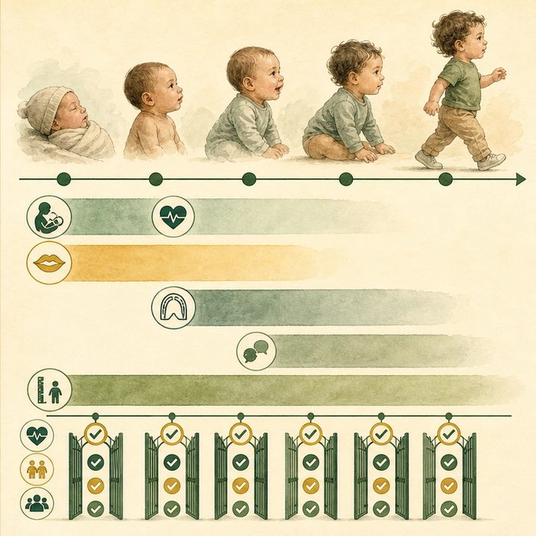
Biomedical teaching illustration: Build Mateo's staged repair calendar
Analogy step | Biology step | How the relationship stays the same
Traffic need | Feeding, speech, and family function | ________________________________
Structural readiness | Infant health and anesthesia readiness | ________________________________
Future expansion | Facial growth and later procedures | ________________________________

ANATOMICAL LESSON 10 | CASE FILE AND DECISION
4. Use the case evidence

ID | Finding supplied in the case | Why it matters
ANA10-E1 | ACPA states that primary lip repair is often initiated within the first six months for healthy infants. | Three months can be a common center target but is not a universal rule.
ANA10-E2 | ACPA states that primary palate repair often occurs at 9 to 14 months and ideally by 18 months. | Speech development and readiness shape the window.
ANA10-E3 | Mateo is medically stable in the composite file, but care is shared with the family and center team. | A final date depends on individual assessment and protocol.

5. Make the clinical decision
You are the cleft-team coordinator. A handout says every infant must have lip repair on the exact 90th day and palate repair on the exact first birthday.
A. Replace exact dates with evidence-based windows and readiness gates.
B. Keep the exact birthdays as universal rules.
C. Avoid discussing timing with the family.
Decision. Choose the calendar language and cite both ACPA timing windows.
________________________________________________________________________________
________________________________________________________________________________
Claim ceiling: You may propose an educational sequence for the stable composite case. You may not schedule real surgery or override the treating team.
Claim. State the choice you can defend.
________________________________________________________________________________
Evidence. Use these labeled IDs: ANA10-E1 + ANA10-E2.
________________________________________________________________________________
Reasoning. Explain why the evidence supports the claim and stays inside the claim ceiling.
________________________________________________________________________________
________________________________________________________________________________

ANATOMICAL LESSON 10 | REDUCE, REFLECT, AND PREPARE
6. Reduce the lesson to one lasting idea

Take-home. Cleft surgery timing balances present safety, early function, future growth, and family readiness rather than following one magic date.
________________________________________________________________________________
________________________________________________________________________________
1. What is the ACPA palate-repair window?
________________________________________________________________________________
2. Why should the team use readiness gates?
________________________________________________________________________________

Glossary
Term | Plain-English definition
surgical timing | Choosing the best age to perform a repair, balancing growth, speech, and healing, such as lip repair in infancy and palate repair before speech.
rule of tens | A classic guideline for timing cleft lip surgery: the infant should be about ten weeks old, ten pounds, and have hemoglobin near ten.
palatoplasty timing | The choice of when to surgically repair a cleft palate, balancing better speech from earlier repair against possible effects on facial growth.
speech-language window | The early childhood period when the brain learns speech and language fastest, making timely cleft palate repair important for clear speech.
growth disturbance | Slowed or uneven growth of a body part, such as the midface after cleft surgery, leading to a smaller or asymmetric structure.

Next lesson unlock
We set Mateo's calendar: his lip repaired around three months, his palate before his first words land. We argued that the timing itself helps protect his speech. But that rests on a claim we have not proven. Why does closing the roof of the mouth matter so much for talking in the first place? We chase that next time.
The journal links on the lesson page are optional. Everything required for this guided-notes set is already supplied here and in the case file.

