ANATOMICAL DOMAIN | LESSON 9 OF 20 | CRANIOFACIAL SURGEON (CLEFT PALATE REPAIR)

Rebuilding the Roof of the Mouth
Why does closing the palate take more than just sewing the hole shut, and why do surgeons argue about which technique is best?
CARRY FORWARD  Lip repair restores a continuous orbicularis ring and aligned lip landmarks, not merely a closed skin line. | 10-YEAR TAKEAWAY  Palate repair must close the oral-nasal opening and rebuild the levator sling while protecting blood supply and growth.

Cells differentiate | Development sculpts | Cells move | Development can go wrong

1. Observe the analogy before naming the biology
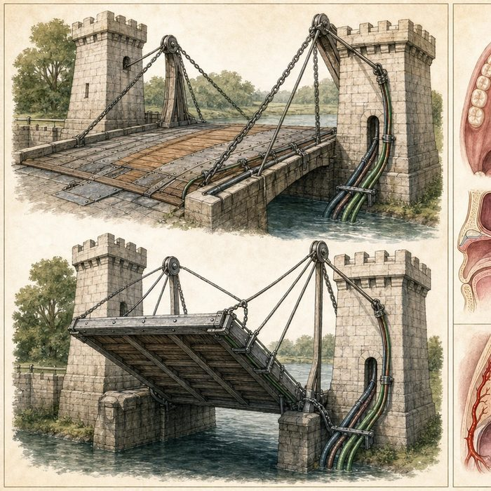
Illustration: A drawbridge needs both a sealed deck and correctly placed lift cables
1. What happens if the deck closes but the cables remain misdirected?
________________________________________________________________________________
2. Which parts must move after repair?
________________________________________________________________________________
3. Why must the repair protect its supply lines?
________________________________________________________________________________

ANATOMICAL LESSON 9 | RULES AND BIOLOGY MAPPING
2. Turn observations into rules

1. Rule 1: Close the tissue layers without tension. Explain it in your own words.
________________________________________________________________________________
2. Rule 2: Reorient the levator into a transverse sling. Explain it in your own words.
________________________________________________________________________________
3. Rule 3: Protect blood supply, airway, and later growth. Explain it in your own words.
________________________________________________________________________________
Where the analogy stops: The soft palate is a living neuromuscular valve, not a bridge mechanism.

3. Map the rules onto the biomedical example
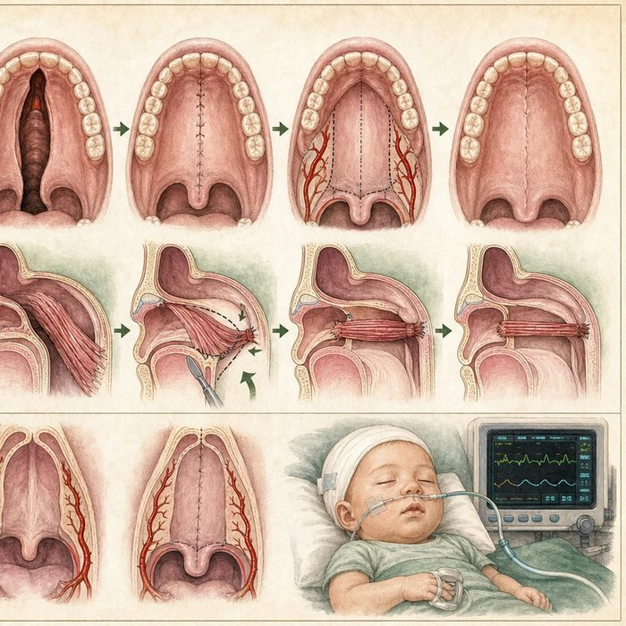
Biomedical teaching illustration: Compare closure-only with functional palatoplasty
Analogy step | Biology step | How the relationship stays the same
Bridge deck | Oral and nasal lining closure | ________________________________
Lift cables | Levator veli palatini sling | ________________________________
Supply lines | Palatal blood supply | ________________________________

ANATOMICAL LESSON 9 | CASE FILE AND DECISION
4. Use the case evidence

ID | Finding supplied in the case | Why it matters
ANA09-E1 | Mateo's cleft opens through hard and soft palate. | Both oral-nasal separation and soft-palate function need repair.
ANA09-E2 | His levator fibers are abnormally oriented along the cleft margins. | Functional repair requires muscle reconstruction, not mucosal closure alone.
ANA09-E3 | Palate surgery can risk bleeding, tissue injury, airway obstruction, fistula, and later growth effects. | A plan must include safety and surveillance, not only closure.

5. Make the clinical decision
You are the cleft surgeon presenting two palatoplasty plans. One plan closes lining only. The other closes layers, rebuilds the levator sling, preserves vascular supply, and includes airway monitoring.
A. Choose the functional layered plan.
B. Choose lining closure only because no visible hole remains.
C. Delay every palate repair until adulthood to avoid all growth effects.
Decision. Choose the plan and cite closure, muscle, and safety evidence.
________________________________________________________________________________
________________________________________________________________________________
Claim ceiling: You may identify required goals and risks. You may not name one palatoplasty technique as best for every patient.
Claim. State the choice you can defend.
________________________________________________________________________________
Evidence. Use these labeled IDs: ANA09-E1 + ANA09-E2.
________________________________________________________________________________
Reasoning. Explain why the evidence supports the claim and stays inside the claim ceiling.
________________________________________________________________________________
________________________________________________________________________________

ANATOMICAL LESSON 9 | REDUCE, REFLECT, AND PREPARE
6. Reduce the lesson to one lasting idea

Take-home. Palate repair must close the oral-nasal opening and rebuild the levator sling while protecting blood supply and growth.
________________________________________________________________________________
________________________________________________________________________________
1. What two functional goals must palatoplasty meet?
________________________________________________________________________________
2. Why is airway monitoring part of the plan?
________________________________________________________________________________

Glossary
Term | Plain-English definition
palatoplasty | Surgery that closes a cleft in the roof of the mouth so the palate can separate the nose from the mouth and support speech.
levator veli palatini | The main muscle that lifts the soft palate to close off the nose during speech and swallowing; it is often disrupted in cleft palate.
muscular sling | The hammock of soft palate muscles that meet in the midline so the palate can lift and seal the nose off during speech and swallowing.
intravelar veloplasty | A cleft palate surgery that frees the soft palate muscles from their wrong attachments and reconnects them across the midline to rebuild the muscle sling.
double-opposing Z-plasty | A cleft palate surgery (the Furlow technique) that uses mirror-image Z-shaped flaps to lengthen the soft palate and rebuild its muscle sling.

Next lesson unlock
We closed Mateo's palate and rebuilt the levator sling. But two children can have the very same closed palate, repaired the very same way, and one speaks clearly while the other does not. Part of that may be the calendar. When should the lip and palate each be repaired, and could timing itself help decide whether Mateo speaks clearly? We chase that next time.
The journal links on the lesson page are optional. Everything required for this guided-notes set is already supplied here and in the case file.

