ANATOMICAL DOMAIN | LESSON 8 OF 20 | CRANIOFACIAL SURGEON (CLEFT LIP REPAIR)

Rebuilding the Lip
When you fix a cleft lip, what are you actually rebuilding, and why is more than one technique still in use?
CARRY FORWARD  Presurgical molding changes the starting geometry before repair; it does not fuse tissue, and long-term benefits remain uncertain. | 10-YEAR TAKEAWAY  Lip repair restores a continuous orbicularis ring and aligned lip landmarks, not merely a closed skin line.

Cells differentiate | Development sculpts | Cells move | Development can go wrong

1. Observe the analogy before naming the biology

Illustration: Repair a circular conveyor belt and its outer cover together
1. Which hidden moving part must reconnect?
________________________________________________________________________________
2. Which surface landmarks must meet?
________________________________________________________________________________
3. Why could the cover look closed while the machine still pulls unevenly?
________________________________________________________________________________

ANATOMICAL LESSON 8 | RULES AND BIOLOGY MAPPING
2. Turn observations into rules

1. Rule 1: Find and release displaced muscle. Explain it in your own words.
________________________________________________________________________________
2. Rule 2: Rebuild a continuous functional ring. Explain it in your own words.
________________________________________________________________________________
3. Rule 3: Align skin, vermilion, mucosa, and nasal base without assuming one universal cut pattern. Explain it in your own words.
________________________________________________________________________________
Where the analogy stops: Surgery involves living tissue, blood supply, healing, and individualized technique, not mechanical replacement parts.

3. Map the rules onto the biomedical example
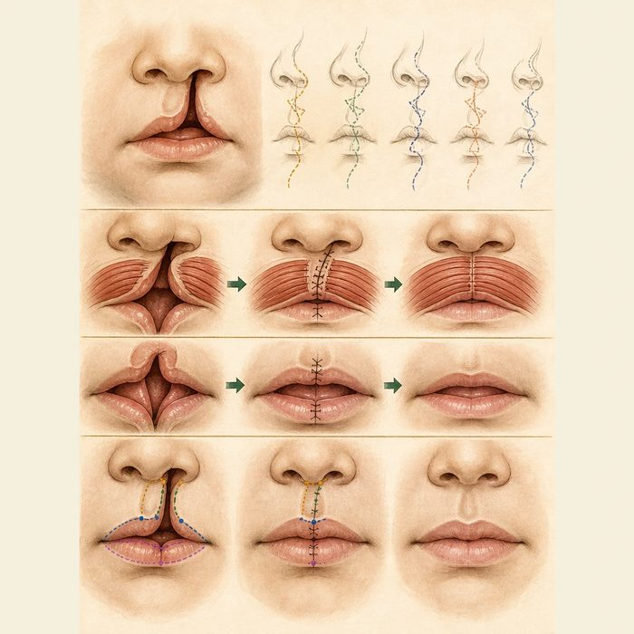
Biomedical teaching illustration: Plan the layers of primary cleft lip repair
Analogy step | Biology step | How the relationship stays the same
Conveyor belt | Orbicularis oris ring | ________________________________
Outer cover | Skin, vermilion, and mucosa | ________________________________
Alignment marks | Philtral and nasal landmarks | ________________________________

ANATOMICAL LESSON 8 | CASE FILE AND DECISION
4. Use the case evidence

ID | Finding supplied in the case | Why it matters
ANA08-E1 | Mateo's orbicularis fibers insert along the cleft margins. | The muscle must be identified and redirected across the gap.
ANA08-E2 | The philtral column, cutaneous roll, vermilion, and mucosa are misaligned. | Visible subunits require precise matching.
ANA08-E3 | ACPA lists orbicularis reconstruction and balanced nasolabial form as primary principles while recognizing multiple protocols. | The goals are shared even when incision geometry differs.

5. Make the clinical decision
You are reviewing the primary lip repair plan. Plan A closes skin only. Plan B identifies muscle, reconnects the ring, and aligns each lip layer and nasal base.
A. Choose Plan B and explain the functional layer.
B. Choose Plan A because a closed skin line proves muscle repair.
C. Pick a named technique without checking anatomy.
Decision. Choose the plan and cite muscle plus landmark evidence.
________________________________________________________________________________
________________________________________________________________________________
Claim ceiling: You may identify reconstruction goals. You may not prescribe one technique as universally best.
Claim. State the choice you can defend.
________________________________________________________________________________
Evidence. Use these labeled IDs: ANA08-E1 + ANA08-E2.
________________________________________________________________________________
Reasoning. Explain why the evidence supports the claim and stays inside the claim ceiling.
________________________________________________________________________________
________________________________________________________________________________

ANATOMICAL LESSON 8 | REDUCE, REFLECT, AND PREPARE
6. Reduce the lesson to one lasting idea

Take-home. Lip repair restores a continuous orbicularis ring and aligned lip landmarks, not merely a closed skin line.
________________________________________________________________________________
________________________________________________________________________________
1. Which hidden layer restores lip seal?
________________________________________________________________________________
2. Why can more than one incision design be reasonable?
________________________________________________________________________________

Glossary
Term | Plain-English definition
cheiloplasty | The surgical repair of a cleft lip, rejoining the separated lip tissue to restore a continuous lip and a more typical appearance.
orbicularis oris | The ring of muscle encircling the mouth that closes and shapes the lips; its fibers are disrupted and repaired in cleft lip surgery.
rotation-advancement | A cleft lip repair (the Millard technique) that rotates the lip down to level the Cupid's bow and advances a flap to fill the gap.
anatomical subunit | A natural region of a body part with its own borders, used by surgeons to plan repairs so scars hide along the edges between regions.
lip height | The vertical distance of the upper lip from its base to its edge, measured to judge symmetry and surgical repair results.

Next lesson unlock
We rebuilt the lip and its muscle ring, but the lip was the easier door to close. The roof of the mouth is deeper and hides a different muscle that must be rebuilt into a working sling. How does the surgeon rebuild the palate, where the repair happens in the dark and the muscle must be remade across the midline? We chase that next time.
The journal links on the lesson page are optional. Everything required for this guided-notes set is already supplied here and in the case file.

