ANATOMICAL DOMAIN | LESSON 7 OF 20 | ORTHODONTIST (PRESURGICAL INFANT ORTHOPEDICS)

Shaping the Gap Before Surgery
Can we shape and narrow Mateo's cleft before surgery, and how strong is the evidence that it helps?
CARRY FORWARD  A cleft palate limits suction because the mouth cannot seal from the nose, so feeding support changes flow rather than blaming effort. | 10-YEAR TAKEAWAY  Presurgical molding changes the starting geometry before repair; it does not fuse tissue, and long-term benefits remain uncertain.

Cells differentiate | Development sculpts | Cells move | Development can go wrong

1. Observe the analogy before naming the biology
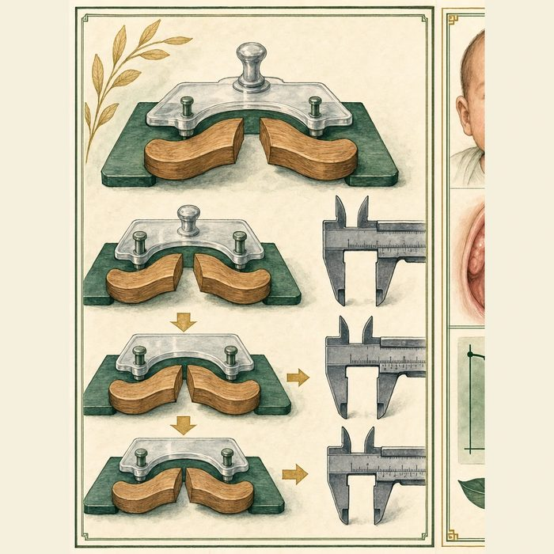
Illustration: A guide jig aligns pieces before they are permanently joined
1. Does the guide permanently join the pieces?
________________________________________________________________________________
2. Which measurements change before fastening?
________________________________________________________________________________
3. What evidence would be needed to know whether the early change lasts?
________________________________________________________________________________

ANATOMICAL LESSON 7 | RULES AND BIOLOGY MAPPING
2. Turn observations into rules

1. Rule 1: Distinguish positioning from closure. Explain it in your own words.
________________________________________________________________________________
2. Rule 2: Measure the preoperative change. Explain it in your own words.
________________________________________________________________________________
3. Rule 3: Separate short-term geometry from long-term function and appearance. Explain it in your own words.
________________________________________________________________________________
Where the analogy stops: Infant tissues grow and respond biologically. They are not rigid workshop pieces.

3. Map the rules onto the biomedical example
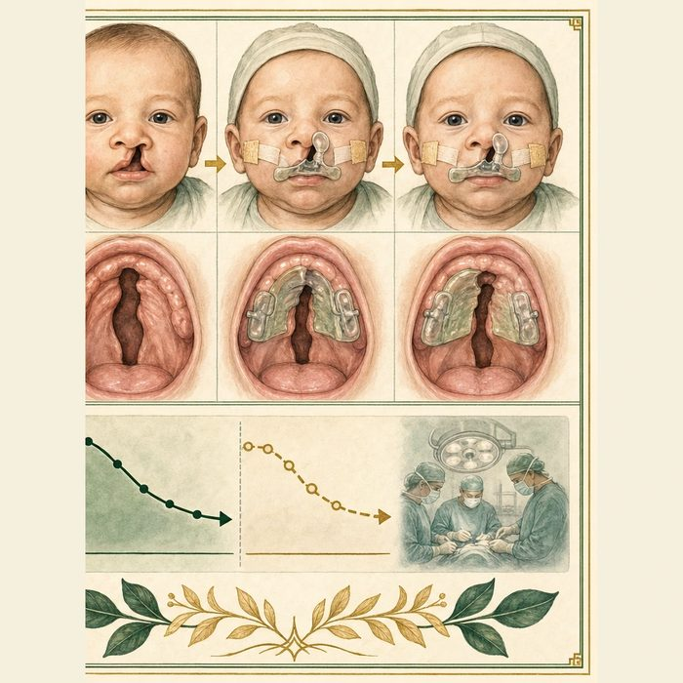
Biomedical teaching illustration: Evaluate nasoalveolar molding for Mateo
Analogy step | Biology step | How the relationship stays the same
Guide jig | Nasoalveolar molding appliance | ________________________________
Aligned pieces | Changed alveolar and nasal position | ________________________________
Final fastening | Later surgical repair | ________________________________

ANATOMICAL LESSON 7 | CASE FILE AND DECISION
4. Use the case evidence

ID | Finding supplied in the case | Why it matters
ANA07-E1 | The supplied model shows Mateo's alveolar gap narrowing during monitored appliance use. | The starting geometry can change before lip repair.
ANA07-E2 | The appliance does not create tissue fusion or replace surgery. | Molding is positioning, not closure.
ANA07-E3 | Systematic reviews report low or very low certainty for many long-term outcomes. | Short-term narrowing should not be sold as a guaranteed lifelong benefit.

5. Make the clinical decision
You are the team orthodontist counseling Mateo's parents. The family can attend frequent visits but was told molding will permanently fix the cleft and prevent all later surgery.
A. Offer it as an optional positioning tool with workload and evidence limits explained.
B. Promise permanent closure and no later surgery.
C. Say the appliance cannot change any preoperative measurement.
Decision. Choose the counseling statement and cite one measured benefit plus one uncertainty.
________________________________________________________________________________
________________________________________________________________________________
Claim ceiling: You may describe short-term positioning evidence. You may not guarantee long-term appearance, function, or fewer operations.
Claim. State the choice you can defend.
________________________________________________________________________________
Evidence. Use these labeled IDs: ANA07-E1 + ANA07-E2.
________________________________________________________________________________
Reasoning. Explain why the evidence supports the claim and stays inside the claim ceiling.
________________________________________________________________________________
________________________________________________________________________________

ANATOMICAL LESSON 7 | REDUCE, REFLECT, AND PREPARE
6. Reduce the lesson to one lasting idea

Take-home. Presurgical molding changes the starting geometry before repair; it does not fuse tissue, and long-term benefits remain uncertain.
________________________________________________________________________________
________________________________________________________________________________
1. What can molding change before surgery?
________________________________________________________________________________
2. What outcome should not be promised?
________________________________________________________________________________

Glossary
Term | Plain-English definition
nasoalveolar molding (NAM) | A custom plate worn before surgery that gradually reshapes a baby's gum and nose, narrowing the cleft to improve the repair.
molding plate | A custom plastic appliance fitted in an infant's mouth before surgery to gradually guide the cleft gum and lip into better position.
nasal stent | A small support placed in the nostril after cleft surgery to hold its shape open while the healing tissue settles.
gingivoperiosteoplasty | A surgery that closes the alveolar cleft with gum and lining tissue flaps to encourage new bone to bridge the gap, without a bone graft.
columella | The thin strip of tissue between the two nostrils that connects the nasal tip to the upper lip and helps hold the nose's shape.

Next lesson unlock
We have shaped Mateo's cleft into a better starting position and kept him feeding. The gap is narrower, but it is still open. How does the surgeon actually rebuild the lip, and especially the ring of muscle inside it, into a working, symmetric whole? We chase that next time.
The journal links on the lesson page are optional. Everything required for this guided-notes set is already supplied here and in the case file.

