ANATOMICAL DOMAIN | LESSON 6 OF 20 | FEEDING SPECIALIST

Why Feeding Fails, and What Helps Right Now
Why can't Mateo feed normally, and what can we change today to help him before any surgery?
CARRY FORWARD  Clefts vary along several independent axes, so one familiar example cannot stand for the whole spectrum. | 10-YEAR TAKEAWAY  A cleft palate limits suction because the mouth cannot seal from the nose, so feeding support changes flow rather than blaming effort.

Cells differentiate | Development sculpts | Cells move | Development can go wrong

1. Observe the analogy before naming the biology
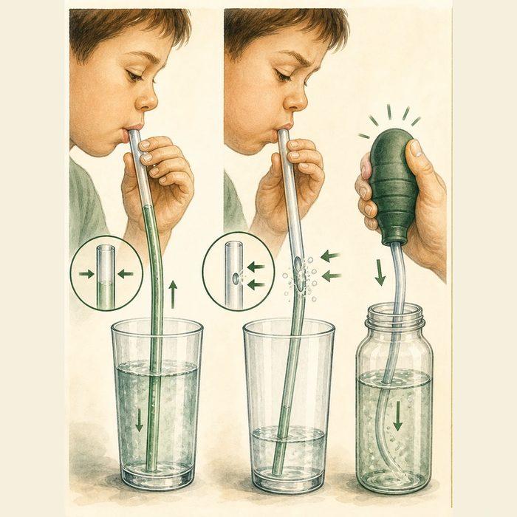
Illustration: A drinking straw cannot pull fluid through an open side port
1. Where does air enter when the side port is open?
________________________________________________________________________________
2. Why does stronger sucking not fix the leak?
________________________________________________________________________________
3. Which change could move fluid without requiring a sealed tube?
________________________________________________________________________________

ANATOMICAL LESSON 6 | RULES AND BIOLOGY MAPPING
2. Turn observations into rules

1. Rule 1: Check whether a pressure chamber can seal. Explain it in your own words.
________________________________________________________________________________
2. Rule 2: Match support to the failed mechanism. Explain it in your own words.
________________________________________________________________________________
3. Rule 3: Track intake, time, breathing, and growth rather than bottle brand alone. Explain it in your own words.
________________________________________________________________________________
Where the analogy stops: Infant feeding also depends on swallowing, airway coordination, endurance, and caregiver technique.

3. Map the rules onto the biomedical example
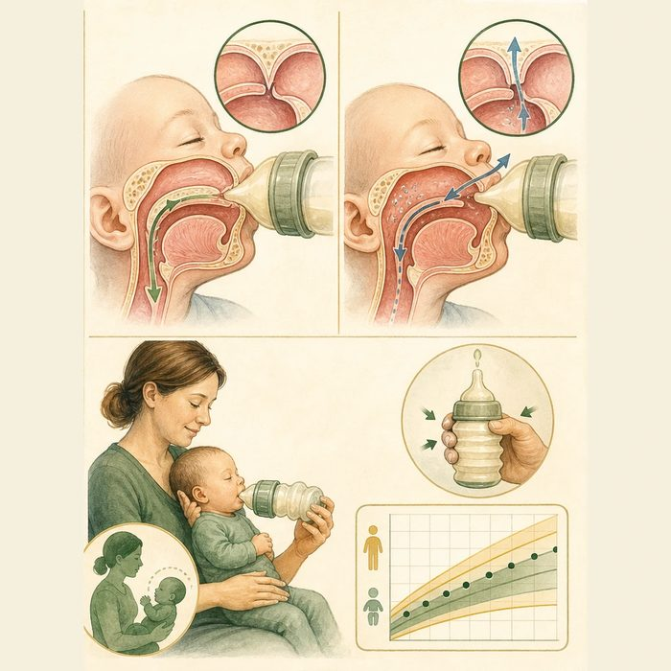
Biomedical teaching illustration: Trace pressure and flow during Mateo's feeding
Analogy step | Biology step | How the relationship stays the same
Open straw port | Oral-nasal opening | ________________________________
Lost pressure | Reduced suction | ________________________________
Assisted flow | Specialized squeezable feeding system | ________________________________

ANATOMICAL LESSON 6 | CASE FILE AND DECISION
4. Use the case evidence

ID | Finding supplied in the case | Why it matters
ANA06-E1 | Mateo has a complete cleft palate connecting the oral and nasal spaces. | He cannot form a typical sealed suction chamber.
ANA06-E2 | He coordinates swallowing and breathing but tires during long feeds. | The primary supplied problem is inefficient transfer, not absent effort.
ANA06-E3 | The team can provide an assisted-flow bottle, upright positioning, pacing, and weight monitoring. | Support works around the pressure leak while protecting growth and breathing.

5. Make the clinical decision
You are the cleft-team feeding specialist. Mateo takes 42 minutes per feed, has nasal milk escape, and is falling off his weight curve without cough or color change.
A. Start assisted-flow feeding education and close growth follow-up.
B. Tell the family to make him suck harder with a standard rigid bottle.
C. Schedule emergency lip surgery as the feeding treatment.
Decision. Choose today's feeding plan and cite the mechanism plus monitoring evidence.
________________________________________________________________________________
________________________________________________________________________________
Claim ceiling: You may recommend the supplied educational support plan. You may not rule out swallowing or airway disease if new safety signs appear.
Claim. State the choice you can defend.
________________________________________________________________________________
Evidence. Use these labeled IDs: ANA06-E1 + ANA06-E2.
________________________________________________________________________________
Reasoning. Explain why the evidence supports the claim and stays inside the claim ceiling.
________________________________________________________________________________
________________________________________________________________________________

ANATOMICAL LESSON 6 | REDUCE, REFLECT, AND PREPARE
6. Reduce the lesson to one lasting idea

Take-home. A cleft palate limits suction because the mouth cannot seal from the nose, so feeding support changes flow rather than blaming effort.
________________________________________________________________________________
________________________________________________________________________________
1. Why does stronger sucking not close the pressure leak?
________________________________________________________________________________
2. Which four outcomes should the team monitor?
________________________________________________________________________________

Glossary
Term | Plain-English definition
intraoral negative pressure | The suction created inside the mouth that lets a baby latch and draw milk; a cleft palate can prevent this seal from forming.
oronasal communication | An abnormal opening that connects the mouth and nasal cavity, letting air, food, or liquid pass between them.
compressible bottle | A soft squeeze bottle used to feed an infant with a cleft, letting a caregiver gently push milk so the baby does not have to create suction.
upright positioning | Holding a baby in a more vertical posture during feeding so gravity helps keep milk out of the nose and airway.
aspiration | When food, liquid, or saliva slips into the airway and lungs instead of the stomach, a risk for infants who have trouble feeding or swallowing.

Next lesson unlock
We can keep Mateo fed today by working around the gap. But the gap is wide, and the wider it is, the harder the lip repair will be. Could we gently shape and narrow the cleft before any operation so feeding gets easier and the surgery starts from a better position? We chase that next time.
The journal links on the lesson page are optional. Everything required for this guided-notes set is already supplied here and in the case file.

