ANATOMICAL DOMAIN | LESSON 5 OF 20 | CRANIOFACIAL SURGEON (THE SPECTRUM OF CLEFT PHENOTYPES)

One Cleft, Many Shapes, The Cleft Spectrum
What makes one cleft different from another, and where does Mateo's cleft fall in the full spectrum?
CARRY FORWARD  A useful cleft label records side, completeness, and anatomical extent without replacing the examination. | 10-YEAR TAKEAWAY  Clefts vary along several independent axes, so one familiar example cannot stand for the whole spectrum.

Cells differentiate | Development sculpts | Cells move | Development can go wrong

1. Observe the analogy before naming the biology

Illustration: A library sorts books by more than one shelf label
1. Can two items share one feature but differ on another?
________________________________________________________________________________
2. Which feature could be hidden from a quick look?
________________________________________________________________________________
3. Why would one shelf label be insufficient?
________________________________________________________________________________

ANATOMICAL LESSON 5 | RULES AND BIOLOGY MAPPING
2. Turn observations into rules

1. Rule 1: Separate laterality from completeness. Explain it in your own words.
________________________________________________________________________________
2. Rule 2: Separate visible surface from hidden muscle and bone. Explain it in your own words.
________________________________________________________________________________
3. Rule 3: Use multiple axes before comparing cases. Explain it in your own words.
________________________________________________________________________________
Where the analogy stops: Cleft categories are clinical descriptors, not rigid boxes for a person's experience.

3. Map the rules onto the biomedical example
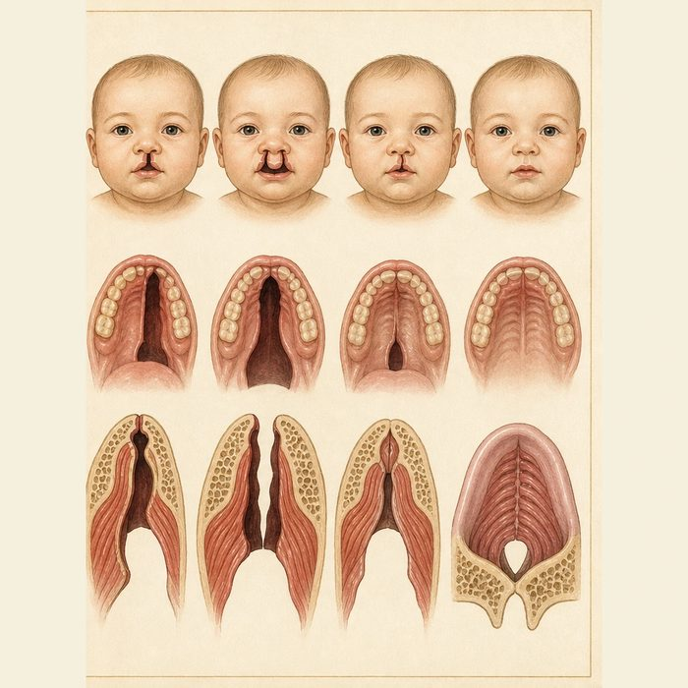
Biomedical teaching illustration: Place four case cards on the cleft spectrum
Analogy step | Biology step | How the relationship stays the same
Shelf side | Unilateral or bilateral | ________________________________
Full series | Complete or incomplete | ________________________________
Hidden edition | Submucous versus overt | ________________________________

ANATOMICAL LESSON 5 | CASE FILE AND DECISION
4. Use the case evidence

ID | Finding supplied in the case | Why it matters
ANA05-E1 | One case card shows a cleft on both sides of the lip and alveolus. | It is bilateral regardless of whether the palate is complete.
ANA05-E2 | Another stops before reaching the nostril floor. | It is an incomplete lip cleft.
ANA05-E3 | A third has intact oral mucosa but a notched hard palate and separated soft-palate muscles. | A submucous cleft can be hidden under intact mucosa.

5. Make the clinical decision
You are triaging four newborn case cards. A teammate wants to call every cleft that is less visible incomplete.
A. Classify each card on separate side, extent, and surface axes.
B. Use visible size as the only axis.
C. Call all intact-mucosa palates normal.
Decision. Choose the classification method and demonstrate it on two cards.
________________________________________________________________________________
________________________________________________________________________________
Claim ceiling: You may describe the supplied anatomy. You may not infer function from appearance alone.
Claim. State the choice you can defend.
________________________________________________________________________________
Evidence. Use these labeled IDs: ANA05-E1 + ANA05-E2.
________________________________________________________________________________
Reasoning. Explain why the evidence supports the claim and stays inside the claim ceiling.
________________________________________________________________________________
________________________________________________________________________________

ANATOMICAL LESSON 5 | REDUCE, REFLECT, AND PREPARE
6. Reduce the lesson to one lasting idea

Take-home. Clefts vary along several independent axes, so one familiar example cannot stand for the whole spectrum.
________________________________________________________________________________
________________________________________________________________________________
1. What can be hidden in a submucous cleft?
________________________________________________________________________________
2. Why should laterality and completeness be scored separately?
________________________________________________________________________________

Glossary
Term | Plain-English definition
unilateral | Affecting only one side of the body or face, as opposed to both sides.
bilateral | Affecting both the left and right sides of the body, such as a cleft that appears on both sides of the lip.
complete cleft | A cleft that extends fully through the structure, such as a lip cleft reaching all the way up into the nostril with no tissue bridge.
incomplete cleft | A cleft that does not extend through the full structure, leaving a band of intact tissue bridging part of the gap.
Simonart's band | A thin bridge of soft tissue that spans across a cleft lip, partly connecting the two sides instead of leaving a complete gap.
submucous cleft palate | A hidden cleft where the palate muscles fail to join in the midline even though the overlying lining looks intact.

Next lesson unlock
We have pinned Mateo to the spectrum: unilateral, complete, overt. But describing his cleft does not solve his most urgent problem. His open cleft connects his mouth and nose, and his parents are most afraid he cannot eat. Why can't Mateo feed normally, and what helps now? We chase that next time.
The journal links on the lesson page are optional. Everything required for this guided-notes set is already supplied here and in the case file.

