ANATOMICAL DOMAIN | LESSON 4 OF 20 | CRANIOFACIAL SURGEON (CLEFT CLASSIFICATION)

Saying It Precisely, How Surgeons Classify a Cleft
How do surgeons classify a cleft precisely enough that the label alone tells another team exactly what they are dealing with?
CARRY FORWARD  A cleft is not only a visible gap; it also redirects muscles and changes the forces they produce. | 10-YEAR TAKEAWAY  A useful cleft label records side, completeness, and anatomical extent without replacing the examination.

Cells differentiate | Development sculpts | Cells move | Development can go wrong

1. Observe the analogy before naming the biology

Illustration: A precise address compresses a route into shared coordinates
1. Which details let two people find the same place?
________________________________________________________________________________
2. What would be lost by writing only city?
________________________________________________________________________________
3. Why must the map still be checked after reading the address?
________________________________________________________________________________

ANATOMICAL LESSON 4 | RULES AND BIOLOGY MAPPING
2. Turn observations into rules

1. Rule 1: State left, right, or bilateral. Explain it in your own words.
________________________________________________________________________________
2. Rule 2: State complete or incomplete. Explain it in your own words.
________________________________________________________________________________
3. Rule 3: Name the structures and use a system only within its scope. Explain it in your own words.
________________________________________________________________________________
Where the analogy stops: A clinical classification summarizes anatomy but cannot capture every three-dimensional feature or family priority.

3. Map the rules onto the biomedical example
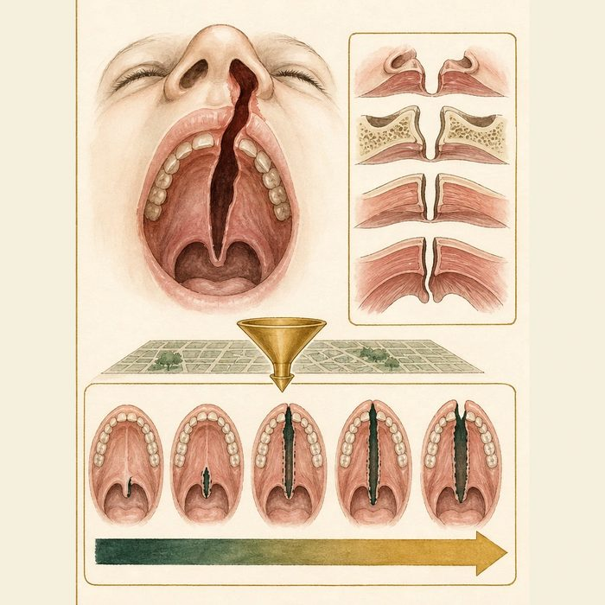
Biomedical teaching illustration: Classify Mateo from the supplied examination
Analogy step | Biology step | How the relationship stays the same
Side of town | Laterality | ________________________________
Full or partial route | Complete or incomplete extent | ________________________________
Address system | Veau and descriptive classification | ________________________________

ANATOMICAL LESSON 4 | CASE FILE AND DECISION
4. Use the case evidence

ID | Finding supplied in the case | Why it matters
ANA04-E1 | The opening is on Mateo's left side. | The cleft is unilateral left.
ANA04-E2 | The cleft extends through the lip and alveolus into both hard and soft palate. | The cleft is complete and involves lip, alveolus, and palate.
ANA04-E3 | Veau III describes a unilateral complete cleft involving the soft and hard palate and continuing through the alveolus on one side. | The palate component fits Veau III.

5. Make the clinical decision
You are completing the operative problem list. Three labels are offered for the same composite examination.
A. Complete unilateral left cleft lip, alveolus, and palate; Veau III.
B. Cleft palate, side and extent unknown.
C. Bilateral incomplete cleft lip only.
Decision. Choose the most precise supported label and cite all three evidence cards.
________________________________________________________________________________
________________________________________________________________________________
Claim ceiling: You may classify the supplied anatomy. You may not use the label to claim a genetic cause or predict outcome.
Claim. State the choice you can defend.
________________________________________________________________________________
Evidence. Use these labeled IDs: ANA04-E1 + ANA04-E2.
________________________________________________________________________________
Reasoning. Explain why the evidence supports the claim and stays inside the claim ceiling.
________________________________________________________________________________
________________________________________________________________________________

ANATOMICAL LESSON 4 | REDUCE, REFLECT, AND PREPARE
6. Reduce the lesson to one lasting idea

Take-home. A useful cleft label records side, completeness, and anatomical extent without replacing the examination.
________________________________________________________________________________
________________________________________________________________________________
1. Which three details belong in a descriptive label?
________________________________________________________________________________
2. What does Veau classification not explain?
________________________________________________________________________________

Glossary
Term | Plain-English definition
classification system | An organized scheme that sorts cases into defined categories, such as grouping clefts by type and location for consistent diagnosis.
Veau class | A four-category system that grades clefts from a soft-palate-only cleft up to a bilateral cleft of the lip and palate.
LAHSHAL | A shorthand code for recording clefts site by site (Lip, Alveolus, Hard palate, Soft palate) from the patient's right to left, capitals marking complete clefts.
Kernahan striped-Y | A Y-shaped diagram that maps cleft lip and palate by shading numbered boxes for each affected part of the lip and palate.
incisive foramen | A small opening in the roof of the mouth just behind the front teeth that marks the boundary between the primary and secondary palate.
laterality | Which side of the body a feature affects, such as whether a cleft is on the left, the right, or both sides.

Next lesson unlock
We can now name Mateo's cleft precisely: Veau III, a complete unilateral left CL/P. But his is only one shape out of many. Some clefts are on both sides, some stop short of the nostril, and some hide under intact skin. What makes one cleft different from another, and what is the full spectrum of forms? We chase that next time.
The journal links on the lesson page are optional. Everything required for this guided-notes set is already supplied here and in the case file.

