ANATOMICAL DOMAIN | LESSON 3 OF 20 | CRANIOFACIAL SURGEON (ANATOMY OF THE DEFECT)

The Anatomy of the Cleft, What Is Actually Interrupted
In a cleft, what exactly is the gap, and what happens to the orbicularis oris and the levator veli palatini?
CARRY FORWARD  Muscle function depends on fiber direction, attachment, and continuity, not merely on muscle presence. | 10-YEAR TAKEAWAY  A cleft is not only a visible gap; it also redirects muscles and changes the forces they produce.

Cells differentiate | Development sculpts | Cells move | Development can go wrong

1. Observe the analogy before naming the biology
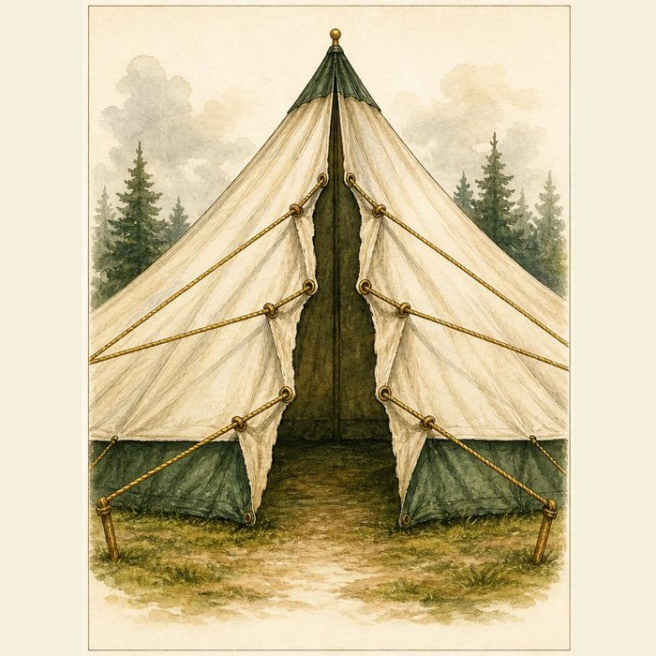
Illustration: A torn tent seam changes both the opening and the pull of its ropes
1. What is visibly missing at the seam?
________________________________________________________________________________
2. Where do the ropes pull after the tear?
________________________________________________________________________________
3. Why would closing only the fabric leave the force problem?
________________________________________________________________________________

ANATOMICAL LESSON 3 | RULES AND BIOLOGY MAPPING
2. Turn observations into rules

1. Rule 1: Identify the tissue discontinuity. Explain it in your own words.
________________________________________________________________________________
2. Rule 2: Trace displaced attachments on both sides. Explain it in your own words.
________________________________________________________________________________
3. Rule 3: Repair must restore geometry and force direction. Explain it in your own words.
________________________________________________________________________________
Where the analogy stops: Cleft anatomy results from development and tissue patterning, not from a post-construction tear.

3. Map the rules onto the biomedical example
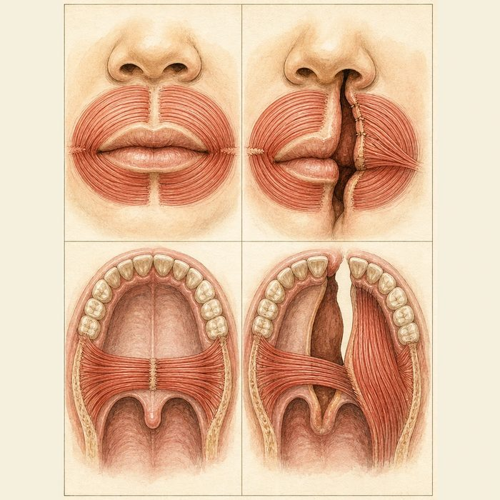
Biomedical teaching illustration: Compare normal and cleft muscle paths
Analogy step | Biology step | How the relationship stays the same
Open seam | Cleft gap | ________________________________
Redirected ropes | Displaced muscle insertion | ________________________________
Uneven pull | Asymmetric lip and palatal motion | ________________________________

ANATOMICAL LESSON 3 | CASE FILE AND DECISION
4. Use the case evidence

ID | Finding supplied in the case | Why it matters
ANA03-E1 | Mateo's left lip, alveolus, and palate are discontinuous in the composite examination. | The cleft crosses skin, muscle, bone, and mucosa.
ANA03-E2 | Orbicularis fibers insert along the cleft margins rather than completing a ring. | The lip pulls asymmetrically.
ANA03-E3 | Levator fibers run more front-to-back and attach abnormally near the posterior hard palate. | The soft-palate sling is not normally oriented.

5. Make the clinical decision
You are marking the preoperative anatomy. The proposed plan says only close the skin and mucosa because both muscles are present.
A. Reject it and require muscle identification and reconstruction.
B. Approve it because the visible gap is the only defect.
C. Remove all muscle tissue before closure.
Decision. Choose the plan and cite one lip finding plus one palate finding.
________________________________________________________________________________
________________________________________________________________________________
Claim ceiling: You may describe the supplied structural displacement. You may not choose a specific surgical technique yet.
Claim. State the choice you can defend.
________________________________________________________________________________
Evidence. Use these labeled IDs: ANA03-E1 + ANA03-E2.
________________________________________________________________________________
Reasoning. Explain why the evidence supports the claim and stays inside the claim ceiling.
________________________________________________________________________________
________________________________________________________________________________

ANATOMICAL LESSON 3 | REDUCE, REFLECT, AND PREPARE
6. Reduce the lesson to one lasting idea

Take-home. A cleft is not only a visible gap; it also redirects muscles and changes the forces they produce.
________________________________________________________________________________
________________________________________________________________________________
1. Why is skin closure alone incomplete?
________________________________________________________________________________
2. How are levator fibers redirected in cleft palate?
________________________________________________________________________________

Glossary
Term | Plain-English definition
cleft | A split or gap left when two parts of the face grow toward each other but do not fully join before birth.
fusion | When two growing tissue edges meet at the midline and join into one continuous structure, as the lip and palate do during development.
displaced muscle | A muscle pulled out of its normal position, such as palate muscles that fail to meet in the midline in a cleft palate.
abnormal insertion | When a muscle attaches in the wrong place, as in cleft palate where palate muscles anchor to the back of the hard palate instead of meeting in the midline.
oronasal communication | An abnormal opening that connects the mouth and nasal cavity, letting air, food, or liquid pass between them.

Next lesson unlock
We know exactly what is interrupted in Mateo and that the muscles are displaced. But we keep describing his cleft in long sentences. How do surgeons describe a cleft precisely and briefly enough that any team in the world knows exactly what they mean? We chase that next time.
The journal links on the lesson page are optional. Everything required for this guided-notes set is already supplied here and in the case file.

