ANATOMICAL DOMAIN | LESSON 2 OF 20 | SURGICAL ANATOMIST

The Muscles That Make a Lip and Palate Work
Which muscles let the lips seal and the soft palate lift, and why does the direction their fibers run matter?
CARRY FORWARD  Anatomy becomes useful when each structure is tied to the job it performs. | 10-YEAR TAKEAWAY  Muscle function depends on fiber direction, attachment, and continuity, not merely on muscle presence.

Cells differentiate | Development sculpts | Cells move | Development can go wrong

1. Observe the analogy before naming the biology
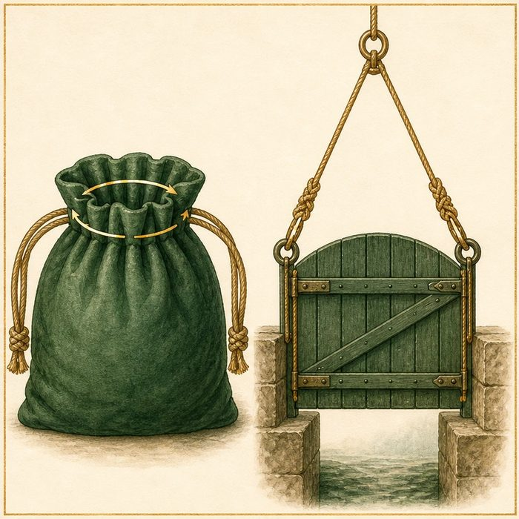
Illustration: A drawstring and a lifting sling only work when their cords run correctly
1. How does the cord direction control the motion?
________________________________________________________________________________
2. What happens if the cord ends are not connected?
________________________________________________________________________________
3. Why would the same amount of cord fail when attached in the wrong place?
________________________________________________________________________________

ANATOMICAL LESSON 2 | RULES AND BIOLOGY MAPPING
2. Turn observations into rules

1. Rule 1: Read fiber direction before predicting motion. Explain it in your own words.
________________________________________________________________________________
2. Rule 2: Check where each muscle begins and ends. Explain it in your own words.
________________________________________________________________________________
3. Rule 3: Continuity lets force travel across the structure. Explain it in your own words.
________________________________________________________________________________
Where the analogy stops: Muscles contract through cells and nerves, not by pulling passive cords.

3. Map the rules onto the biomedical example
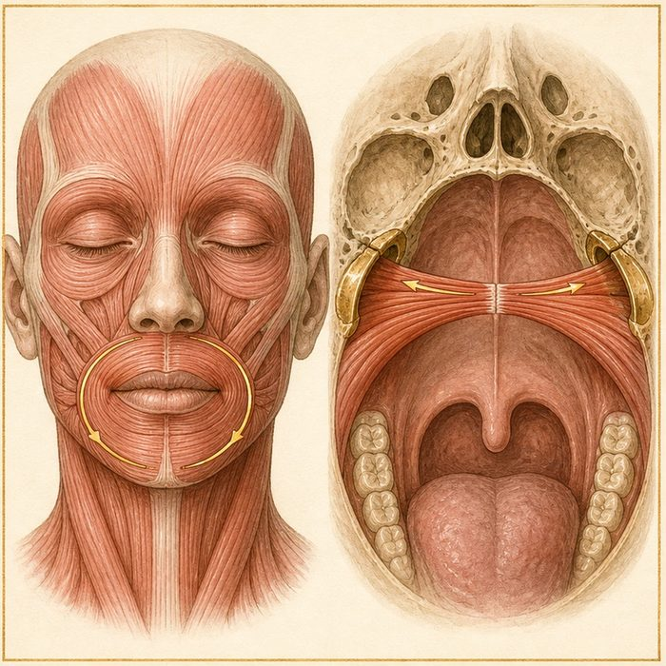
Biomedical teaching illustration: Trace the normal lip sphincter and palatal sling
Analogy step | Biology step | How the relationship stays the same
Drawstring ring | Orbicularis oris sphincter | ________________________________
Lifting sling | Levator veli palatini sling | ________________________________
Cord attachment | Muscle insertion and continuity | ________________________________

ANATOMICAL LESSON 2 | CASE FILE AND DECISION
4. Use the case evidence

ID | Finding supplied in the case | Why it matters
ANA02-E1 | Orbicularis oris fibers normally form a continuous ring around the mouth. | The ring supports lip seal and coordinated movement.
ANA02-E2 | Levator veli palatini fibers normally form a transverse sling across the soft palate. | The sling elevates the velum toward the pharyngeal wall.
ANA02-E3 | Fiber direction predicts the line of pull. | A muscle can be present but function poorly when redirected or interrupted.

5. Make the clinical decision
You are the anatomy fellow preparing a function map. A diagram shows both muscles but leaves out fiber direction and attachments.
A. Add direction, attachment, and continuity before predicting function.
B. Approve it because the muscle names are present.
C. Replace the muscle map with skin landmarks only.
Decision. Choose the revision and use both muscle examples.
________________________________________________________________________________
________________________________________________________________________________
Claim ceiling: You may predict normal lines of pull. You may not infer Mateo's exact muscle displacement before viewing cleft anatomy.
Claim. State the choice you can defend.
________________________________________________________________________________
Evidence. Use these labeled IDs: ANA02-E1 + ANA02-E2.
________________________________________________________________________________
Reasoning. Explain why the evidence supports the claim and stays inside the claim ceiling.
________________________________________________________________________________
________________________________________________________________________________

ANATOMICAL LESSON 2 | REDUCE, REFLECT, AND PREPARE
6. Reduce the lesson to one lasting idea

Take-home. Muscle function depends on fiber direction, attachment, and continuity, not merely on muscle presence.
________________________________________________________________________________
________________________________________________________________________________
1. What shape does orbicularis oris normally form?
________________________________________________________________________________
2. Why does the levator need a sling across the midline?
________________________________________________________________________________

Glossary
Term | Plain-English definition
orbicularis oris | The ring of muscle encircling the mouth that closes and shapes the lips; its fibers are disrupted and repaired in cleft lip surgery.
levator veli palatini | The main muscle that lifts the soft palate to close off the nose during speech and swallowing; it is often disrupted in cleft palate.
muscular sling | The hammock of soft palate muscles that meet in the midline so the palate can lift and seal the nose off during speech and swallowing.
velopharynx | The space where the soft palate meets the back of the throat, which must seal off the nose during speech and swallowing.
sphincter | A ring of muscle that tightens to close an opening and relaxes to open it, such as the muscle ring that seals the throat during speech.

Next lesson unlock
We know the normal muscle plan and the rule that direction and continuity decide function. But we have not yet looked closely at Mateo. So what exactly is interrupted in his lip and palate, and what happens to these muscles? We chase that next time.
The journal links on the lesson page are optional. Everything required for this guided-notes set is already supplied here and in the case file.

