ANATOMICAL DOMAIN | LESSON 1 OF 20 | PEDIATRIC ANATOMIST

The Normal Lip and Palate, Part by Part
What are the parts of a normal lip and palate, and what is the roof of the mouth actually doing?
CARRY FORWARD  Mateo's strongest genetic story is multifactorial and evidence-bounded: IRF6 explains a pathway, not a proven individual cause. | 10-YEAR TAKEAWAY  Anatomy becomes useful when each structure is tied to the job it performs.

Cells differentiate | Development sculpts | Cells move | Development can go wrong

1. Observe the analogy before naming the biology
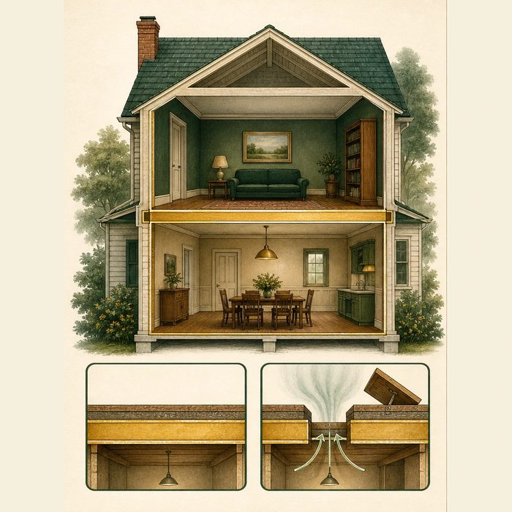
Illustration: A two-room house needs a complete ceiling and floor
1. Which surfaces create two separate spaces?
________________________________________________________________________________
2. What changes if the barrier has a gap?
________________________________________________________________________________
3. Which part must stay rigid and which part must move?
________________________________________________________________________________

ANATOMICAL LESSON 1 | RULES AND BIOLOGY MAPPING
2. Turn observations into rules

1. Rule 1: Name the structure and its boundary. Explain it in your own words.
________________________________________________________________________________
2. Rule 2: Tie each part to a function. Explain it in your own words.
________________________________________________________________________________
3. Rule 3: A working barrier can include rigid and movable regions. Explain it in your own words.
________________________________________________________________________________
Where the analogy stops: The palate is living tissue with muscles, nerves, vessels, and growth. It is not a building floor.

3. Map the rules onto the biomedical example
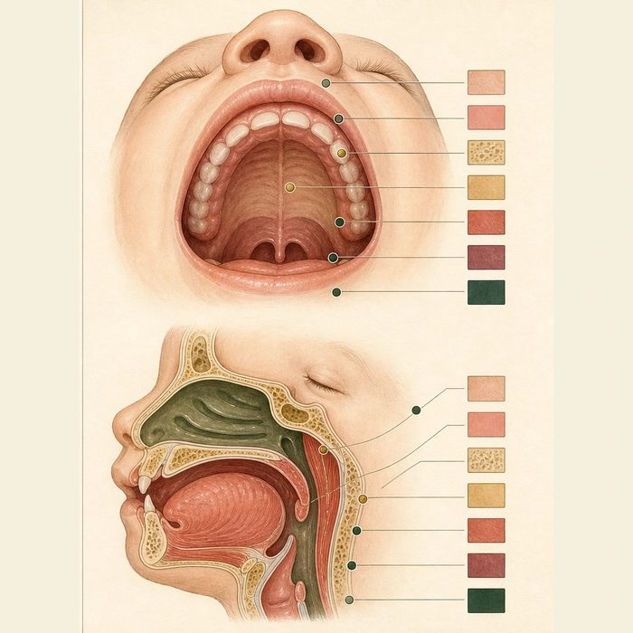
Biomedical teaching illustration: Map the normal lip, primary palate, and secondary palate
Analogy step | Biology step | How the relationship stays the same
Two rooms | Oral and nasal cavities | ________________________________
Rigid floor | Hard palate | ________________________________
Movable hatch | Soft palate and velum | ________________________________

ANATOMICAL LESSON 1 | CASE FILE AND DECISION
4. Use the case evidence

ID | Finding supplied in the case | Why it matters
ANA01-E1 | The incisive foramen separates the primary palate in front from the secondary palate behind. | It is a landmark for describing the extent of a cleft.
ANA01-E2 | The hard palate is bony and the soft palate is muscular. | One provides a fixed roof while the other moves for speech and swallowing.
ANA01-E3 | Mateo's composite file describes an opening from the lip through the palate. | The normal oral-nasal barrier is interrupted across more than one region.

5. Make the clinical decision
You are the pediatric anatomist orienting the cleft team. A trainee labels the palate as one flat bone and cannot explain Mateo's feeding problem.
A. Correct the map to include primary palate, hard palate, soft palate, and two cavities.
B. Keep one label because every palate part has the same tissue and job.
C. Skip the normal map and start with surgery.
Decision. Choose the anatomy correction and cite the landmark plus one function.
________________________________________________________________________________
________________________________________________________________________________
Claim ceiling: You may map normal structures and the barrier function. You may not classify Mateo's cleft until its full extent is supplied.
Claim. State the choice you can defend.
________________________________________________________________________________
Evidence. Use these labeled IDs: ANA01-E1 + ANA01-E2.
________________________________________________________________________________
Reasoning. Explain why the evidence supports the claim and stays inside the claim ceiling.
________________________________________________________________________________
________________________________________________________________________________

ANATOMICAL LESSON 1 | REDUCE, REFLECT, AND PREPARE
6. Reduce the lesson to one lasting idea

Take-home. Anatomy becomes useful when each structure is tied to the job it performs.
________________________________________________________________________________
________________________________________________________________________________
1. Which landmark divides the primary and secondary palate?
________________________________________________________________________________
2. Why must the soft palate move?
________________________________________________________________________________

Glossary
Term | Plain-English definition
philtrum | The vertical groove in the middle of the upper lip, bordered by two ridges, that forms where facial parts fuse during development.
vermilion border | The sharp line where the colored part of the lip meets the surrounding facial skin, a key landmark that must align in cleft lip repair.
alveolus | A tiny air sac at the end of an airway in the lung where oxygen enters the blood and carbon dioxide leaves it across a thin wall.
hard palate | The bony front part of the roof of the mouth that separates the mouth from the nasal cavity and supports chewing and speech.
soft palate (velum) | The flexible muscular back portion of the roof of the mouth that lifts to seal off the nose during speech and swallowing.
incisive foramen | A small opening in the roof of the mouth just behind the front teeth that marks the boundary between the primary and secondary palate.

Next lesson unlock
We have a clean map of the normal lip and palate. But a lip and a palate are not just static shapes; they have to move, close, and seal. Which muscles make a lip and a palate work? We chase that next time.
The journal links on the lesson page are optional. Everything required for this guided-notes set is already supplied here and in the case file.

