TEACHER GUIDE | SEVEN LESSONS
How to teach the track step by step
Clear moves, reasons, student products, and slide alignment for a Socratic classroom

PLANNING RULE The teacher does not open with a lecture. Students first study an image, describe what they notice, and build a rule. The teacher then names the biology, gives a real evidence card, and asks for a concrete decision.

Before the unit
- Print or share the composite case file and student explainer pack.
- Open the matching deck and keep the guided notes available.
- Tell students that every required source is inside the unit. Optional links are enrichment only.
- Protect the claim ceiling: a model mechanism is not a diagnosis of CF-001.

Lesson 1 | Meet Mateo
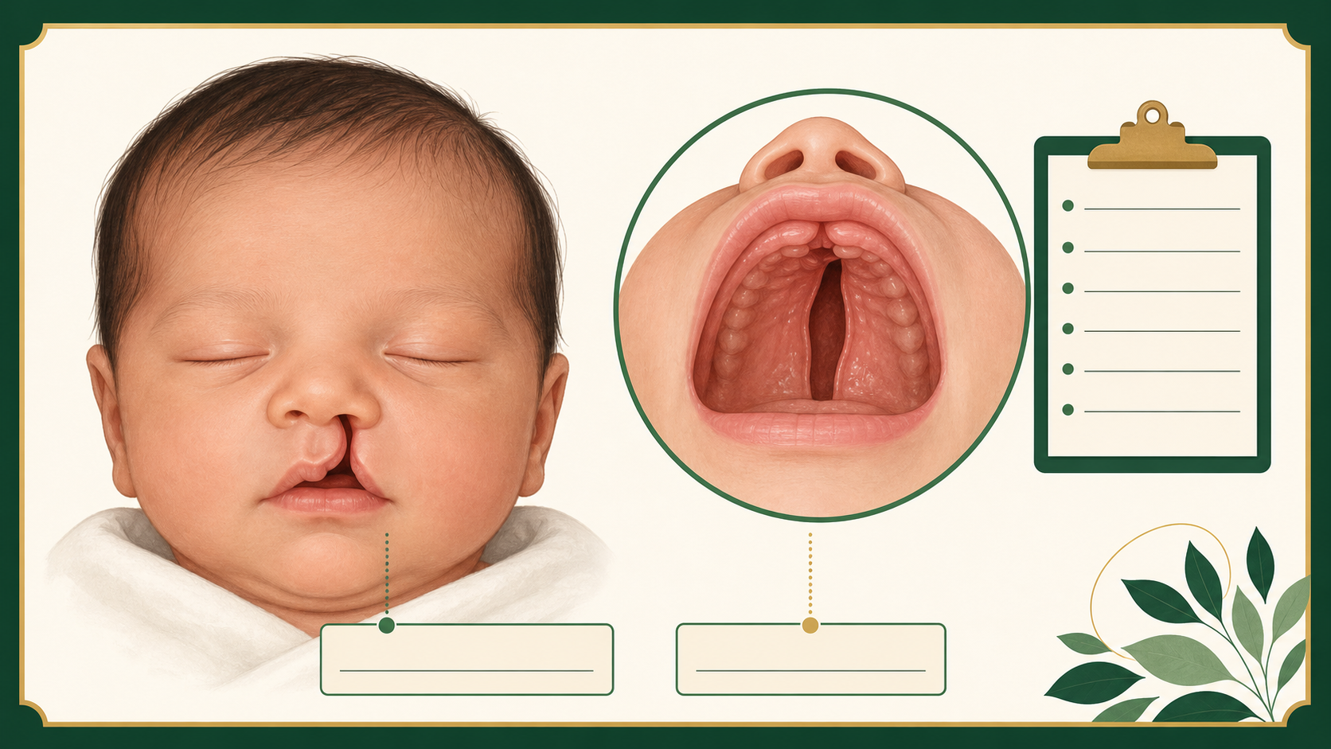
Visual anchor used in the matching slide deck.
LESSON GOAL Students separate observation from explanation and write one testable question.

Teacher sequence
- Slides 1-4: state the question, carry in the four truths, and name the take-home.
- Slide 5: show the case-file image. Ask students to list only what they see. Do not name a cause.
- Slide 6: ask which marks are observations, which marks show uncertainty, and which question evidence could answer.
- Slide 7: sort student language into facts and questions. Name the analogy rule after students defend it.
- Slide 8: introduce IRF6 as a real biology question. Read the claim ceiling aloud.
- Slides 9-11: map the case record to the biology step, then ask the team to choose the strongest next question.
- Slides 12-13: collect the exit ticket and show that the next lesson will watch the face being built.
- Teacher reason: Students need a clean difference between seeing and explaining before any gene name appears.
STUDENT PRODUCT two observations, one testable question, and one sentence that says what the evidence cannot prove.

Lesson 2 | How a Face Is Built
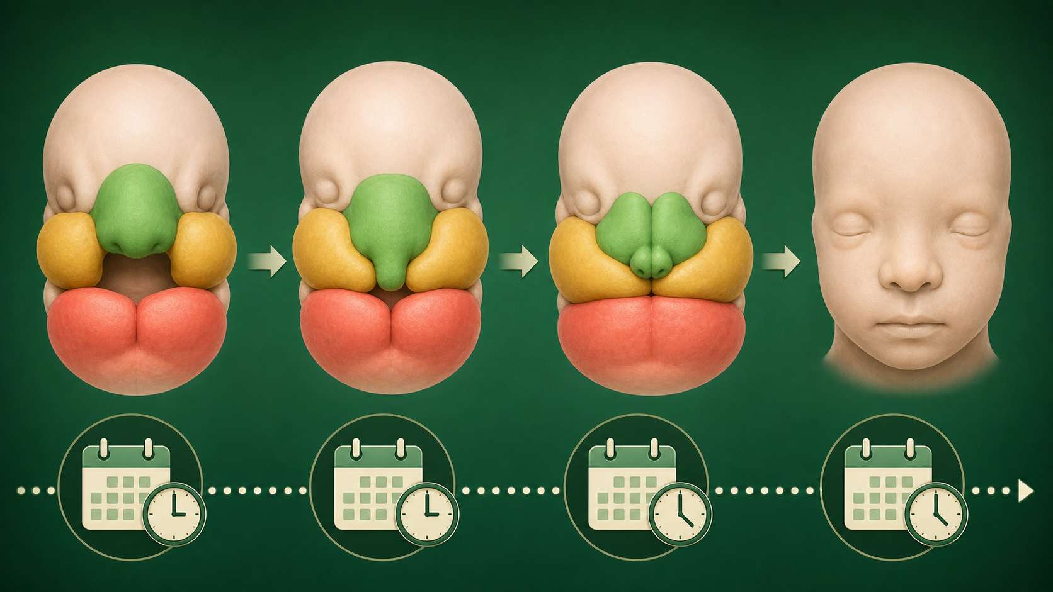
Visual anchor used in the matching slide deck.
LESSON GOAL Students use a timeline to explain why growth, position, and timing all matter.

Teacher sequence
- Slides 1-4: retrieve the prior question and introduce the take-home that tissues move and join on a schedule.
- Slide 5: show the bridge-build analogy. Ask what both crews must do before the crossing works.
- Slide 6: elicit the rules: grow toward the same place, arrive in the same window, and connect.
- Slide 7: translate those rules into prominences, midline, and fusion. Point to the case timeline.
- Slide 8: show the face-build illustration and ask when a WNT9B-linked cue would be worth testing.
- Slides 9-11: label the analogy step beside the facial step, then choose whether the first test is growth, position, or timing.
- Slides 12-13: write the timing take-home and preview the question of what an opening tells us.
- Teacher reason: A visible opening is easier to reason about when students can place the missed step on a clock.
STUDENT PRODUCT a marked week 4 to 12 timeline and a justified choice of the first process to test.

Lesson 3 | A Cleft Marks a Step That Did Not Finish
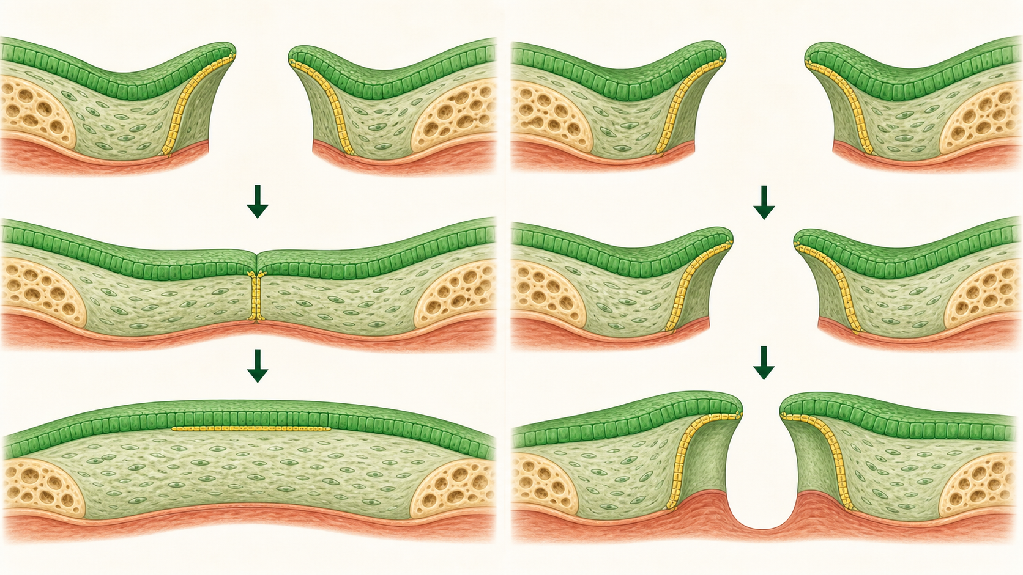
Visual anchor used in the matching slide deck.
LESSON GOAL Students name a cleft as an unfinished process, not a cause.

Teacher sequence
- Slides 1-4: retrieve the timing idea and state the take-home about an interrupted join.
- Slide 5: show the zipper analogy. Ask what the remaining gap tells us and what it does not tell us.
- Slide 6: let students compare growth, contact, and completion without using gene names.
- Slide 7: write the process rule: edges must meet and the join must finish.
- Slide 8: show the fusion-gap figure and introduce IRF6 as evidence about epithelial cell behavior.
- Slides 9-11: label the analogy step beside the biology step and decide which evidence would separate contact failure from seam failure.
- Slides 12-13: collect a one-sentence process explanation and bridge to the cells that travel to the build site.
- Teacher reason: The word cleft names the result. Students need practice stopping short of an unsupported cause.
STUDENT PRODUCT one process claim, one supplied evidence card, and one limitation statement.

Lesson 4 | The Cells That Build the Face
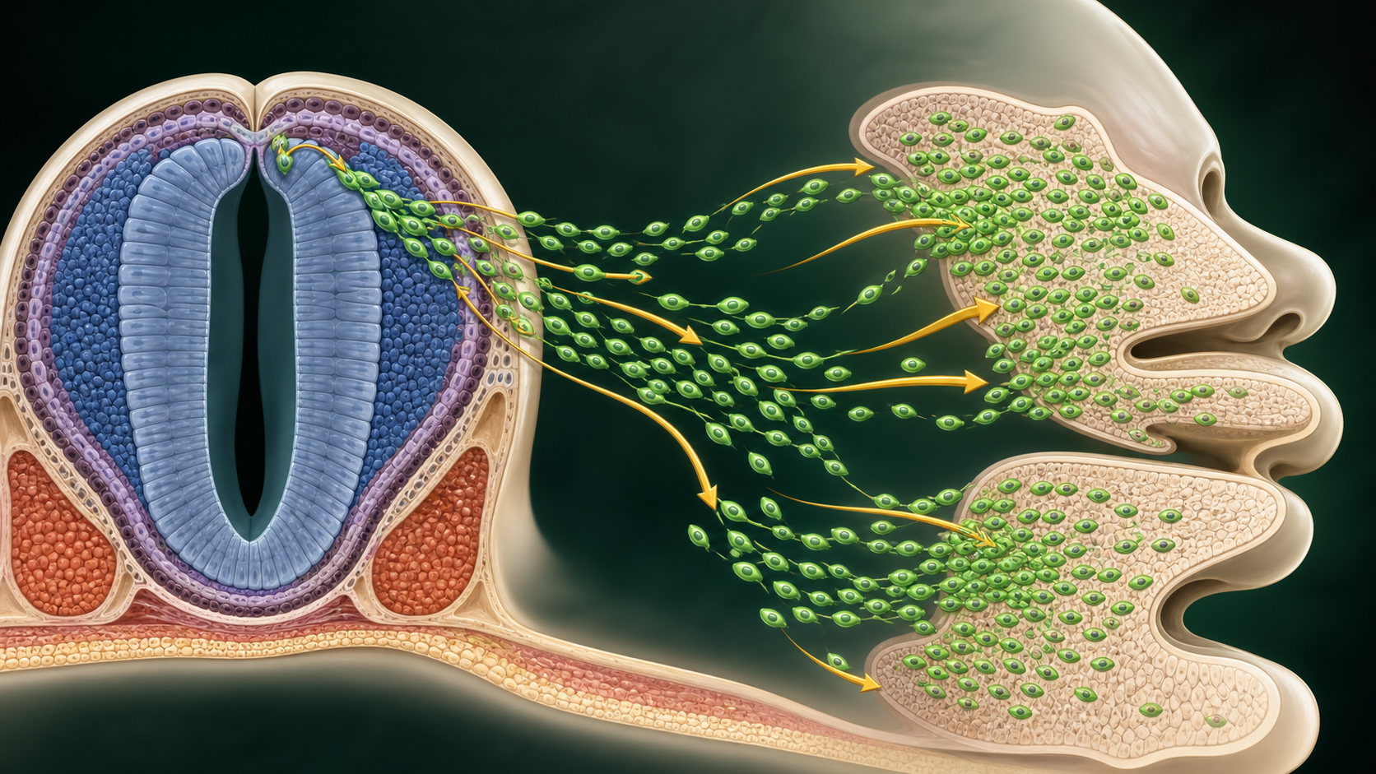
Visual anchor used in the matching slide deck.
LESSON GOAL Students explain how a migration problem can appear later as a tissue problem.

Teacher sequence
- Slides 1-4: retrieve the unfinished-join idea and add the truth that cells move.
- Slide 5: show the traffic analogy. Ask what a route, barrier, and destination might represent.
- Slide 6: collect observations about paths and missed exits. Keep the word neural crest hidden until the rule is clear.
- Slide 7: map route to migration, cars to cells, and destination to facial tissue.
- Slide 8: show the neural crest illustration and the SOX10 marker card. State that a marker tracks location but does not prove cause.
- Slides 9-11: map the route to a facial prominence and choose the next test if too few cells arrive.
- Slides 12-13: collect the migration explanation and bridge to cell fate after arrival.
- Teacher reason: Students often treat a tissue as if it appears in place. The route makes the developmental story visible.
STUDENT PRODUCT an arrowed migration sketch and a claim that stays below the marker ceiling.

Lesson 5 | How Cells Choose What to Become
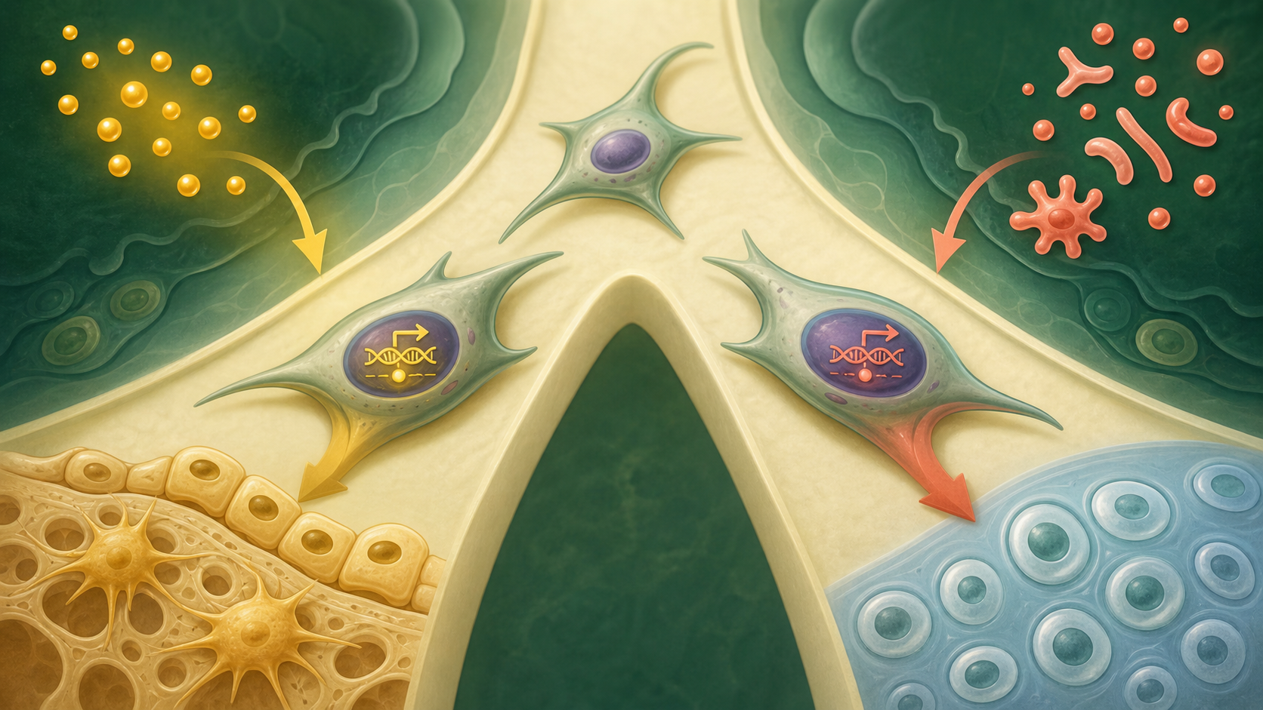
Visual anchor used in the matching slide deck.
LESSON GOAL Students explain why nearby cells with the same DNA can take different roles.

Teacher sequence
- Slides 1-4: retrieve arrival and introduce internal state plus external cue.
- Slide 5: show the GPS and driver analogy. Ask what information is inside and outside the car.
- Slide 6: ask students to find a cue, a choice, and a constraint in the picture.
- Slide 7: name cell fate, instructive cue, and permissive condition in plain English.
- Slide 8: show the cell-fate illustration and the WNT, RUNX2, and SOX9 card.
- Slides 9-11: map analogy to biology, then decide which fate is more likely in a concrete cue scenario.
- Slides 12-13: collect a contrast between instructive and permissive and bridge to seam remodeling.
- Teacher reason: Students need the logic of a decision before molecular labels. The analogy keeps the idea causal but not deterministic.
STUDENT PRODUCT a cue plus internal-state explanation and a choice between competing cell fates.

Lesson 6 | Fusion Requires Sculpting
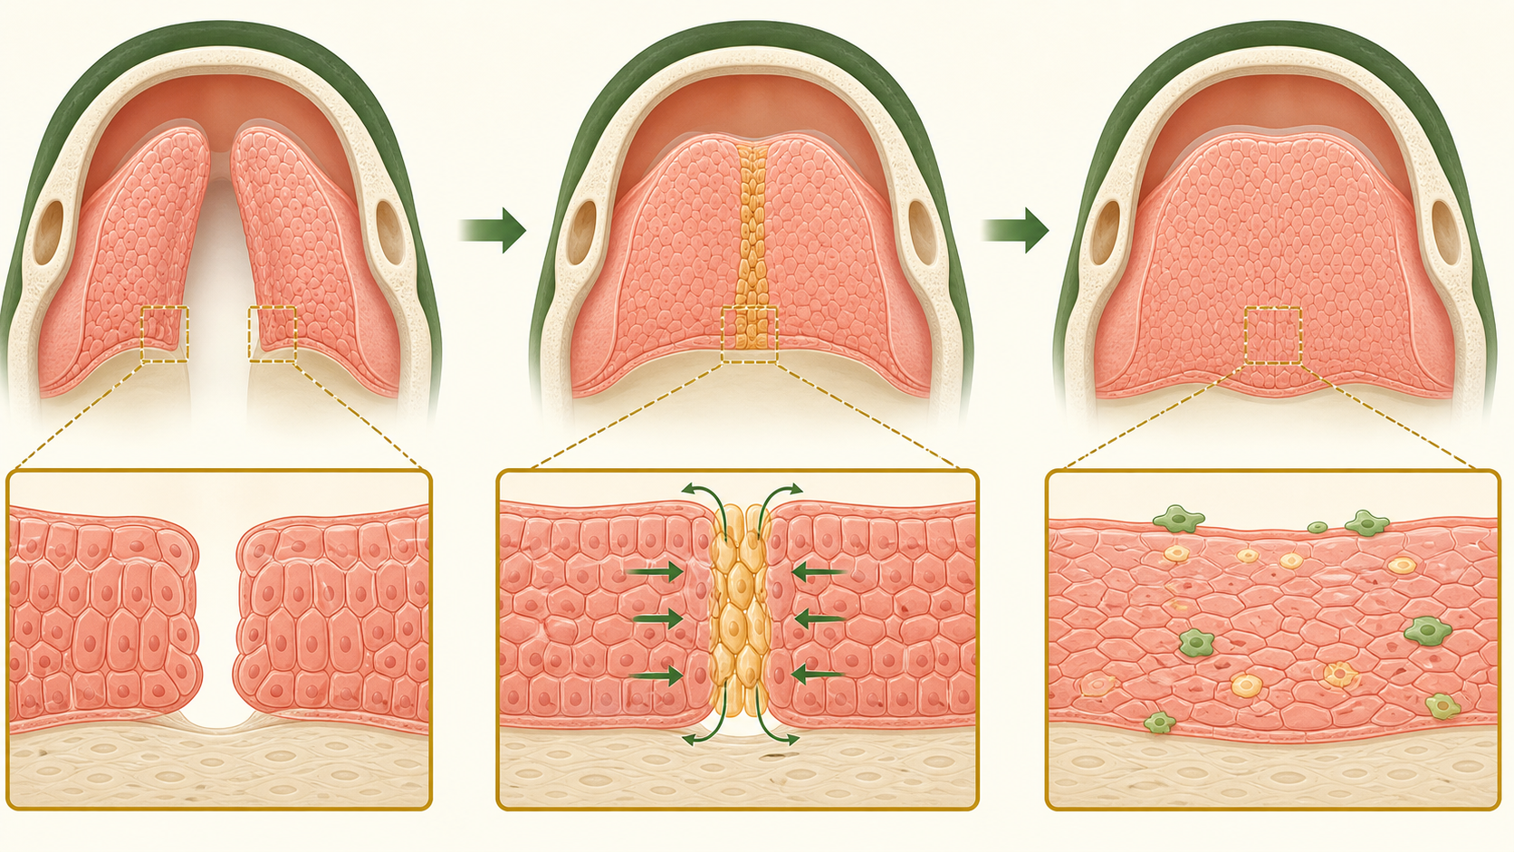
Visual anchor used in the matching slide deck.
LESSON GOAL Students explain why contact is not the same as a finished palate.

Teacher sequence
- Slides 1-4: retrieve cell fate and state the sculpting take-home.
- Slide 5: show the bridge-scaffolding analogy. Ask why temporary support must be removed.
- Slide 6: sequence approach, contact, seam, and remodeling from the image.
- Slide 7: name the rule that removal can be part of construction. Define seam, remodel, EMT, and apoptosis before asking students to use them.
- Slide 8: show the seam-remodeling figure and TGFB3 evidence card.
- Slides 9-11: map scaffolding to seam, then decide whether the case points first to growth, contact, or remodeling.
- Slides 12-13: collect a one-sentence explanation of why more growth cannot repair every failure.
- Teacher reason: This lesson prevents the common misconception that growth alone makes a continuous structure.
STUDENT PRODUCT a four-step sequence and a process-level decision with evidence.

Lesson 7 | From a Gene Instruction to a Cell Behavior
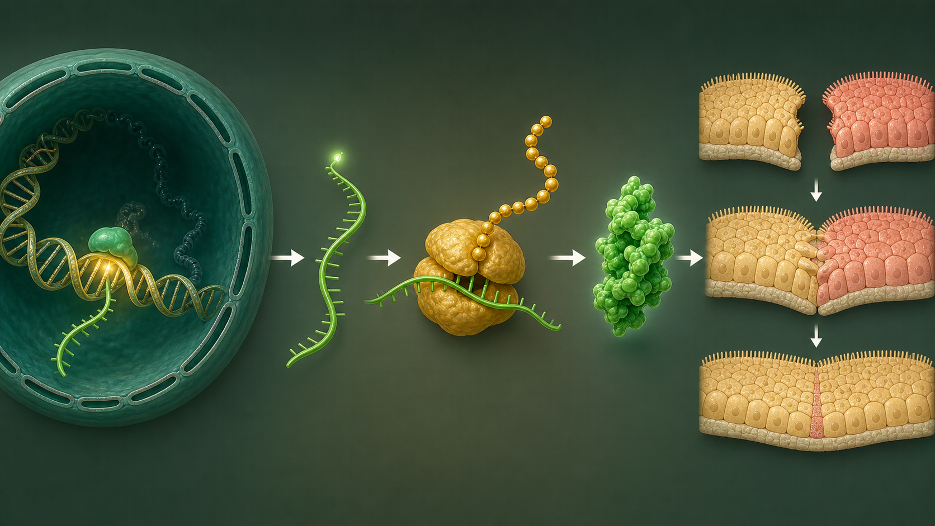
Visual anchor used in the matching slide deck.
LESSON GOAL Students connect DNA, RNA, protein, and cell behavior while keeping context and evidence limits visible.

Teacher sequence
- Slides 1-4: retrieve seam remodeling and frame genes as instructions used by cells.
- Slide 5: show the construction-manual analogy. Ask what must happen between a page and a finished tool.
- Slide 6: ask what changes when the job site, crew, or timing changes.
- Slide 7: name DNA, RNA, protein, and cell behavior in that order.
- Slide 8: show the gene-to-protein illustration and connect IRF6 to epithelial and periderm behavior.
- Slides 9-11: label each analogy step beside the molecular step, then decide what an IRF6 variant could justify testing and what it cannot prove.
- Slides 12-13: collect the final four-truth summary and point forward to comparing evidence types in the next unit.
- Teacher reason: The gene story stays inside development. Students leave with mechanism and uncertainty, not gene-as-destiny thinking.
STUDENT PRODUCT a complete DNA to cell-behavior chain, one context factor, and one evidence limitation.

Sources for enrichment
The seven lessons are self-contained. These links are for optional teacher or student follow-up, not required homework.
- National Institute of Dental and Craniofacial Research, Cleft Lip and Palate: https://www.nidcr.nih.gov/health-info/cleft-lip-palate
- Craniofacial development review, PubMed Central: https://pmc.ncbi.nlm.nih.gov/articles/PMC3039913/
- Cranial neural crest and facial development review, PubMed Central: https://pmc.ncbi.nlm.nih.gov/articles/PMC11072871/
- IRF6 and epithelial seam biology, PubMed Central: https://pmc.ncbi.nlm.nih.gov/articles/PMC2659566/
- Palatal fusion and seam remodeling review, PubMed Central: https://pmc.ncbi.nlm.nih.gov/articles/PMC3552505/

