STUDENT EXPLAINER PACK | SEVEN LESSONS
How a face is built
Plain-language science notes for the case file and the Socratic questions

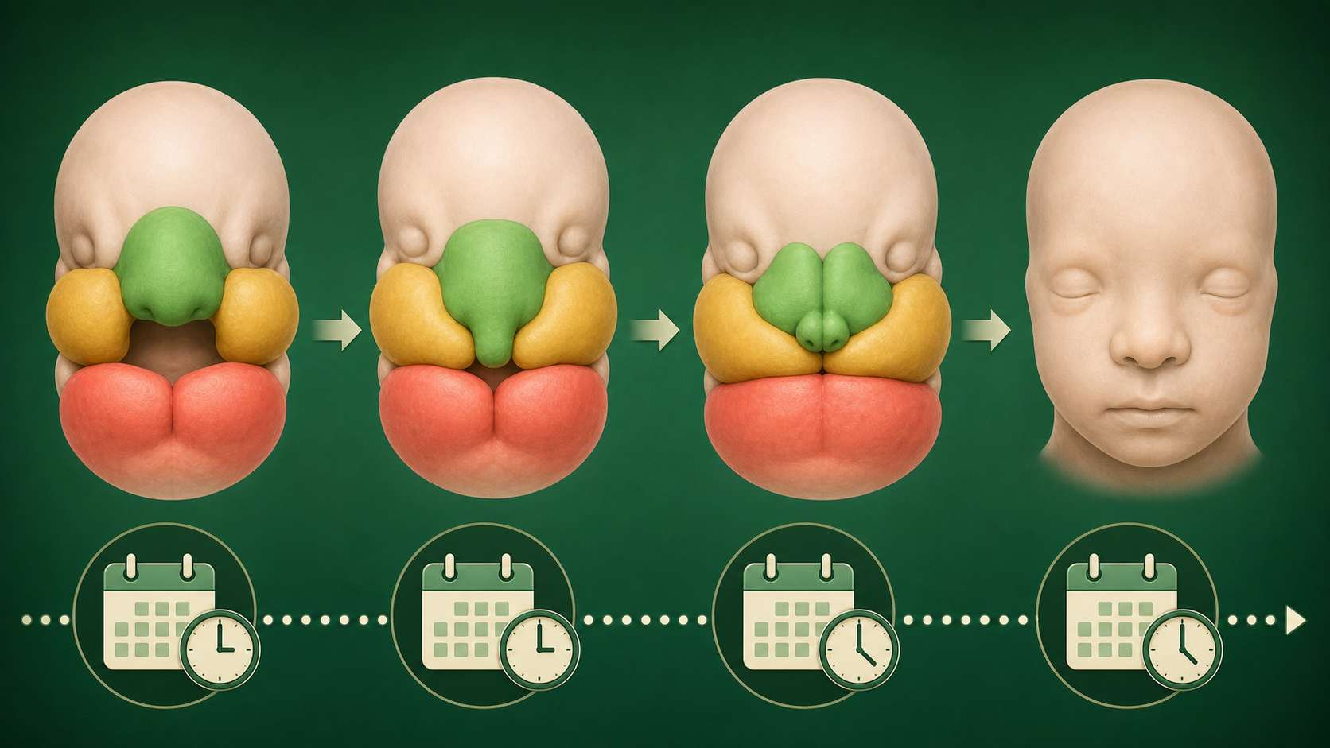
The unit story: cells move, choose roles, meet, and remodel.
HOW TO USE THIS PACK Read the short explanation before you answer the deck question. Then point to a supplied figure or evidence card. If you cannot point to evidence inside the packet, write that the evidence is missing instead of searching the web.

Lesson 1 | Observe before you explain
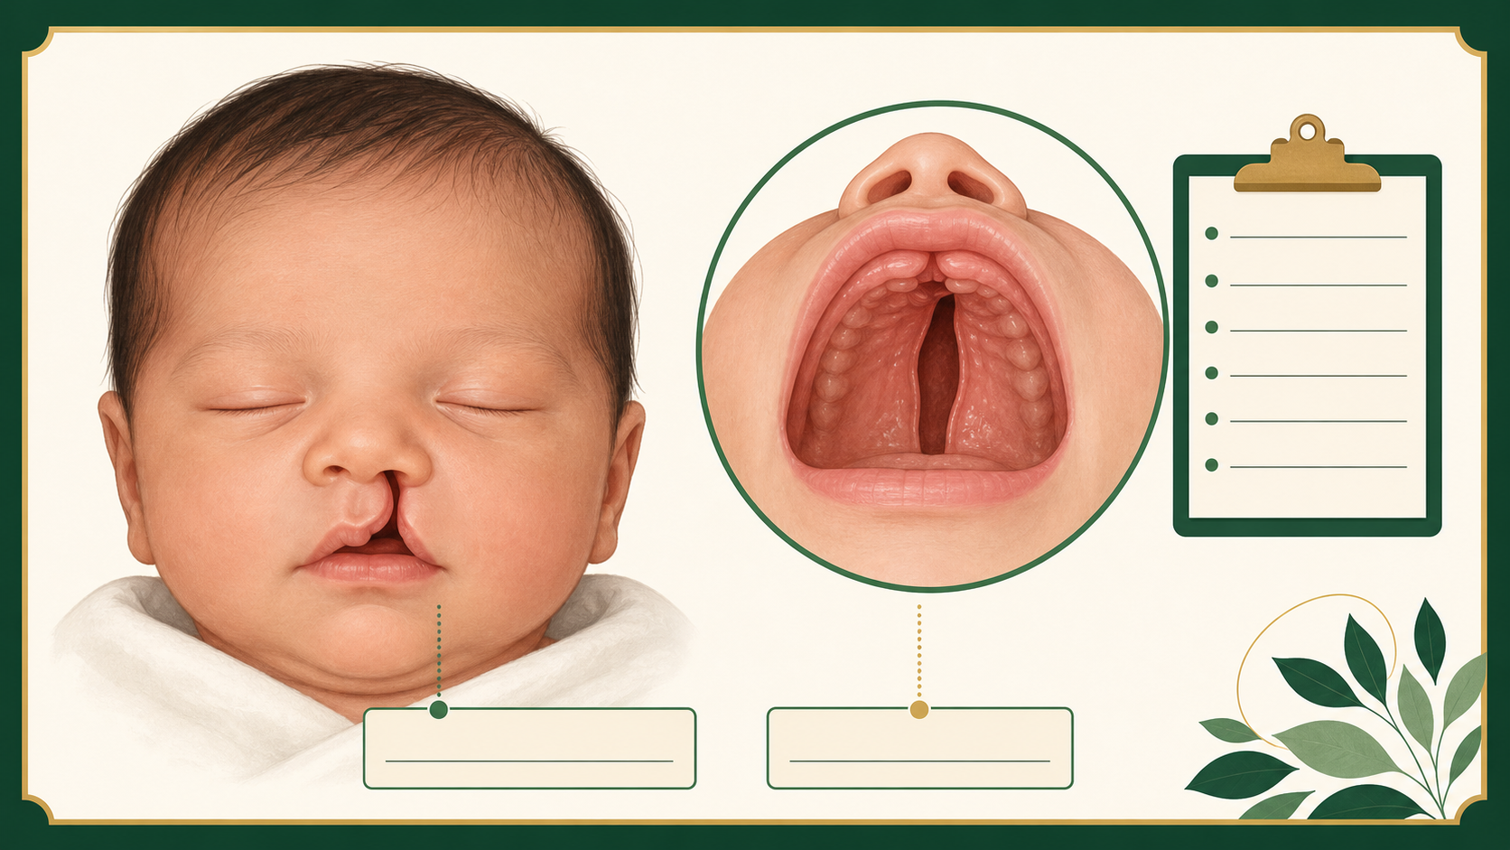
Lesson 1 visual anchor.
An observation is what a record or image shows. A hypothesis is a testable idea about why it happened. In this unit, the opening in the lip or palate is an observation. “A gene caused it” is not an observation; it is a claim that needs evidence.
WORDS TO KEEP Vocabulary: observation = what is seen; hypothesis = an idea that can be tested; evidence = a result that supports or weakens an idea.

USE IT NOW Use it now: Write one observation from CF-001 and one question that could be answered with evidence.

Optional link: NIDCR, Cleft Lip and Palate: https://www.nidcr.nih.gov/health-info/cleft-lip-palate

Lesson 2 | Build on a schedule
Lesson 2 visual anchor.
The early face is assembled from tissue regions called prominences. These regions grow toward one another and fuse. Fusion means the edges meet and become one continuous tissue. Because each step has a time window, the same visible opening can come from different missed steps.
WORDS TO KEEP Vocabulary: prominence = a facial tissue region; fuse = join into one tissue; time window = the period when a step can occur.

USE IT NOW Use it now: Place the CF-001 question on the timeline: growth, contact, or remodeling.

Optional link: Craniofacial development review: https://pmc.ncbi.nlm.nih.gov/articles/PMC3039913/

Lesson 3 | A cleft marks an unfinished join
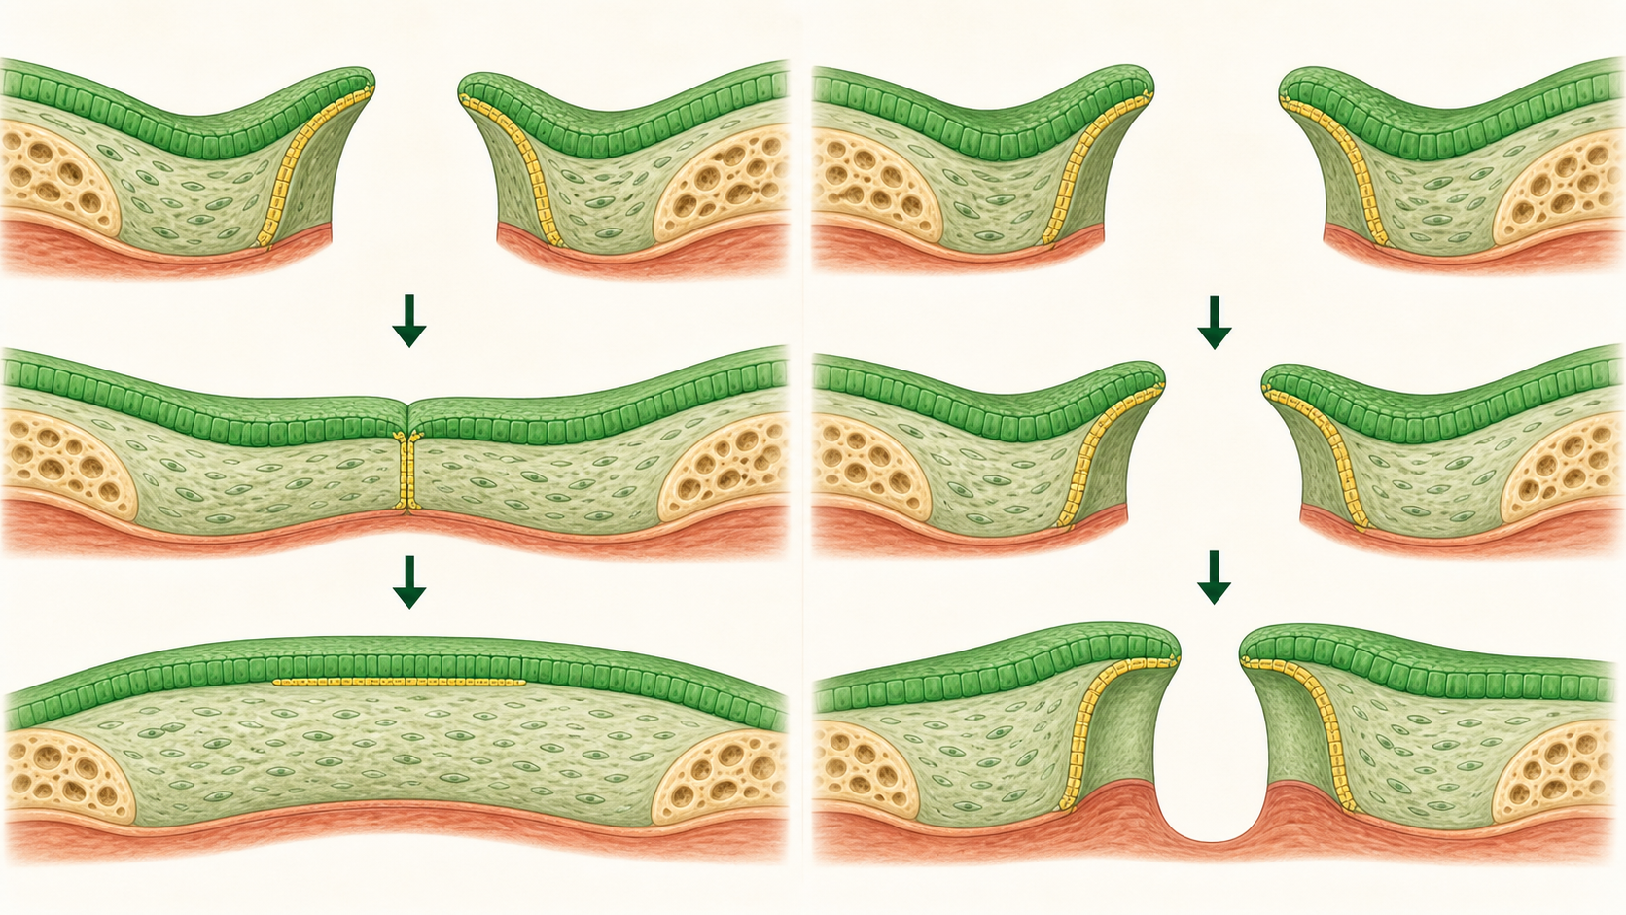
Lesson 3 visual anchor.
A cleft is an opening where a continuous lip or palate structure did not form. The word names the result, not the reason. A useful investigator asks whether tissue did not grow enough, did not reach the partner tissue, or reached it but did not finish the seam.
WORDS TO KEEP Vocabulary: cleft = a persistent opening; contact = two tissue edges touch; seam = the temporary boundary where they meet.

USE IT NOW Use it now: Choose the first process you would test for the lip observation and defend the choice with the fusion-gap figure.

Optional link: NIDCR, Cleft Lip and Palate: https://www.nidcr.nih.gov/health-info/cleft-lip-palate

Lesson 4 | Cells travel to the build site
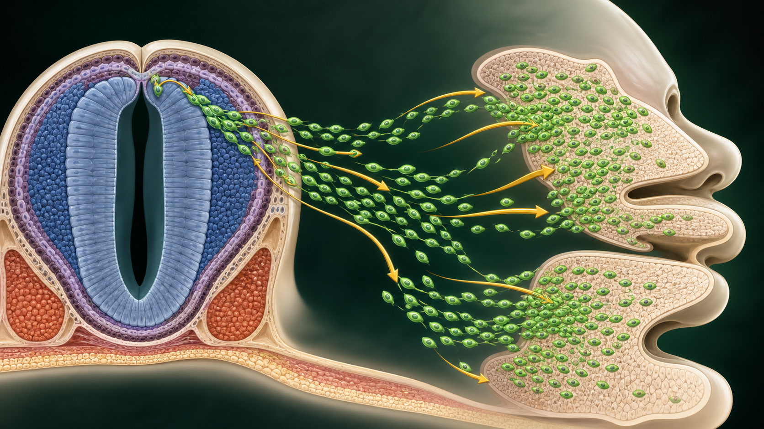
Lesson 4 visual anchor.
Neural crest cells start in one part of the early embryo and migrate to new locations. There they contribute to facial support tissues. A marker such as SOX10 is a tracking label used in model tissue. It can show where cells are, but a label alone does not prove why they moved.
WORDS TO KEEP Vocabulary: migrate = move from one region to another; neural crest = a traveling embryonic cell population; marker = a label used to track cells.

USE IT NOW Use it now: Draw one arrow on the neural crest figure and write what the marker lets you claim.

Optional link: Cranial neural crest review: https://pmc.ncbi.nlm.nih.gov/articles/PMC11072871/

Lesson 5 | Cells choose a role
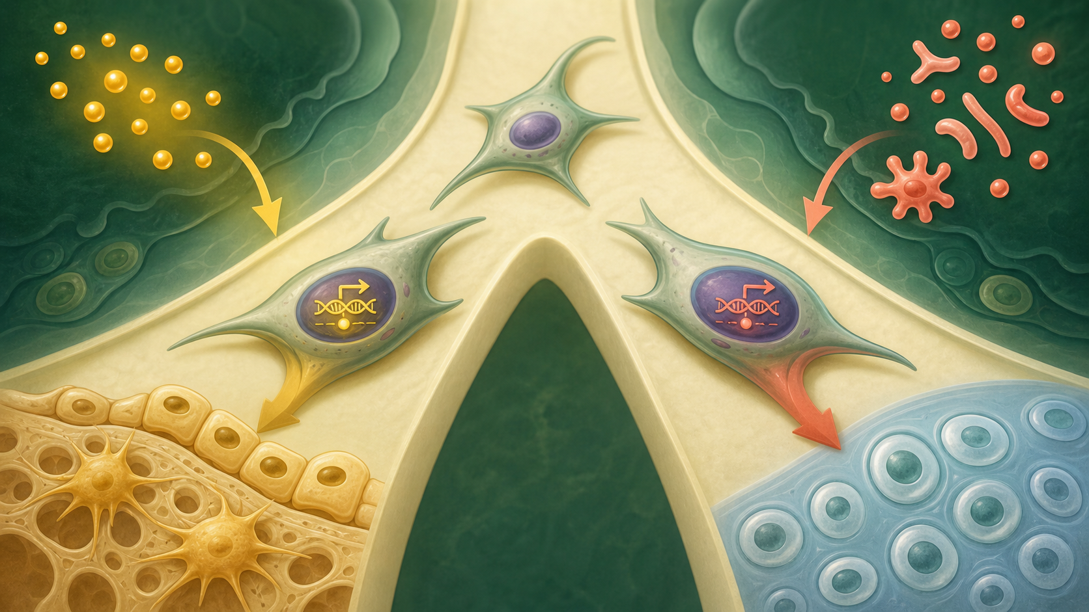
Lesson 5 visual anchor.
Most cells carry the same DNA, but different genes are active in different cells. A cell reads cues from outside and combines them with its internal state. WNT/β-catenin can support a bone-forming program in cranial progenitors, while SOX9 is linked to a cartilage program and RUNX2 supports bone programs. These are interacting programs, not one magic switch.
WORDS TO KEEP Vocabulary: cell fate = the role a cell takes; cue = a signal that changes a choice; progenitor = a cell that can still take more than one path.

USE IT NOW Use it now: On the cell-fate figure, circle the cue and underline the internal program. Explain why both matter.

Optional link: WNT and craniofacial bone review: https://pmc.ncbi.nlm.nih.gov/articles/PMC11072871/

Lesson 6 | Fusion needs sculpting
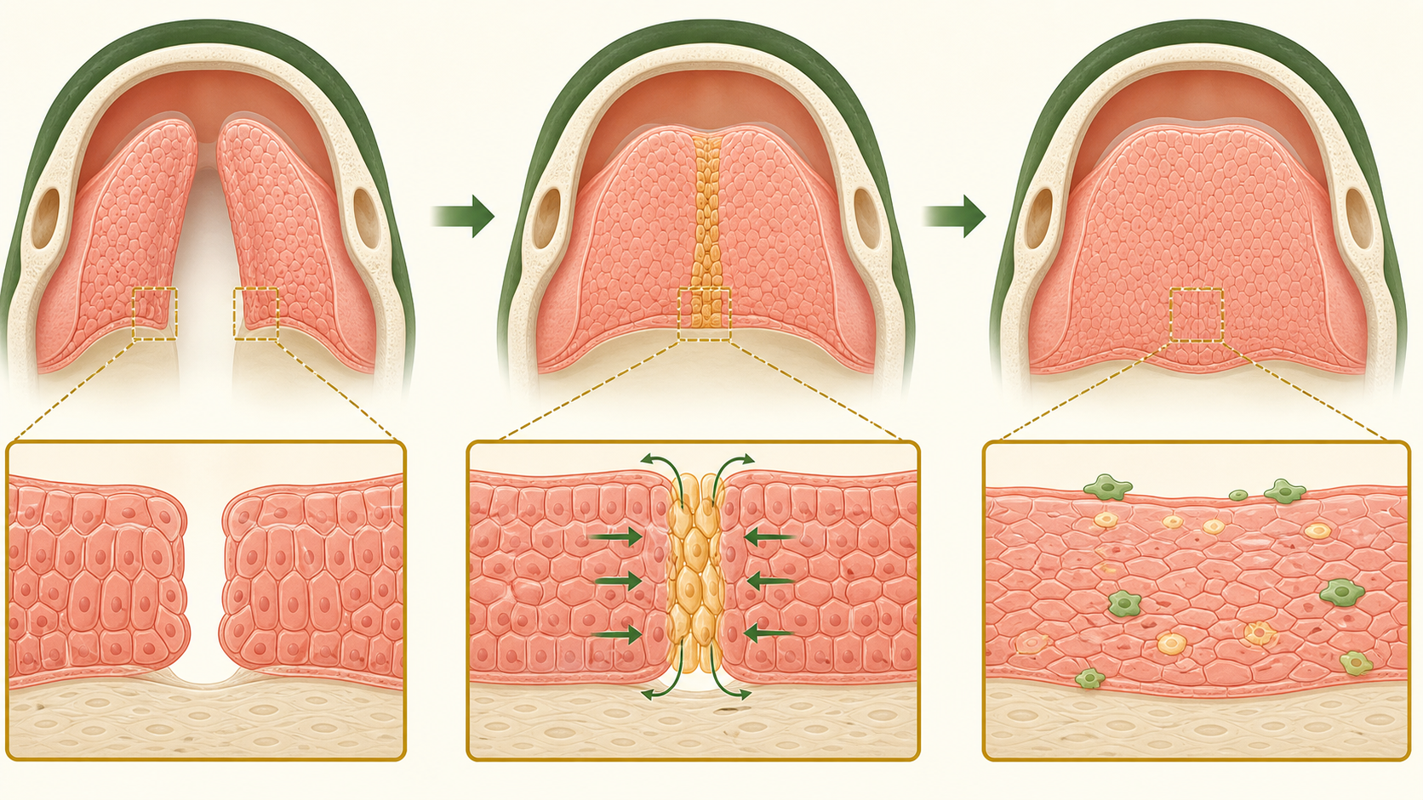
Lesson 6 visual anchor.
Growth brings tissue edges near each other. Contact is only the middle of the story. The medial epithelial seam is a temporary layer at the join. Seam cells must change or be removed so the finished palate is continuous. Cell death and epithelial-to-mesenchymal transition are two mechanisms scientists study; neither should be treated as the only explanation without evidence.
WORDS TO KEEP Vocabulary: seam = temporary joining layer; remodel = change or remove tissue to finish a structure; EMT = a cell-state change in which an epithelial cell becomes more mobile and mesenchymal-like.

USE IT NOW Use it now: Sequence the four steps in the seam figure: approach, contact, seam, remodeling.

Optional link: Palatal fusion review: https://pmc.ncbi.nlm.nih.gov/articles/PMC3552505/

Lesson 7 | A gene becomes a cell-behavior question
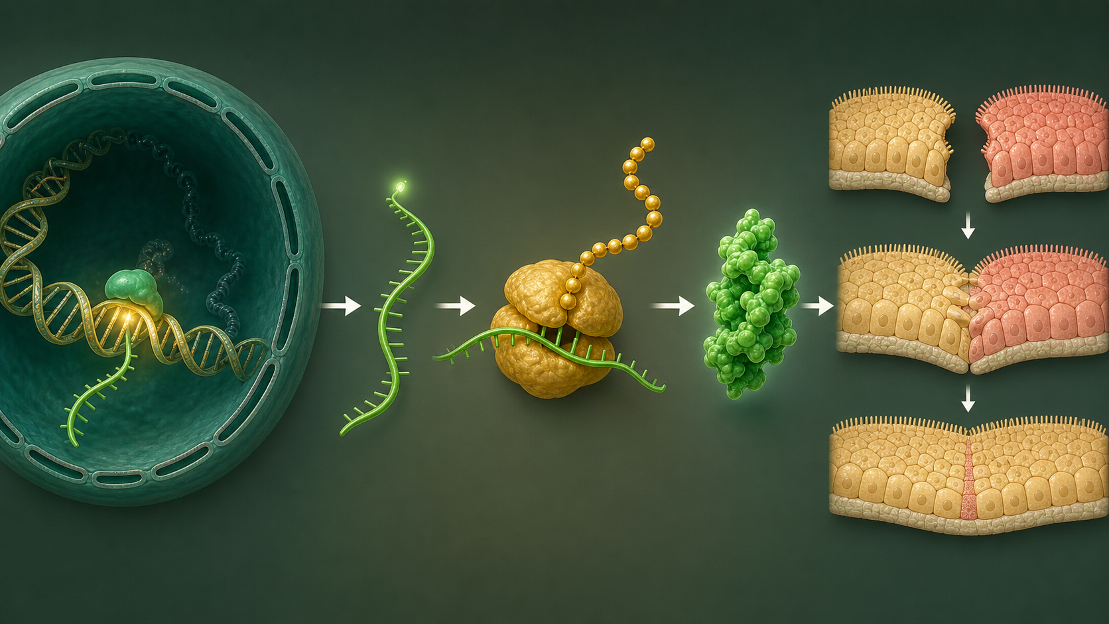
Lesson 7 visual anchor.
A gene is DNA information. Cells copy a gene into RNA, and the RNA is used to build a protein. The protein can change cell behavior. IRF6 is one example connected to epithelial and periderm behavior during lip and palate development. A variant can change a protein, but the developmental outcome still depends on cell type, timing, other genes, and environment.
WORDS TO KEEP Vocabulary: gene = DNA information; RNA = a working copy of that information; protein = a molecule that does cell work; variant = a DNA difference.

USE IT NOW Use it now: Trace IRF6 from DNA to protein to cell behavior. End by naming one conclusion the evidence cannot support.

Optional link: IRF6 and epithelial seam biology: https://pmc.ncbi.nlm.nih.gov/articles/PMC2659566/

Glossary
Use these short definitions before you use the word in a claim.
- apoptosis: a controlled way a cell dies; it can help remove temporary tissue
- cell fate: the role or type of cell a cell becomes
- cleft: an opening left when a continuous lip or palate structure did not form
- cue: a signal from the cell or its surroundings that can change a choice
- epithelium: a sheet of cells that covers or lines a surface
- fuse: join two tissue edges into one continuous tissue
- gene: a stretch of DNA that carries information for a cell job
- marker: a label scientists use to track a cell or cell population
- migrate: move from one region to another
- mesenchyme: a flexible embryonic tissue that can help form support structures
- prominence: a facial tissue region that grows as the face is assembled
- protein: a molecule built by a cell that carries out a job
- remodel: change, reshape, or remove tissue to finish a structure
- RNA: a working copy of DNA information used to build a protein
- seam: the temporary cell layer where two tissue edges meet
- variant: a difference in DNA sequence

Sources for enrichment
The seven lessons are self-contained. These links are for optional teacher or student follow-up, not required homework.
- National Institute of Dental and Craniofacial Research, Cleft Lip and Palate: https://www.nidcr.nih.gov/health-info/cleft-lip-palate
- Craniofacial development review, PubMed Central: https://pmc.ncbi.nlm.nih.gov/articles/PMC3039913/
- Cranial neural crest and facial development review, PubMed Central: https://pmc.ncbi.nlm.nih.gov/articles/PMC11072871/
- IRF6 and epithelial seam biology, PubMed Central: https://pmc.ncbi.nlm.nih.gov/articles/PMC2659566/
- Palatal fusion and seam remodeling review, PubMed Central: https://pmc.ncbi.nlm.nih.gov/articles/PMC3552505/

